#### 23.4.2 Applications

In Fig. [23.30](#u116076_4_En_23_Chapter-Fig30), the revenue in the worldwide diode laser market is shown. The drop after 2000 is due to the burst of the ‘internet bubble’. Nondiode laser (gas, ruby, excimer, ...) revenue is currently stable at around 2 billion US$, thus semiconductor lasers account for the largest share of all laser types sold.

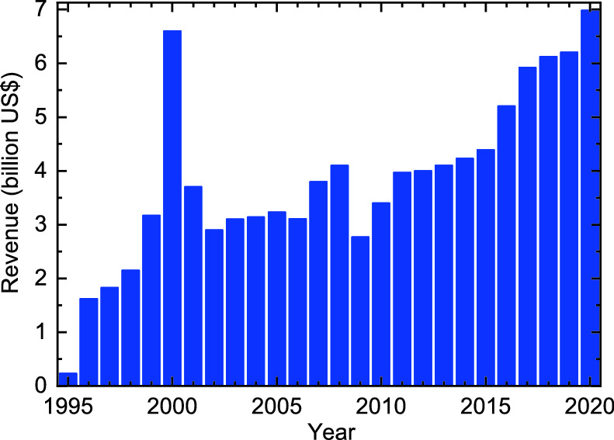

Fig. 23.30

Revenue in worldwide diode laser market. Based on numbers from [1978], data for 2020 estimated

The following applications rely on semiconductor lasers:

optical communication, mostly optical fiber based (senders), typically at 10 GBit/s, in special situations also 40 GBit/s data rate.

optical information storage and retrieval (CD, DVD, BD[16](#u116076_4_En_23_Chapter-Fn16)) with as short of a wavelength as possible, as shown in Fig. [23.31](#u116076_4_En_23_Chapter-Fig31), currently 405 nm.

pumping of solid-state lasers, typically 910 or 940 nm for pumping Nd:YAG

portable projectors, laser TV, entertainment.

laser pointers, see Fig. [23.32](#u116076_4_En_23_Chapter-Fig32). A red laser pointer simply uses the collimated red emission of a GaAs-based diode. In a green laser pointer, an infrared diode pumps a Nd:YAG or Nd:YVO

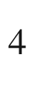

crystal. The emitted beam is then frequency doubled, typically with a KTiOPO

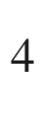

(KTP) crystal.

medical instruments with a variety of wavelengths in ophthalmology, dermatology, cosmetics (hair removal, tattoo removal).

various other uses, such as remote control, position detection, distance measurement, printing, scientific instrumentation.

The market for photonic devices is much more dynamic than the electronics market. An example is the rapid change of dominating laser applications. For diode lasers, the two most prominent applications are telecommunication (77% market share in 2000, 25% in 2003, 45% in 2008) and optical data storage (17% market share in 2000, 60% in 2003, 44% in 2008).

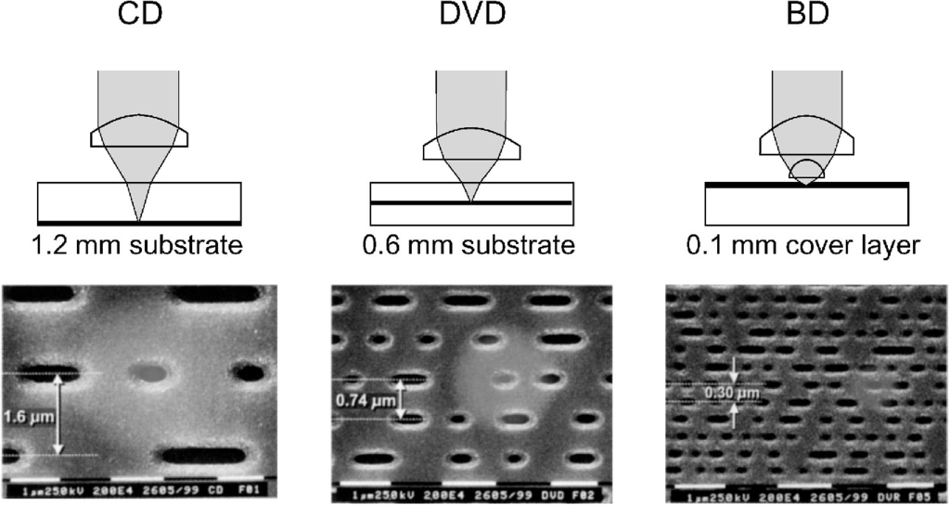

Fig. 23.31

Evolution of optical data storage technology, ‘CD’: compact disk (laser: 780 nm, pitch: 1.6 µm, capacity: 0.7 GB), ‘DVD’: digital versatile disk (laser: 635–650 nm, pitch: 0.74 µm, capacity: 4.7 GB for one layer), ‘BD’: ‘Blu-ray’ disk (laser: 405 nm, pitch: 0.32 µm, capacity: 27 GB for one layer)

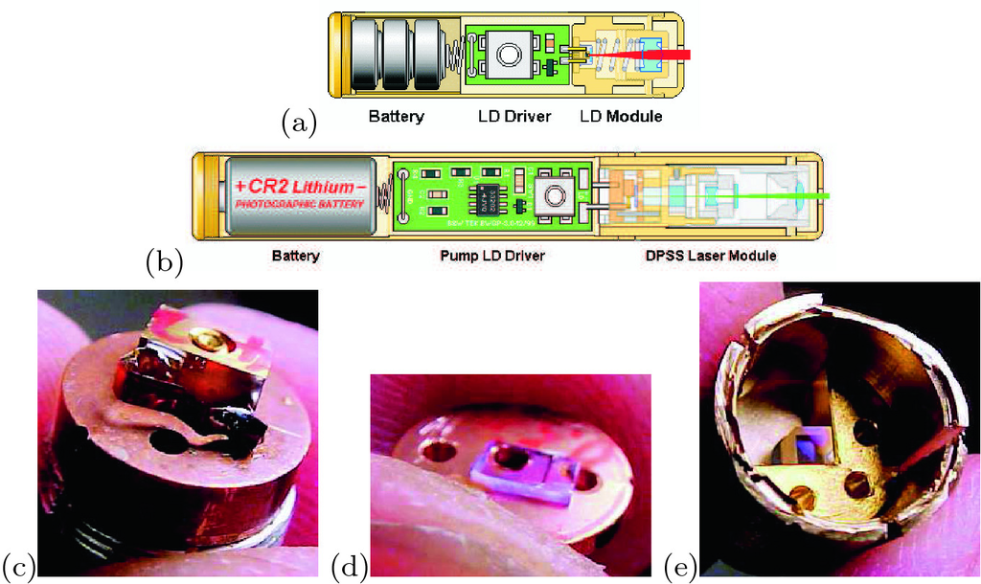

Fig. 23.32

**a** Scheme of red laser pointer, **b** scheme of green laser pointer. Parts of a green laser pointer: **c** pump laser diode, **d** YVO



crystal, **e** KTP doubler

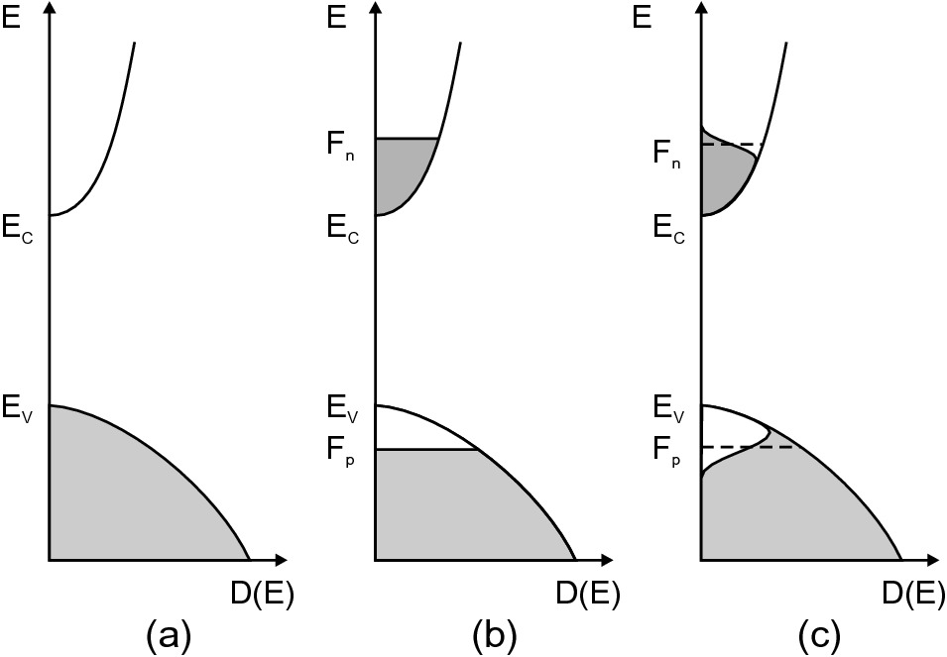

Fig. 23.33

Population **a** in thermodynamic equilibrium

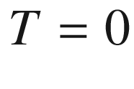

 K, **b** under inversion for

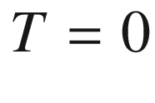

 K, **c** under inversion for

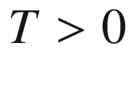

 K. *Shaded areas* are populated with electrons

#### 23.4.3 Gain

Due to current injection,[17](#u116076_4_En_23_Chapter-Fn17) a nonequilibrium carrier distribution is created. After fast thermalization processes (phonon scattering), it can mostly described by quasi-Fermi levels. Sufficiently strong pumping leads to inversion, i.e. conduction-band states are more strongly populated with electrons than valence-band states (Fig. [23.33](#u116076_4_En_23_Chapter-Fig33)). In this case, the stimulated emission rate is stronger than the absorption rate (cf. Sect. [10.​2.​6](The_Physics_of_Semiconductors00005.docx#u116076_4_En_10_Chapter)). The thermodynamic laser condition (cf. ([10.​23](The_Physics_of_Semiconductors00005.docx#u116076_4_En_10_Chapter))) requires the difference of the quasi-Fermi levels to be larger than the band gap.

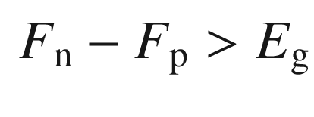

(23.10)

The gain is defined as the (frequency-dependent) coefficient

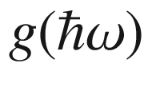

that describes the light intensity along a path *L* according to

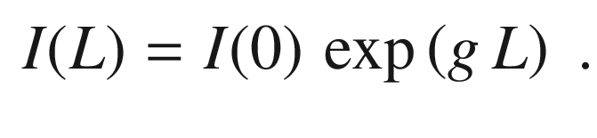

(23.11)

The gain spectrum as a function of the photon energy

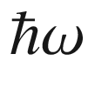

is given for non-*k*-conserving recombination by (cf. ([10.​5](The_Physics_of_Semiconductors00005.docx#u116076_4_En_10_Chapter)) and ([10.​6](The_Physics_of_Semiconductors00005.docx#u116076_4_En_10_Chapter)))

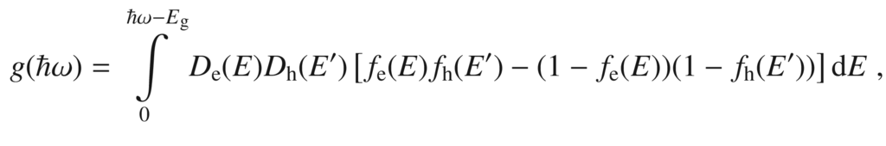

(23.12)

with

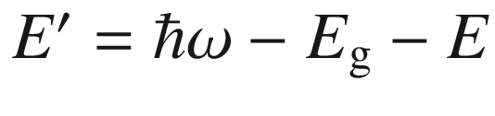

. The gain is positive for those photon energies for which light is amplified and negative for those that are absorbed. In Fig. [23.34](#u116076_4_En_23_Chapter-Fig34)a, the electron and hole concentrations are shown for GaAs as a function of the quasi-Fermi energies. In Fig. [23.34](#u116076_4_En_23_Chapter-Fig34)b, the difference of the quasi-Fermi energies is shown as a function of the carrier density (for neutrality

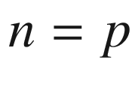

). The gain spectrum is shown in Fig. [23.34](#u116076_4_En_23_Chapter-Fig34)c for a simple two-band model.[18](#u116076_4_En_23_Chapter-Fn18) For a more elaborate discussion of such matters we refer to [1979]. In the case of inversion, the gain is positive for energies between

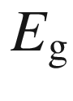

and

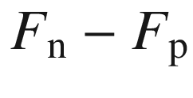

. At

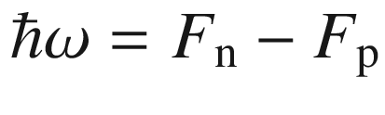

, the gain is zero (transparency) and for larger energies negative (positive absorption coefficient). The agreement of experimental gain spectra of quantum wells with theoretical considerations, including carrier collision effects at the level of quantum kinetic theory in the Markovian limit, is very good (Fig. [23.35](#u116076_4_En_23_Chapter-Fig35)a) [1980].

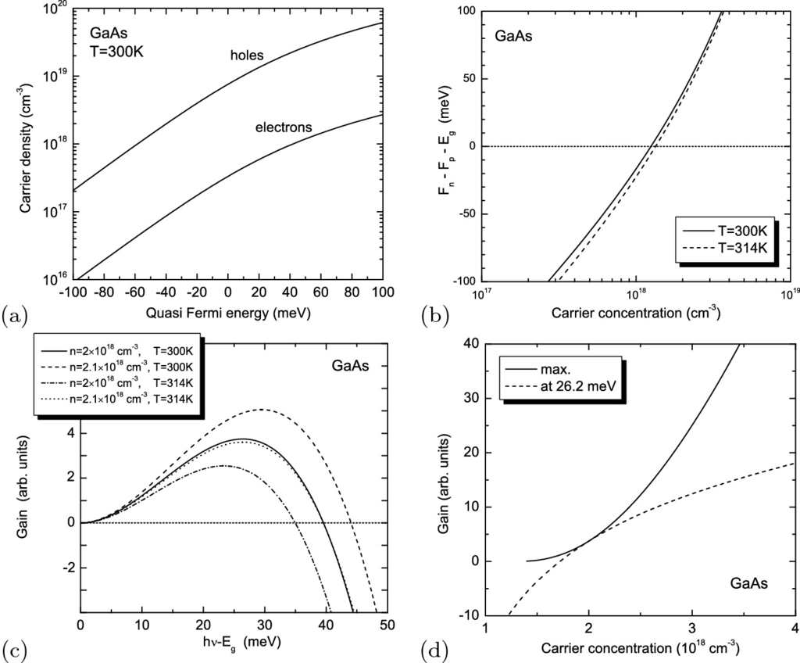

Fig. 23.34

Gain in the two-band model for GaAs. **a** Electron and hole concentrations at

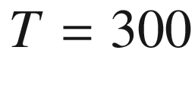

 K as a function of the quasi-Fermi energies counted relative to the band edges, i.e.

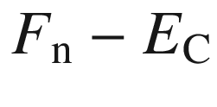

and

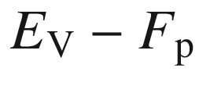

. **b** Difference of quasi-Fermi levels as a function of carrier concentration (

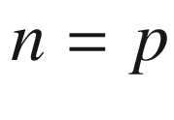

) for GaAs at two different temperatures. **c** Gain spectra according to ([23.12](#u116076_4_En_23_Chapter-Equ15)) for

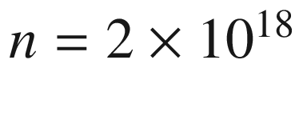

and



 K (*solid line*), increased carrier density

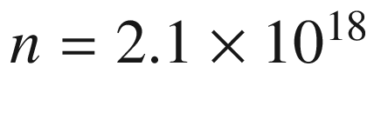

and



 K (*dashed line*), higher temperature

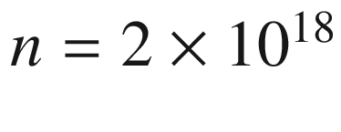

and

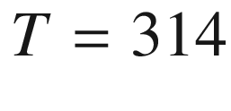

 K (*dash-dotted line*) and same difference of the quasi-Fermi levels as for the *solid line*,

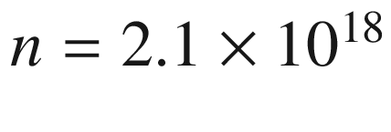

and

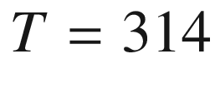

 K (*dotted line*). **d** Maximum gain (*solid line*) and gain at a particular energy (*dashed line*, for photon energy

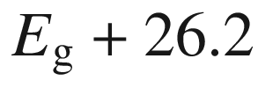

 meV for which the gain is maximal for

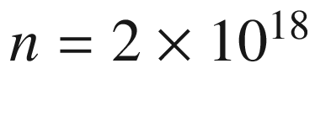

and

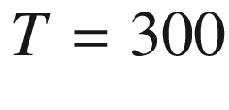

 K, see *solid line* in part **c**)

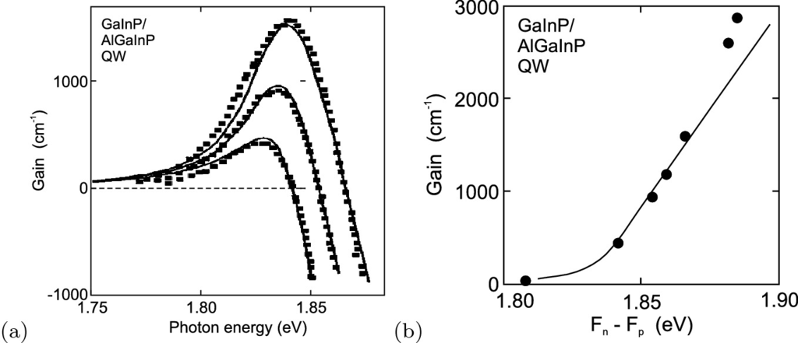

Fig. 23.35

**a** Gain spectra of a 6.8 nm thick Ga

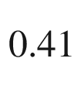

In

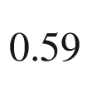

P/(Al

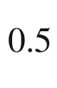

Ga

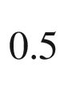

)

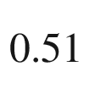

In

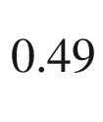

P quantum well, experimental data (*symbols*) and theory (*lines*) for three different sheet carrier densities

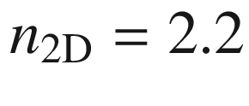

, 2.7, and

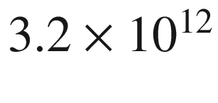

 cm

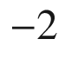

. **b** Maximum gain as a function of the separation of the quasi-Fermi levels, experimental data (*symbols*) and theory (*lines*).

Adapted from [1980]

For a given fixed energy, the gain increases with increasing pumping and increasing carrier density *n* (Fig. [23.34](#u116076_4_En_23_Chapter-Fig34)d). For very small density, it is given as

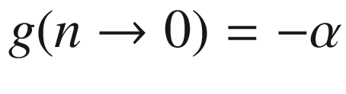

. The gain rises around transparency approximately linearly with the pumping intensity. At transparency carrier density

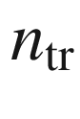

, the gain is zero. Therefore, the relation *g*(*n*) can be approximated as (linear gain model)

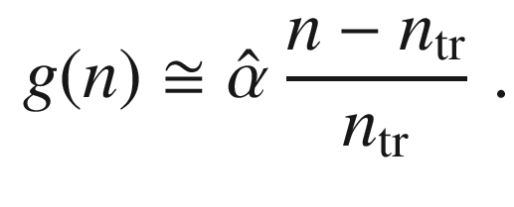

(23.13)

For large carrier density, the gain saturates (at a value similar to

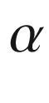

). The onset of positive gain is related to the separation of the quasi-Fermi levels being larger than the band gap ([23.10](#u116076_4_En_23_Chapter-Equ13)), Fig. [23.35](#u116076_4_En_23_Chapter-Fig35)b. The gain in quantum dot lasers [150] has been discussed in [1981].

#### 23.4.4 Optical Mode

The light wave that is amplified must be guided in the laser. An optical cavity is needed to provide optical feedback such that the photons travel several times through the gain medium and contribute to amplification. We explain the light-wave management for the edge emitter first:

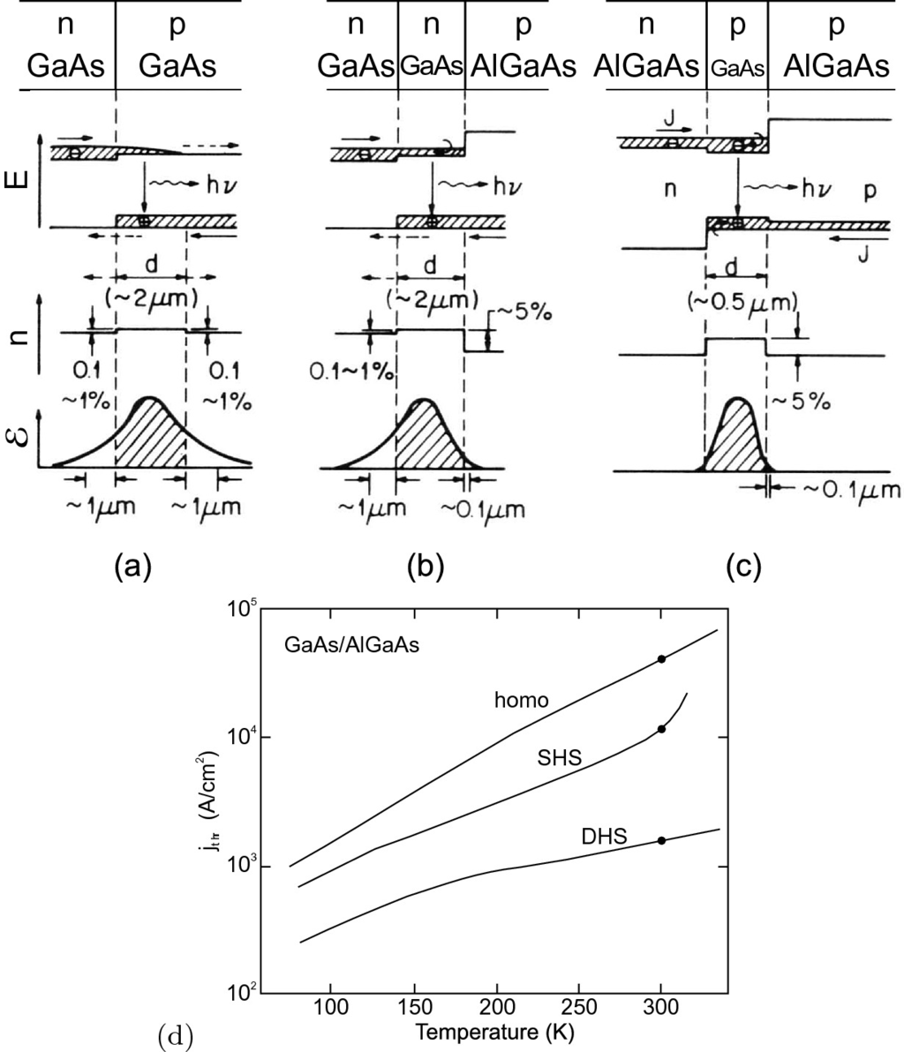

Fig. 23.36

Laser with **a** homojunction, **b** single heterostructure (SHS), **c** double heterostructure (‘DHS’), **d** reduction of threshold current with design progress (‘SHS’:

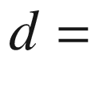

2 µm, ‘DHS’:

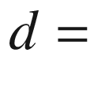

0.5 µm).

Adapted from [1982]

**Vertical Mode Guiding**

In the course of the historical development of the semiconductor laser, the most significant improvements (reduction of lasing threshold current) have been achieved through the improvement of the overlap of the optical wave with the gain medium, as shown in Fig.[23.36](#u116076_4_En_23_Chapter-Fig36). From homojunctions over the single heterojunction, eventually the double heterostructure (DHS) design could reduce the laser threshold current density to the 1 kA/cm

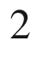

level.

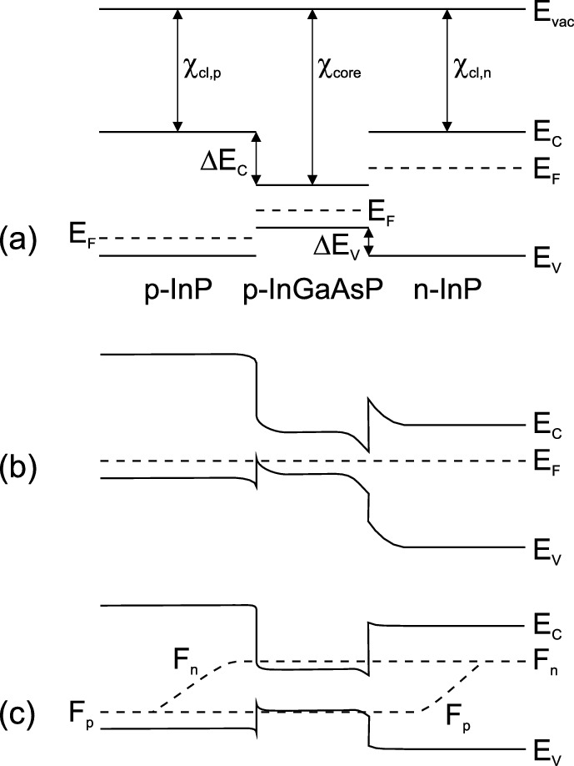

Fig. 23.37

Schematic band diagram of a pn double heterostructure (DHS) diode (InP/InGaAsP/InP) **a** before contact of the materials, **b** in thermodynamic equilibrium (zero bias, *dashed line* is Fermi level

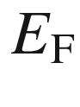

= const.), **c** with forward bias close to flat-band conditions, *dashed lines* are quasi-Fermi levels.

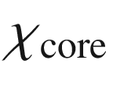

denotes the electron affinity of the core material,

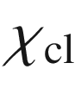

that of the cladding layers

The band diagram of a double heterostructure is shown in Fig. [23.37](#u116076_4_En_23_Chapter-Fig37) for zero and forward bias. In the DHS, the optical mode is guided by total reflection within the low band gap center layer (core), which has a larger index of refraction than the outer, large band gap layer (cladding).[19](#u116076_4_En_23_Chapter-Fn19) When the layer thickness is in the range of

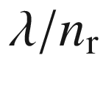

, the form of the optical mode is determined by the (one-dimensional) wave equation ([19.​3](The_Physics_of_Semiconductors00007.docx#u116076_4_En_19_Chapter)) for the electrical field

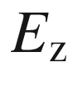

. In Fig. [23.38](#u116076_4_En_23_Chapter-Fig38)a, the shape of the optical mode for GaAs/Al

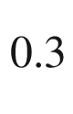

Ga

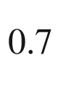

As DHS with different GaAs thickness is shown.

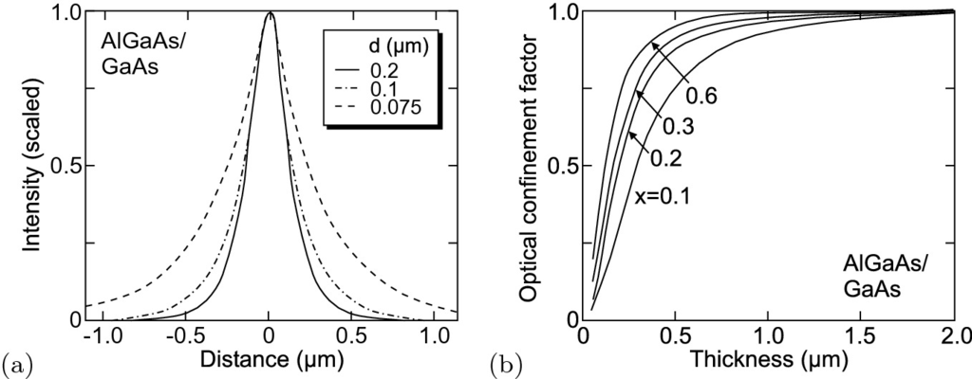

Fig. 23.38

**a** Optical mode (relative intensity) for various values of the thickness *d* of the active layer as labeled of a GaAs/Al

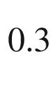

Ga

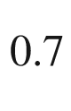

As DHS laser, **b** Optical confinement factor

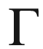

as a function of the thickness of the active layer and the Al concentration *x* of the barrier as labeled in a GaAs/Al



Ga

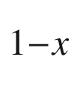

As DHS laser.

Adapted from [1976]

The optical confinement factor

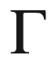

is the part of the wave that has geometrical overlap with the gain medium, i.e. is subject to amplification. It is shown for GaAs/Al



Ga

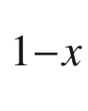

As DHS with different GaAs thickness and different Al concentration in Fig. [23.38](#u116076_4_En_23_Chapter-Fig38)b. The modal gain

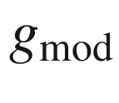

that is responsible for light amplification in the cavity consists of the material gain

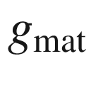

due to inversion and the optical confinement factor.

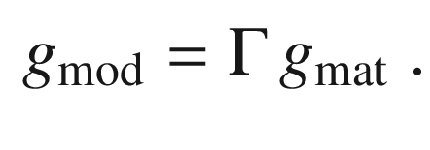

(23.14)

In order to allow simultaneous optimization of the light mode and the carrier confinement, the separate confinement heterostructure (SCH) has been designed. Here, a single or multiple quantum well of a third material with even smaller band gap is the active medium (Fig. [23.39](#u116076_4_En_23_Chapter-Fig39)a,b,d). A single quantum well has an optical confinement factor of a few per cent only. It offers, however, efficient carrier capture and efficient radiative recombination. An increase in the carrier capture efficiency can be achieved using a graded index in the barrier (GRINSCH, Fig. [23.39](#u116076_4_En_23_Chapter-Fig39)c).

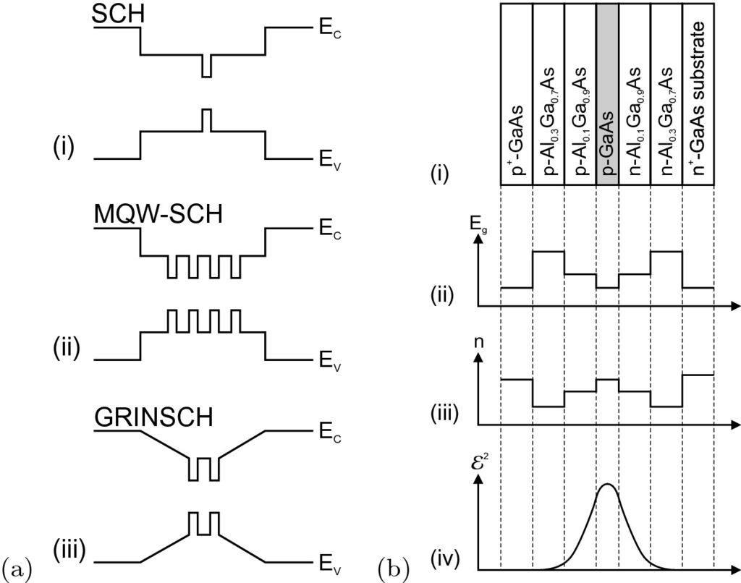

Fig. 23.39

**a** Various geometries of the active layer of a DHS laser with quantum wells as active medium, (**i**) single QW (separate confinement heterostructure, SCH), (**ii**) multiple QW SCH, and **c** GRINSCH (graded-index SCH) structure. **b** Layer sequence for a separate confinement heterostructure laser

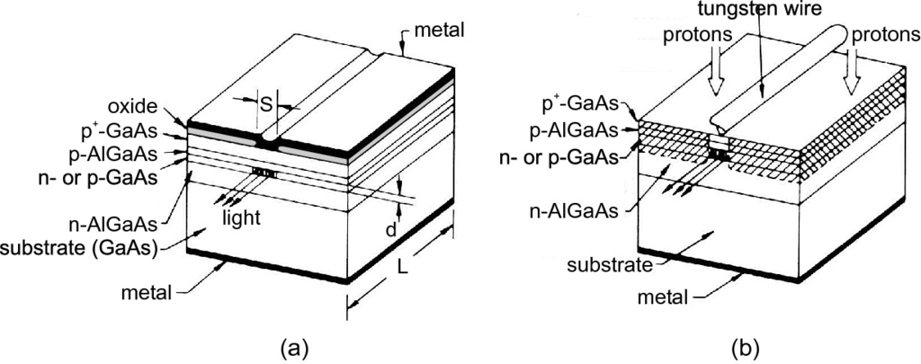

Fig. 23.40

Scheme of gain-guided lasers with stripe contact: **a** oxide stripe, **b** proton implanted with shadow mask from tungsten wire (

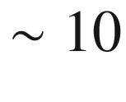

 µm).

Adapted from [1983]

The thin wave-guiding layer leads to large divergence of the laser beam along the vertical direction, typically about 90

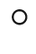

. The strong confinement of light also limits the maximum achievable output power due to catastrophic optical damage (COD). Several ideas have been realized to overcome this problem and achieve much smaller divergence of about 18

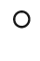

. The waveguide can be designed to be very thick (large optical cavity, LOC) that leads to an increase of threshold. Other schemes are insertion of a low-index layer into the confinement layer, insertion of a high-index layer into the cladding layer or the use of high-index quarter-wavelength reflecting layers [1984].

**Lateral Mode Guiding**

Lateral waveguiding can be achieved with gain guiding and index guiding (or a mixture of the two). In the gain-guiding scheme (Fig. [23.40](#u116076_4_En_23_Chapter-Fig40)), the current path that is defined by the stripe contact and the current spreading underneath it, defines the gain region and therefore the volume of amplification that guides the optical wave. Since a high carrier density reduces the index of refraction, a competing antiguiding effect can occur. For index guiding, the lateral light confinement is caused by a lateral increase of the index of refraction. This index modulation can be achieved by using a mesa-like contact stripe (Fig. [23.41](#u116076_4_En_23_Chapter-Fig41)a). A shallow mesa reaches down into the upper cladding, a deep mesa reaches down into or through the active layer. Possible problems with surface recombination can be avoided by regrowth of the structure (Fig. [23.41](#u116076_4_En_23_Chapter-Fig41)b) with a wide band gap material (compared to the active layer). Optimization of regrowth is targeted to achieve a well-defined surface for subsequent contact processing. A lateral pn-diode can be incorporated that avoids current spreading in the upper part of the structure.

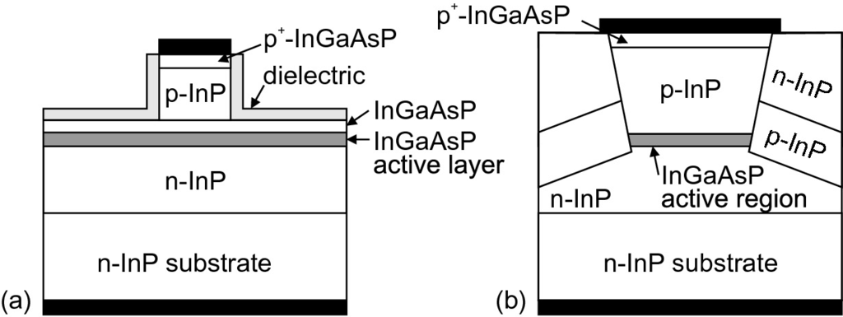

Fig. 23.41

Schematic cross section of index-guided lasers: **a** shallow ridge, **b** deep etch and regrowth. *Black areas* are metal contacts

Depending on the width of the lateral mode, it can be monomode or multimode (Fig. [23.42](#u116076_4_En_23_Chapter-Fig42)a,b). For laterally monomode lasers, the stripe width may only be a few µm. In particular for such lasers, the current spreading must be controlled. Problems can arise for wide stripe widths due to current filamentation and inhomogeneous laser emission from the facet. Since the optical mode is typically more confined in the growth direction than in the lateral direction, the far field is asymmetric (Fig. [23.43](#u116076_4_En_23_Chapter-Fig43)a,b). The vertical axis has the higher divergence and is called the fast axis. The lateral axis is called the slow axis. The asymmetric beam shape is detrimental when the laser needs to be coupled into an optical fiber or a symmetric beam profile is needed for subsequent optics. The beam can be made symmetric using special optic components such as anamorphic prisms (Fig. [23.43](#u116076_4_En_23_Chapter-Fig43)c) and graded-index lenses. The beam from a laterally monomode laser is diffraction limited and can therefore generally be refocused efficiently (beam quality

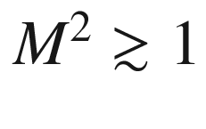

).

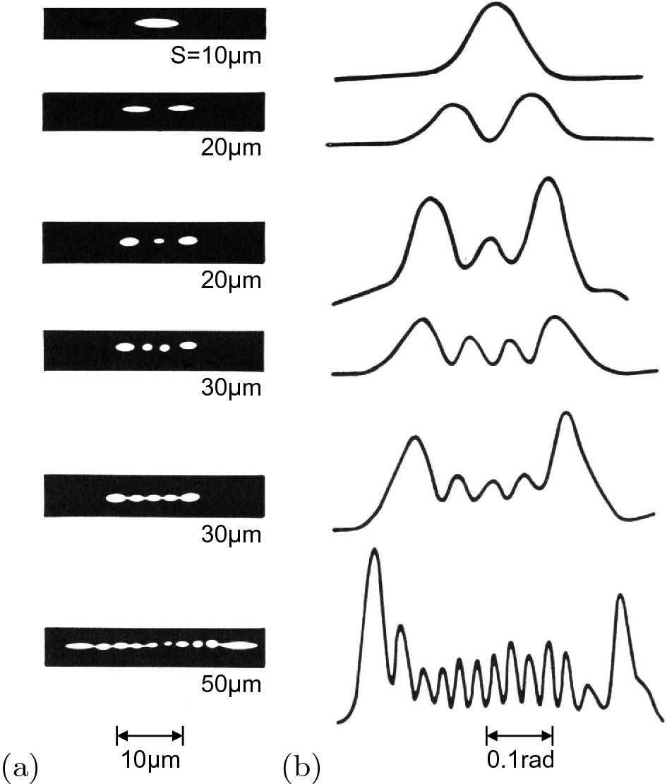

Fig. 23.42

Lateral near field **a** and far field **b** of lasers with various width *S* of the injection stripe as labeled.

Adapted from [1985]

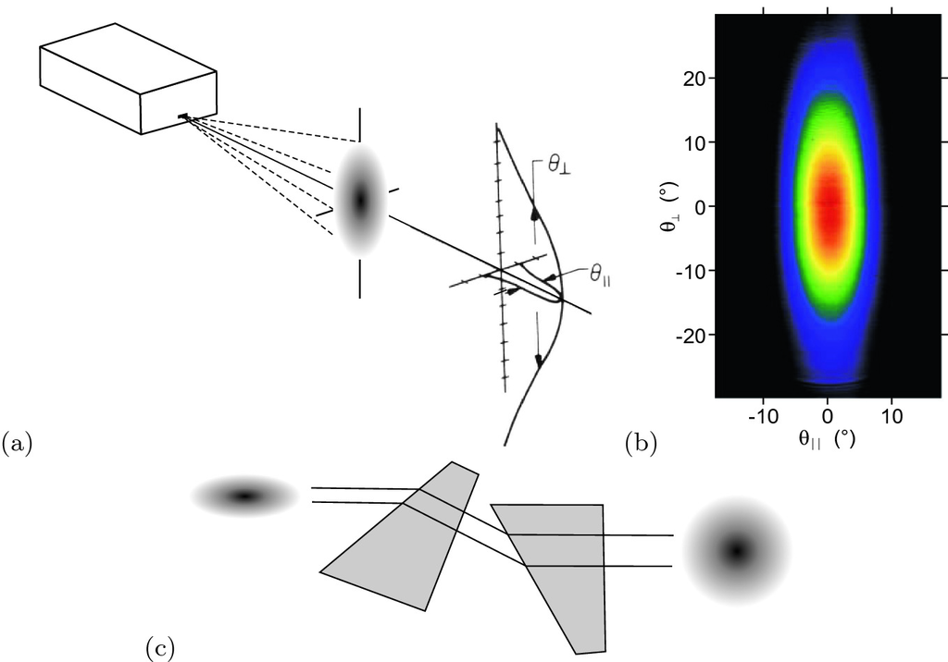

Fig. 23.43

**a** Schematics of the asymmetric far field of an edge emitter. Adapted from [574]. **b** Far-field distribution of violet GaN-based laser. Adapted from [1986]. **c** Correction of asymmetric far field with a pair of anamorphic prisms

**Longitudinal Modes**

The spectral positions of the laser modes for a cavity with length *L* is given by the condition (cf. ([19.​39](The_Physics_of_Semiconductors00007.docx#u116076_4_En_19_Chapter)))

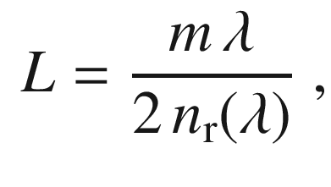

(23.15)

where *m* is a natural number and

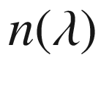

is the dispersion of the index of refraction. The distance of neighboring modes is given by (for large *m*)

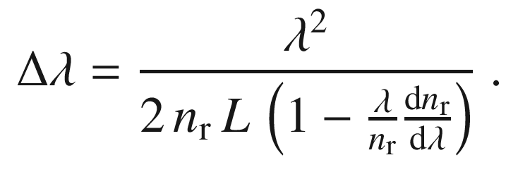

(23.16)

The dispersion

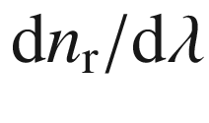

can sometimes be neglected.

The facets of edge-emitting lasers are typically cleaved. Cleaving bears the danger of mechanical breakage and tends to have poor reproducibility, low yield and therefore high cost. Etched facets are another possibility to form the cavity mirror. The etch process, typically reactive ion dry etching, must yield sufficiently smooth surfaces to avoid scattering losses. A highly efficient distributed Bragg mirror (cf. Sect. [19.​1.​4](The_Physics_of_Semiconductors00007.docx#u116076_4_En_19_Chapter)) with only a few periods can be created by using the large index contrast between the semiconductor and air. As shown in Fig. [23.44](#u116076_4_En_23_Chapter-Fig44), slabs can be etched that make a Bragg mirror with the air gaps [1987]. In this way, very short longitudinal cavities can be made (

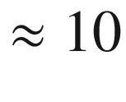

 µm).

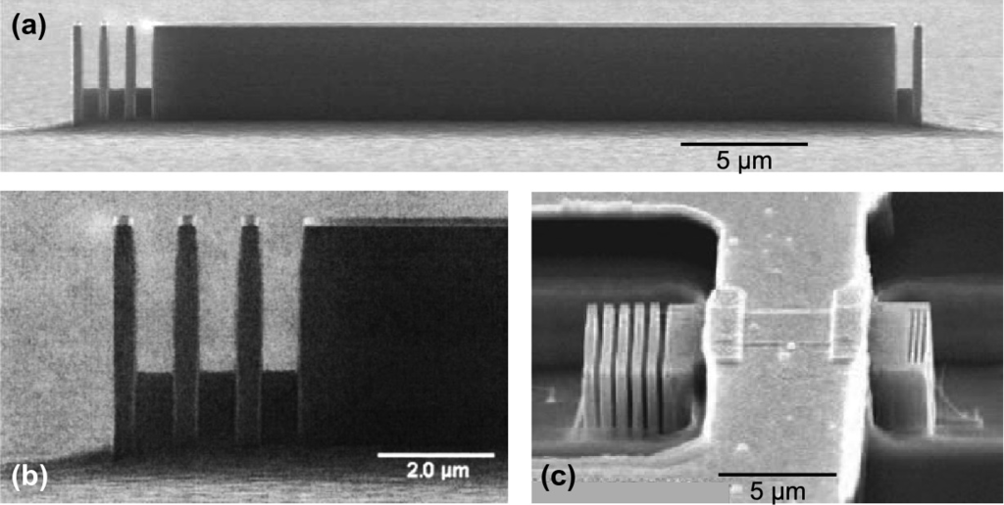

Fig. 23.44

SEM image of **a** an InP microlaser with third-order Bragg mirrors, **b** magnified view of the front facet with three slabs, **c** a 12-µm long microlaser with five third-order mirrors on the rear side and three first-order mirrors on the front side with top contact.

From [1988]; part **b** reprinted with permission from [1987], ©2001 AIP

#### 23.4.5 Loss Mechanisms

While the light travels through the cavity, it is not only amplified but it also suffers losses. The internal loss

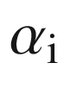

and the mirror loss

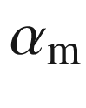

contribute to the total loss

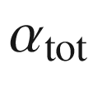

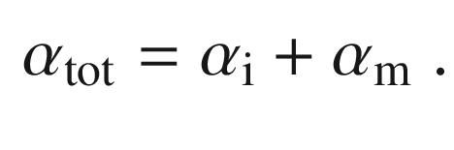

(23.17)

The internal loss is due to absorption in the cladding, scattering at waveguide inhomogeneities and possibly other processes. It can be written as

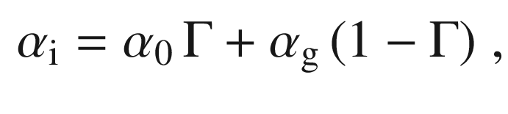

(23.18)

where

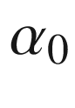

is the loss coefficient in the active medium and

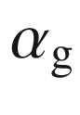

is the loss coefficient outside the active medium.

The mirror loss is due to the incomplete reflection of the optical wave at the laser facets. This condition is necessary, however, to observe a laser beam outside the cavity.

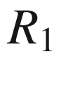

and

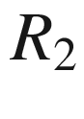

are the values of reflectance of the two facets, respectively. An as-cleaved facet has a reflectance of about 30% (cf. ([23.8](The_Physics_of_Semiconductors00008.docx#u116076_4_En_23_Chapter-Equ11))). Using dielectric layers on the facets, the reflectance can be increased (high reflection, HR-coating) or decreased (antireflection, AR-coating). One round-trip through the cavity of length *L* has the length 2*L*. The intensity loss due to reflection at the facets is expressed via

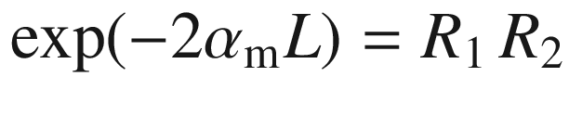

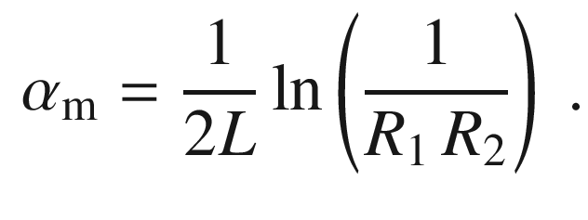

(23.19)

If both mirrors have the same reflectance *R*, we have

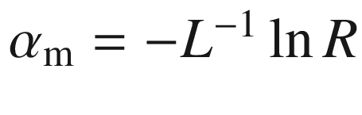

. For

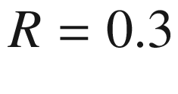

a 1-mm cavity has a loss of 12 cm

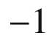

. For the internal loss a typical value is 10 cm

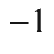

, very good waveguides go down to 1–2 cm

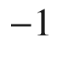

.

Lasing is only possible if the gain overcomes all losses (at least for one wavelength), i.e.

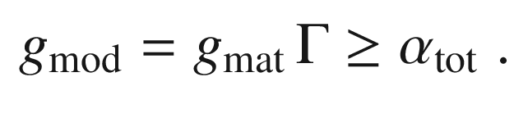

(23.20)

#### 23.4.6 Threshold

When the laser reaches threshold, the (material) gain is pinned at the threshold value

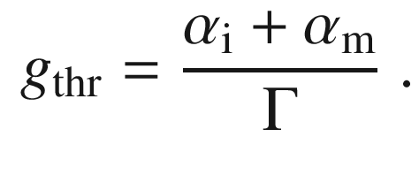

(23.21)

Since

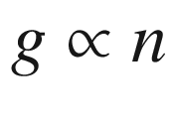

, the carrier density is also pinned at its threshold value and does not increase further with increasing injection current. Instead, additional carriers are quickly converted into photons by stimulated emission. The threshold carrier density  is (using the linear gain model, cf. ([23.13](#u116076_4_En_23_Chapter-Equ16)))

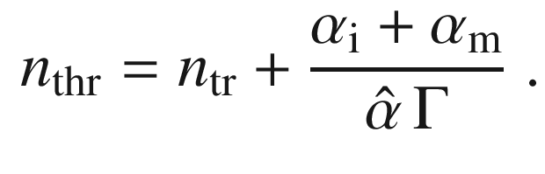

(23.22)

For an active layer of thickness *d*, the threshold current density is

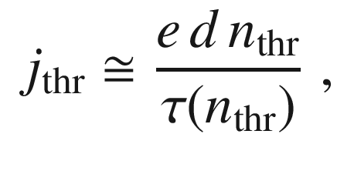

(23.23)

where

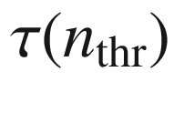

is the (minority) carrier lifetime at the threshold carrier density (cmp. Sect. [10.​10](The_Physics_of_Semiconductors00005.docx#u116076_4_En_10_Chapter)) from

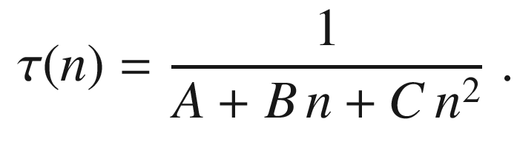

(23.24)

Using ([23.22](#u116076_4_En_23_Chapter-Equ25)), we can write (for

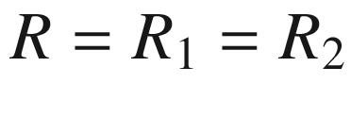

)

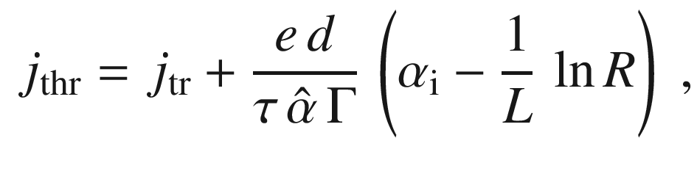

(23.25)

where the transparency current  density is

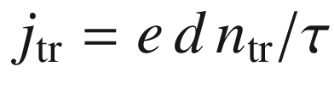

. Thus, the plot of

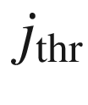

versus 1/*L* (or the optical loss) should be linear and can be extrapolated towards the transparency current density (cf. Fig. [23.45](#u116076_4_En_23_Chapter-Fig45)a).

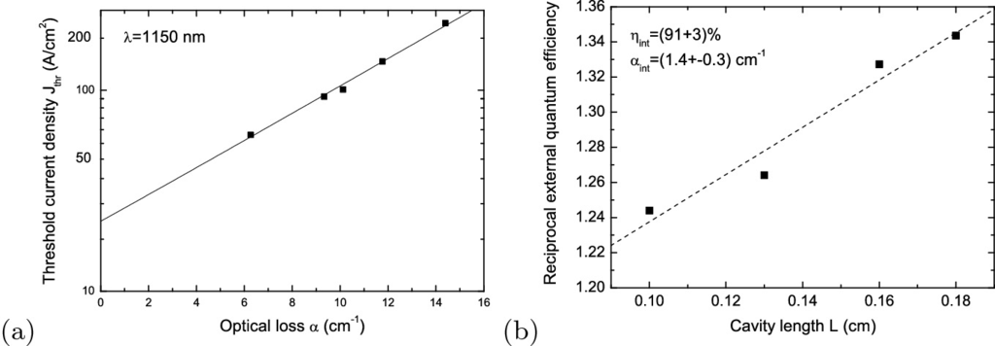

Fig. 23.45

**a** Threshold current density for (three-fold InGaAs/GaAs QD stack) laser (

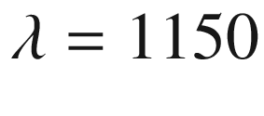

 nm) at 10



C with different cavity length vs. the optical loss (

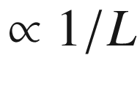

). The extrapolated transparency current density is

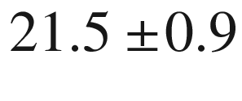

 A/cm

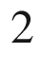

. **b** Inverse external quantum efficiency versus cavity length. The internal quantum efficiency determined from the plot is 91% and the internal loss is 1.4 cm

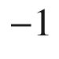

Any additional increase of the current *j* leads to stimulated emission with the rate

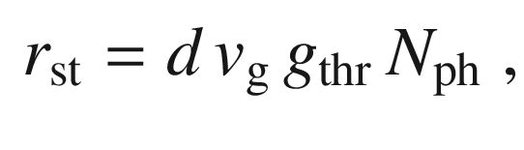

(23.26)

where

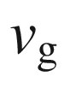

is the group velocity (mostly

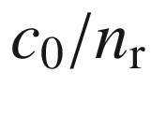

) and

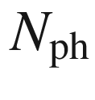

is the photon density (per length) in the cavity. The photon density increases linearly beyond the threshold

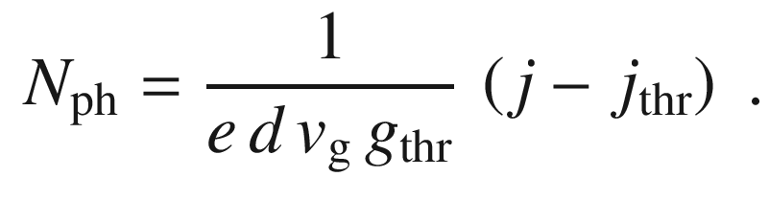

(23.27)

The photon lifetime

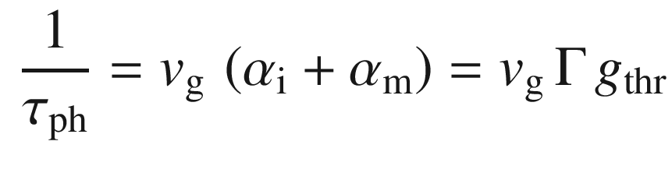

(23.28)

is introduced that describes the loss rate of photons.

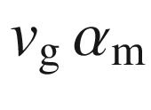

describes the escape rate of photons from the cavity into the laser beam(s). Therefore,

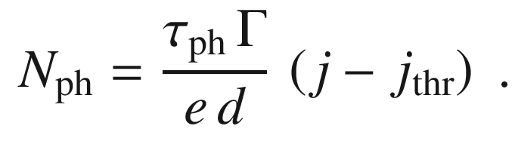

(23.29)

Since the threshold depends on the carrier density, it is advantageous to reduce the active volume further and further. In this way, the same *amount* of injected carriers creates a larger carrier *density*. Figure [23.46](#u116076_4_En_23_Chapter-Fig46) shows the historic development of laser threshold due to design improvements.

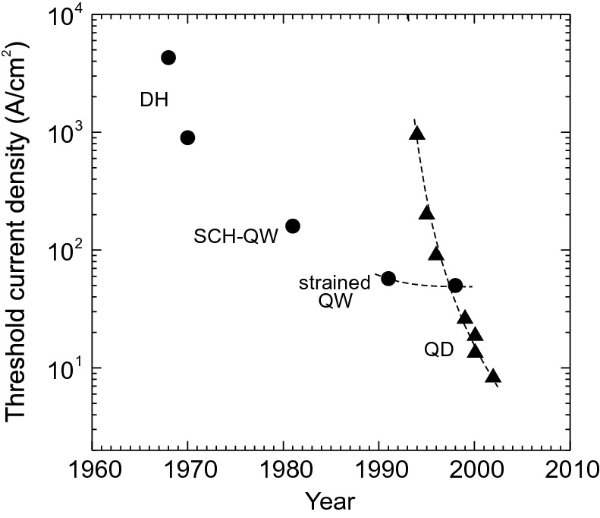

Fig. 23.46

Historic development of threshold current density (at room temperature, extrapolated for infinite cavity length and injection stripe width) for various laser designs, ‘DH’: double heterostructure, ‘SCH–QW’: separate confinement heterostructure with quantum wells. ‘QD’: quantum dots. *Dashed lines* are guides to the eye

#### 23.4.7 Spontaneous Emission Factor

The spontaneous emission factor

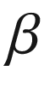

is the fraction of spontaneous emission (emitted into all angles) that is emitted into laser modes. For Fabry–Perot lasers,

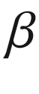

is typically in the order of

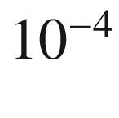

–

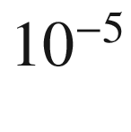

. The design of a microcavity can increase

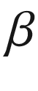

drastically by several orders of magnitude to

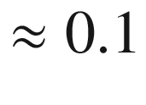

[1989] or above and thus reduce the threshold current. The photon number as a function of the pump current can be calculated from the laser rate equations and is depicted in Fig. [23.47](#u116076_4_En_23_Chapter-Fig47). For

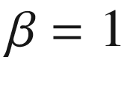

, all emitted power goes into the laser mode regardless of whether emission is spontaneous or stimulated. The definition of threshold in such ‘nonclassical’ lasers with large

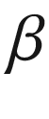

is discussed in detail in [1990].

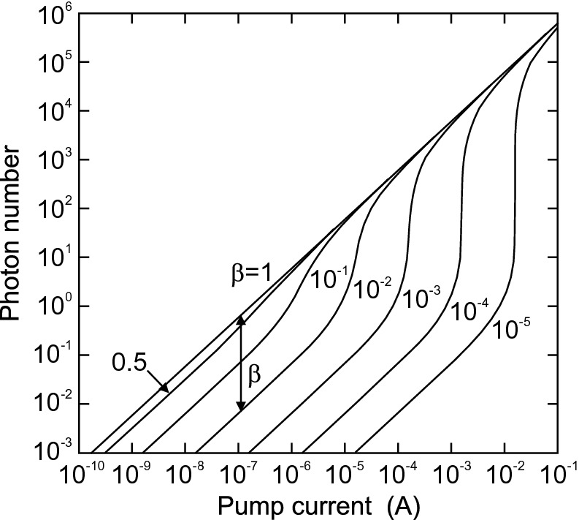

Fig. 23.47

Photon number versus pump current for a model laser.

Adapted from [1991]

#### 23.4.8 Output Power

The output power is given by the product of photon energy, the photon density in the cavity, the effective mode volume and the escape rate:

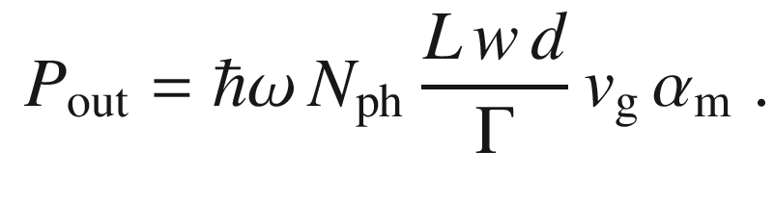

(23.30)

Thus, it is given by

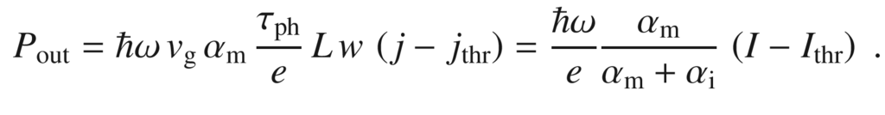

(23.31)

To this equation, the factor

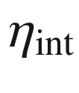

must be added. The internal quantum efficiency describes the efficiency of the conversion of electron–hole pairs into photons (cmp. ([10.​59](The_Physics_of_Semiconductors00005.docx#u116076_4_En_10_Chapter))):

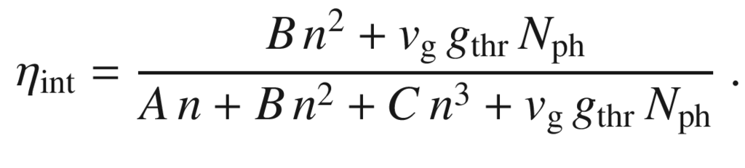

(23.32)

All in all, now (see Fig. [23.49](#u116076_4_En_23_Chapter-Fig49)a)

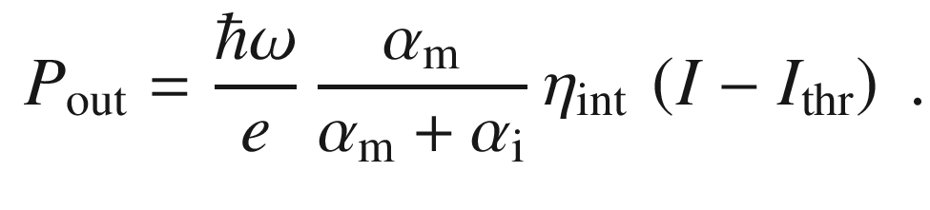

(23.33)

The differential (or slope) quantum efficiency, also called the external quantum efficiency

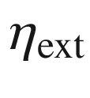

, is the slope of the

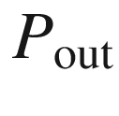

curve versus the current in the lasing regime. It is given by

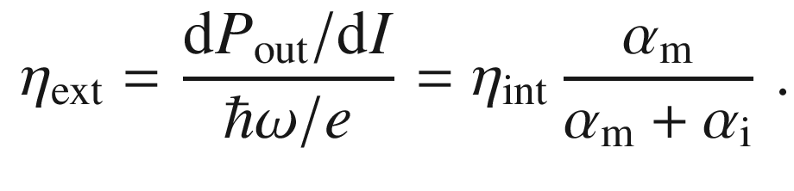

(23.34)

The external quantum efficiency can also be written as

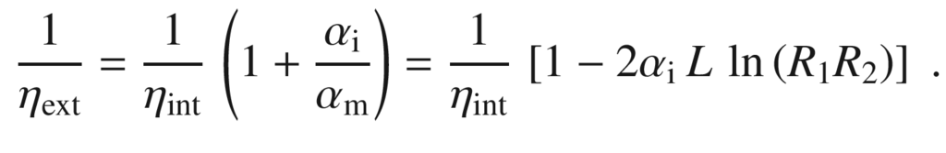

(23.35)

Therefore, if

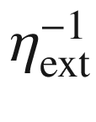

is plotted for similar lasers with different cavity length (see Fig. [23.45](#u116076_4_En_23_Chapter-Fig45)b), a straight line should arise from which the internal quantum efficiency (extrapolation to

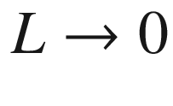

) and the internal loss (

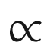

slope) can be determined experimentally.

The threshold current for a given laser is typically determined from the *P*–*I* characteristic via extrapolation of the linear regime as shown in Fig. [23.49](#u116076_4_En_23_Chapter-Fig49)a. Other measures of the threshold current can be the change in junction resistance, the narrow peak in excess noise or the peak in the logarithmic derivative of mode power. The S-shaped curve of the power in the dominant mode (of a single-mode laser) as a function of voltage (Fig.[23.48](#u116076_4_En_23_Chapter-Fig48)), similar to the S-shaped curves of Fig.[23.47](#u116076_4_En_23_Chapter-Fig47) has been discussed in [1992]. A related discussion of laser dynamics (cmp. Sect. [23.4.13](#u116076_4_En_23_Chapter-Sec30)) can be found in [1993].

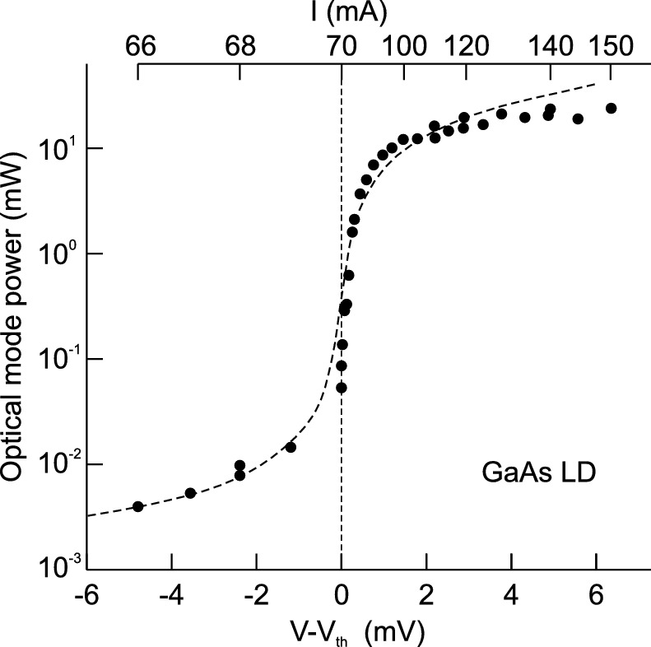

Fig. 23.48

Optical power (experimental data and modelling) in the dominant mode of a single-mode GaAs laser diode (Hitachi HLP 1400) as a function of voltage (in pulsed operation in order to avoid heating effects) around the threshold voltage

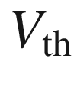

.

Adapted from [1992]

Record values for the threshold current density are often given for the limit

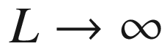

. Due to current spreading, the threshold current density also depends on the width of the injection stripe. Record low thresholds are therefore often given for the limit

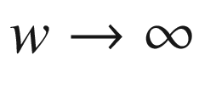

.

The total quantum efficiency is given by

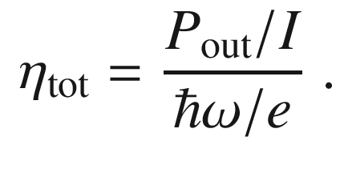

(23.36)

This quantity is shown in Fig. [23.49](#u116076_4_En_23_Chapter-Fig49)b for a laser as a function of the current. For a linear *P*–*I* lasing characteristic, the total quantum efficiency converges towards the external quantum efficiency for high currents because the low quantum efficiency subthreshold regime no longer plays any role. Another important figure of merit is the wall-plug efficiency

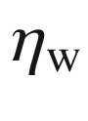

that describes the power conversion:

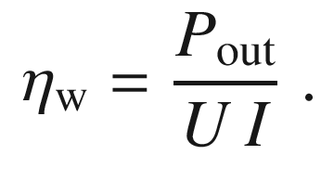

(23.37)

Additionally to the current balance discussed so far, typically a leakage current exists that flows without contributing to recombination or lasing. Carriers not captured into or escaping from the active layers can contribute to this current. The present record for wall-plug efficiency of high-power laser diodes is above 70% [1994, 1995], employing careful control of band alignment (graded junctions, avoiding voltage barriers), optical losses, Joule heating, spontaneous emission and carrier leakage. It seems possible to achieve

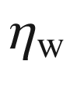

of 80%.

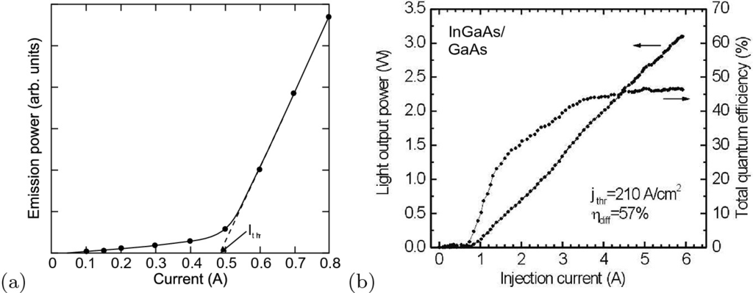

Fig. 23.49

**a** Typical *P*–*I* characteristic of a semiconductor laser. Adapted from [574]. **b** Output power and total quantum efficiency of a quantum dot laser (3 stacks of InGaAs/GaAs QDs,

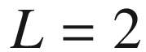

 mm,

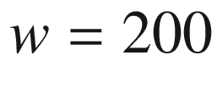

 µm,

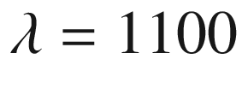

 nm,

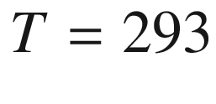

 K) versus injection current

The *P*–*I* characteristic is not linear to arbitrary high currents. Generally, the output power will saturate or even decrease for increasing current. These effects can be due to increasing leakage current, increasing internal loss at high current or temperature effects, e.g. an increase of threshold with increasing temperature (cf. Sect. [23.4.9](#u116076_4_En_23_Chapter-Sec26)) and therefore a reduction of total efficiency. All nonradiative losses will eventually show up as heat in the laser that must be managed with a heat sink.

A radical effect is catastrophic optical damage (COD) at which the laser facet is irreversible (partially) destructed. Antioxidation or protective layers can increase the damage threshold to

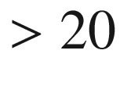

 MW/cm

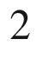

. The record power from a single edge emitter is

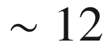

 W (200 µm stripe width). For a lateral monomode laser, cw power of about 1.2 W has been reached from a 1480-nm InGaAsP/InP double quantum-well lasers with 3–5 µm stripes and 3 mm cavity length [1996]. About 500 mW can be coupled into a single-mode fiber [1997].

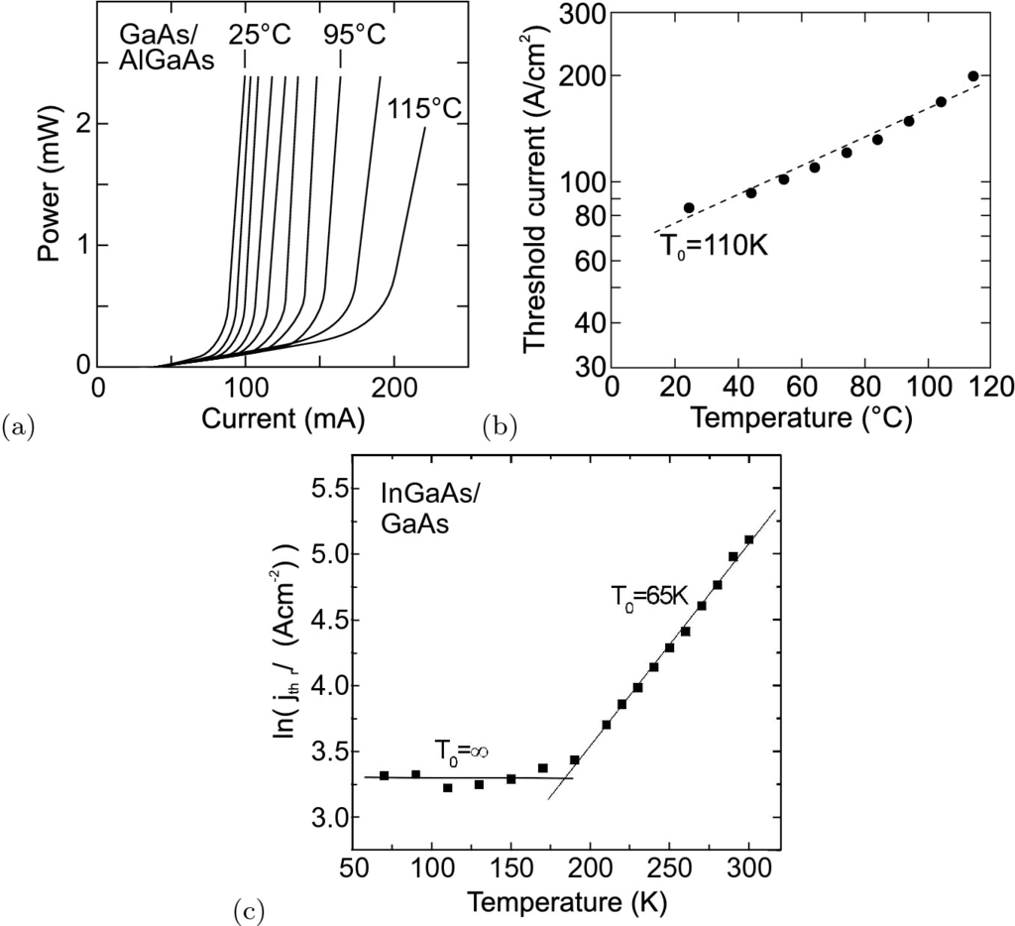

Fig. 23.50

**a** *P*–*I* characteristic (cw output power per mirror facet) of stripe-buried heterostructure laser at various temperatures of the heat sink between 25

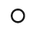

C and 115

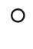

C in steps of 10 K. **b** Threshold current (in logarithmic scale) of this laser as a function of heat-sink temperature and exponential fit (*dashed line*) with

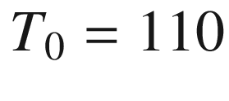

 K. Parts **a** and **b** adapted from [1998]. **c** Temperature dependence of the threshold current density of a quantum dot laser (3 stacks of InGaAs/GaAs QDs,

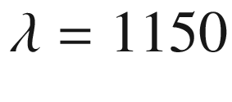

 nm) with

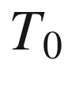

(*solid lines* are fits) given in the figure

#### 23.4.9 Temperature Dependence

The threshold of a laser typically increases with increasing temperature as shown in Fig. [23.50](#u116076_4_En_23_Chapter-Fig50)a. Empirically, in the vicinity of a temperature

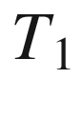

the threshold follows an exponential law (see Fig. [23.50](#u116076_4_En_23_Chapter-Fig50)b)

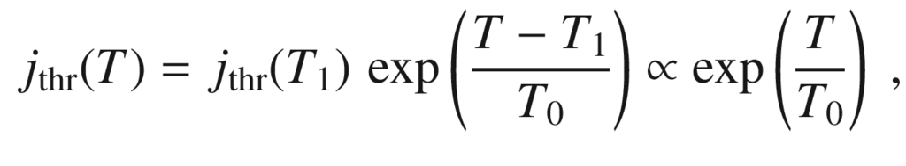

(23.38)

with

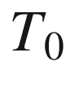

being the so-called characteristic temperature.[20](#u116076_4_En_23_Chapter-Fn20) It is the inverse logarithmic slope,

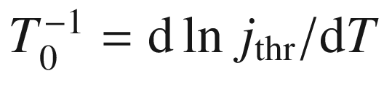

.

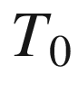

summarizes the temperature-dependent loss and the carrier redistribution in



-space due to the change of the Fermi distribution with temperature. With increasing temperature, populated states below the quasi-Fermi level become unpopulated and nonlasing states become populated. Therefore, the gain decreases with increasing temperature. This redistribution must be compensated by an increase of the quasi-Fermi energy, i.e. stronger pumping. This effect is present for (even ideal) bulk, quantum well and quantum wire lasers. Only for quantum dots with a

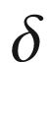

-like density of states is the change of Fermi distribution irrelevant as long as excited states are energetically well separated from the (lasing) ground state. In Fig. [23.50](#u116076_4_En_23_Chapter-Fig50)c, the threshold of a quantum dot laser is indeed temperature independent (

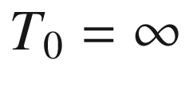

) as long as excited states are not thermally populated (for

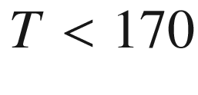

 K for the present laser).

#### 23.4.10 Mode Spectrum

In Fig. [23.51](#u116076_4_En_23_Chapter-Fig51)a, the mode spectrum of a typical edge-emitting laser is shown. Below threshold, the amplified spontaneous emission (ASE) spectrum exhibits a comb-like structure due to the Fabry–Perot modes. Above threshold, some modes grow much faster than others, possibly resulting in single longitudinal mode operation at high injection. The relative strength of the strongest side mode is expressed through the side-mode suppression ratio (SSR) in dB

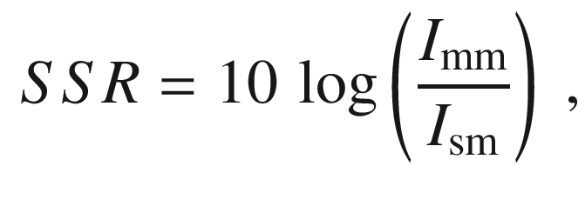

(23.39)

where

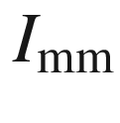

(

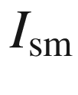

) is the intensity of the maximum (strongest side) mode in the lasing spectrum.

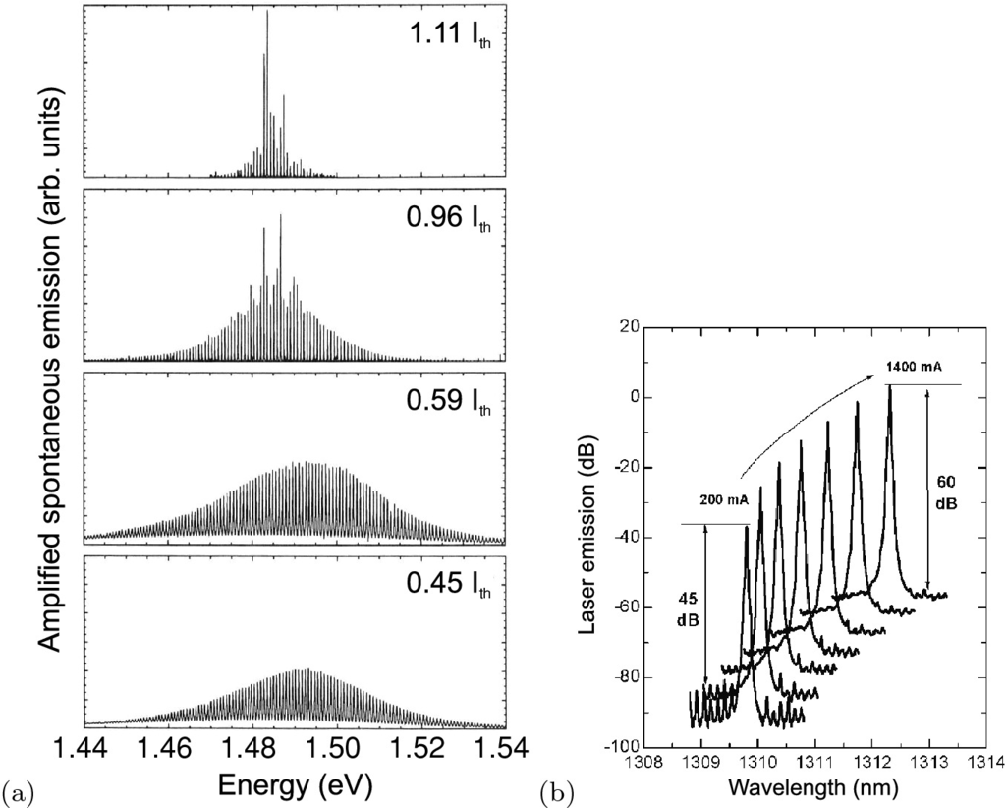

Fig. 23.51

**a** Mode spectra of a Fabry–Perot laser, under, at and above threshold (

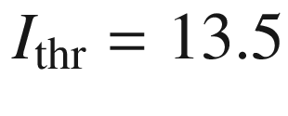

 mA). Adapted from [1185]. **b** Mode spectra of a cw DFB InGaAs/InP laser with 2 mm cavity length at various currents of 200, 400,

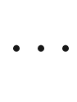

, 1400 mA (

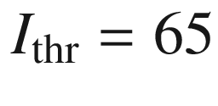

 mA), SSR>40 dB at

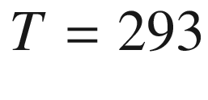

 K. Adapted from [1999], reproduced with permission from SPIE

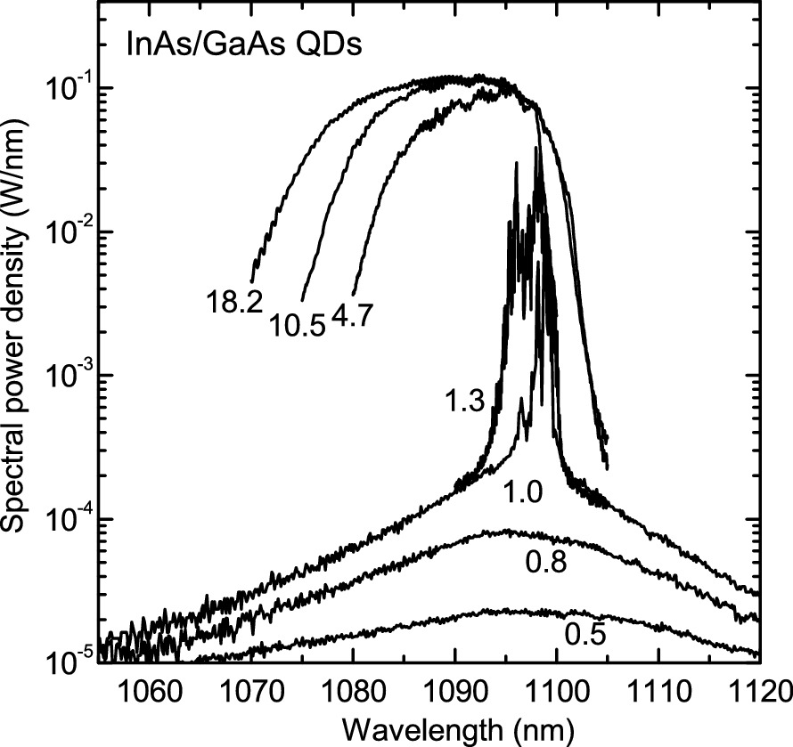

Fig. 23.52

Lasing spectra of quantum dot laser (

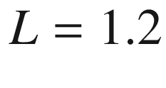

 mm, stripe width

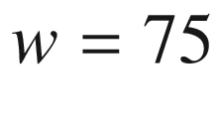

 µm) at room temperature. The active medium is a three-fold stack of InGaAs/GaAs QDs. The current density as labeled is given in units of the threshold current density (

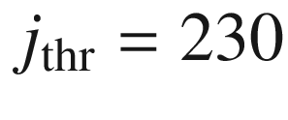

 A/cm

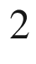

).

Adapted from [2000]

As a tendency a DHS or QW semiconductor laser above threshold develops a narrow spectrum since the pump power is channeled into one or few modes with large gain. A quantum dot laser behaves differently when pumped largely above threshold. Since the gain of individual QDs in an inhomogeneously broadened ensemble (due to different QD sizes) is independent, a broad gain spectrum is present [2001]. The lasing spectrum takes a hat-like shape when homogeneous broadening is small compared to the inhomogeneous broadening[2000, 2002] (Fig. [23.52](#u116076_4_En_23_Chapter-Fig52)) as predicted theoretically [2001, 2003].

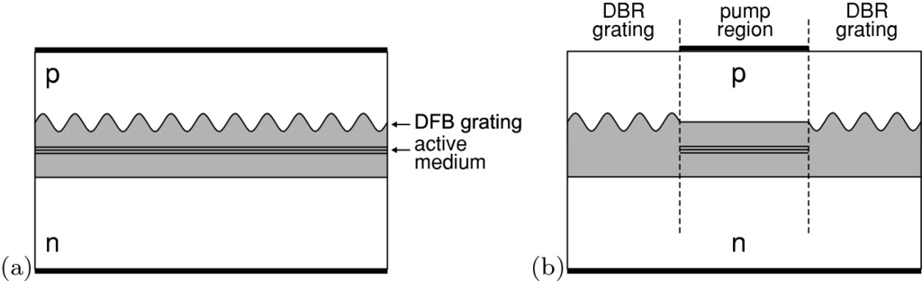

Fig. 23.53

Schematic drawing of **a** DFB (distributed feedback) and **b** DBR (distributed Bragg reflection) lasers. The active medium is schematically shown as a triple quantum well, the waveguide is shown as a *grey area*

#### 23.4.11 Longitudinal Single-Mode Lasers

In order to achieve a high SSR or single longitudinal mode lasing, the feedback must offer a higher wavelength selectivity than a simple mirror. A preferential feedback for certain modes can be obtained using a periodic dielectric structure that ‘fits’ to a particular wavelength, similar to a Bragg mirror. The periodic modulation of the refractive index can be made within the cavity (distributed feedback, DFB, Fig. [23.53](#u116076_4_En_23_Chapter-Fig53)a) or at the mirror (distributed reflection, DBR, Fig. [23.53](#u116076_4_En_23_Chapter-Fig53)b). In this way, monochromatic lasers with SSR

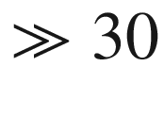

 dB are possible (Fig. [23.51](#u116076_4_En_23_Chapter-Fig51)b).

It is possible to couple several hundred mW optical power of a laterally and spectrally monomode laser into a monomode optical fiber [2004] (Fig. [23.54](#u116076_4_En_23_Chapter-Fig54)).

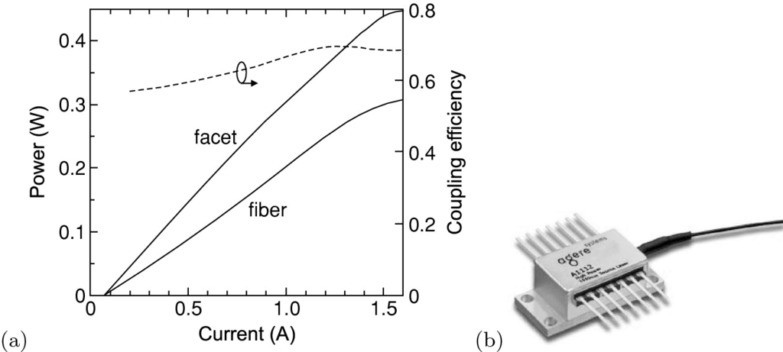

Fig. 23.54

**a** Output power of an InGaAsP/InP cw single-mode DFB laser at 1427 nm with 2 mm cavity length from the facet and coupled to a single-mode fiber versus driving current (

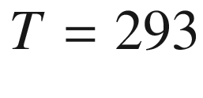

 K). The *dashed* line represents the coupling efficiency to the fiber (right scale). Adapted from [2004]. **b** Package with pigtail of fiber coupled 1550 nm DFB laser with 40 mW output power in the fiber. From [2005]

#### 23.4.12 Tunability

The tunability of the emission wavelength [2006] is important for several applications such as wavelength division multiplexing[21](#u116076_4_En_23_Chapter-Fn21) and spectroscopy.

The simplest possibility to tune a laser is to vary its temperature and thus its band gap. This method is particularly used for lead salt lasers in the mid-infrared region,[22](#u116076_4_En_23_Chapter-Fn22) as shown in Fig. [23.55](#u116076_4_En_23_Chapter-Fig55).

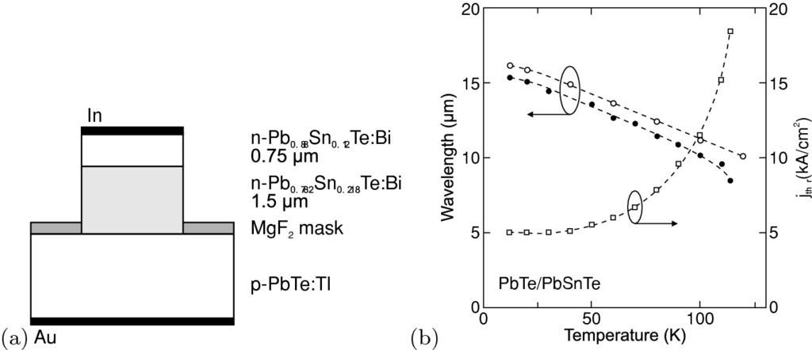

Fig. 23.55

**a** Schematic drawing of PbTe lead salt laser. **b** Tuning characteristics of such laser: Emission wavelength (*left scale*, *filled circles*: emission wavelength at cw threshold, *empty circles*: emission maximum under pulsed operation) and cw threshold current density (*right scale*) as a function of the heat-sink temperature. *Symbols* are experimental data, *dashed lines* are guides to the eye.

Adapted from [2007]

For monomode lasers, mode hopping, i.e. the discontinuous shift of lasing wavelength (or gain maximum) from one mode to the next, poses a problem for continuous tuning, as shown in Fig. [23.56](#u116076_4_En_23_Chapter-Fig56). The continuous shift of emission wavelength is due to the temperature dependence of the index of refraction and subsequently the longitudinal modes. The index of refraction increases with increasing temperature at typically

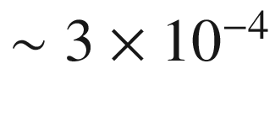

 K

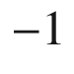

. Generally, a red-shift is the consequence.

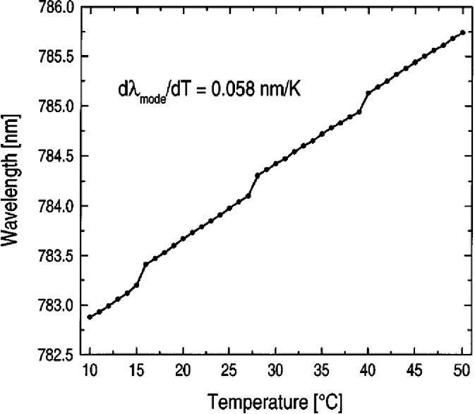

Fig. 23.56

Wavelength as a function of temperature (with mode hopping) for a GaAs-based DFB laser

Another possibility to vary the index of refraction (and thus the optical path length) is a variation of the carrier density. The coefficient

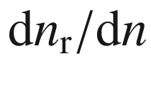

is about

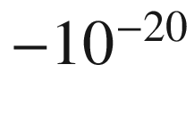

 cm

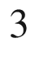

. In a two-section laser, separate regions (with separately controlled currents) for gain and tuning are present. The regions are separated with deep-etched trenches to avoid crosstalk. The tuning range is limited to about 10 nm. For a mode-hopping free tuning, the control of the phase in the cavity is important and requires an additional section for the phase control. Such a three-section laser has separate regions (and current control) for the reflection, phase and amplification (or gain) region.

Using sampled gratings, the tuning range can be strongly increased to about 100 nm. A sampled grating is a nonperiodic lattice that has several (

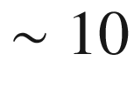

) reflection peaks. The laser structure has four sections (Fig. [23.57](#u116076_4_En_23_Chapter-Fig57)) with two mirrors that have slightly different sampled gratings. Via the carrier densities in the two mirror sections, different maxima can be brought to overlap (Vernier effect) and the position of the selected maximum can be tuned over a wide spectral range (Fig. [23.58](#u116076_4_En_23_Chapter-Fig58)).

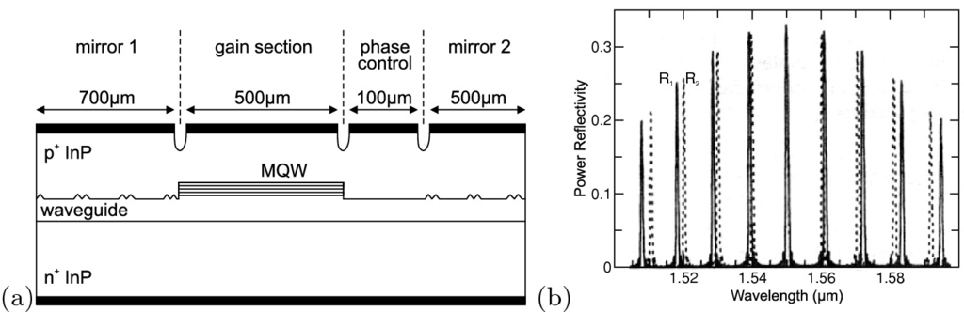

Fig. 23.57

**a** Schematic representation of SGDBR (sampled-grating DBR) laser with four sections. Adapted from [2008]. **b** Reflectance of two sampled gratings DBR mirrors

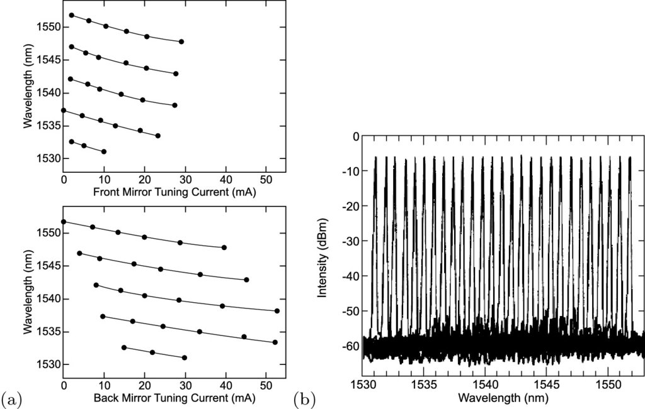

Fig. 23.58

**a** Tuning curves of two sampled gratings DBR mirrors for the front and back mirror current. **b** 27 wavelength channels (1531.12 to 1551.72 nm) with a channel separation of 1 nm.

Adapted from [2009]

#### 23.4.13 Dynamics and Modulation

For transmission of information in the time domain, the laser intensity must be modulated. This can be accomplished by *direct* modulation, i.e. modulation of the injection current, or *external* modulators, for example using the voltage-induced shift of the absorption spectrum due to QCSE (cf. Sect. [15.​1.​2](The_Physics_of_Semiconductors00006.docx#u116076_4_En_15_Chapter)). For direct modulation, small- and large-signal modulation are distinguished. Detailed treatments of laser dynamics and modulation can be found in [1993, 2010, 2011].

**Laser Dynamics**

The dynamical properties of the laser are described by the coupled rate equations for the carrier density *n* and the photon density (per volume) *S* (for a single mode):

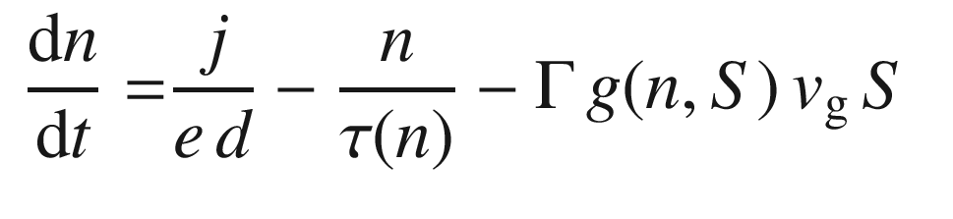

(23.40a)

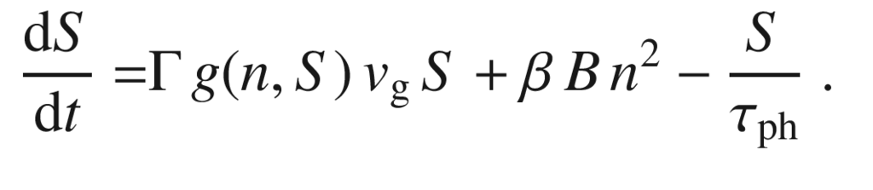

(23.40b)

The first term in ([23.40a](#u116076_4_En_23_Chapter-Equ43)) describes the electrical injection[23](#u116076_4_En_23_Chapter-Fn23) (

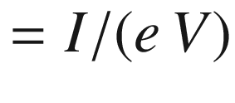

), the second one the recombination (all channels) and the third one the carrier conversion to photons through stimulated emission via the gain *g*. In the photon dynamics ([23.40b](#u116076_4_En_23_Chapter-Equ44)), the first term represents the gain term, the second one the photons in the laser mode from the recombination (spontaneous emission, cmp. Sect. [23.4.7](#u116076_4_En_23_Chapter-Sec24)) and the third term the photon loss (due to internal losses and the mirrors). The recombination rate

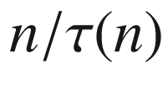

is typically given by ([23.24](#u116076_4_En_23_Chapter-Equ27)). The photon lifetime

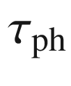

is given by ([23.28](#u116076_4_En_23_Chapter-Equ31)). If several optical modes are present, ([23.40b](#u116076_4_En_23_Chapter-Equ44)) must be written down for each mode

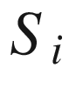

and ([23.40a](#u116076_4_En_23_Chapter-Equ43)) must be summed over all modes.

For the gain, various models are used. A simple one, going beyond ([23.13](#u116076_4_En_23_Chapter-Equ16)), considering gain compression due to spectral hole burning, i.e. depletion of carriers due to stimulated emission, is

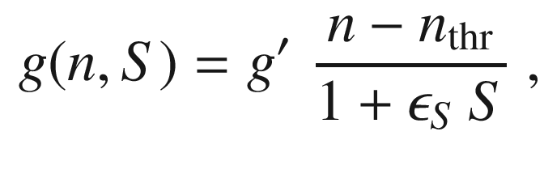

(23.41)

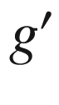

being the differential gain,

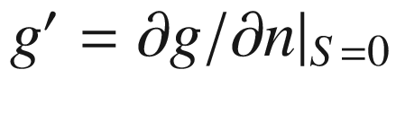

, and

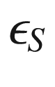

being the gain compression coefficient.

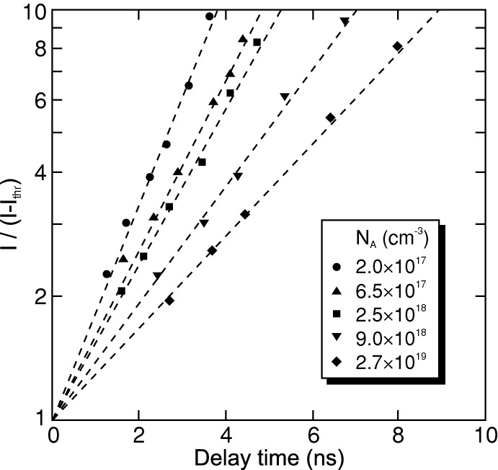

Fig. 23.59

Variation of turn-on delay time with the injected current for a laser at room temperature.

Adapted from [2012]

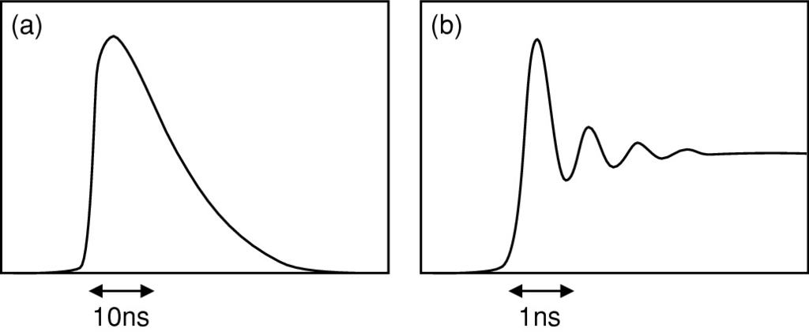

Fig. 23.60

Schematic response of **a** LED to current pulse and **b** of laser to current step

**Large-Signal Modulation**

If a current pulse is fed to the laser, the laser radiation is emitted with a short time delay, the so-called turn-on delay (TOD) time. This time is needed to build up the carrier density for inversion. The time dependence of the density is (neglecting the density dependence of the lifetime)

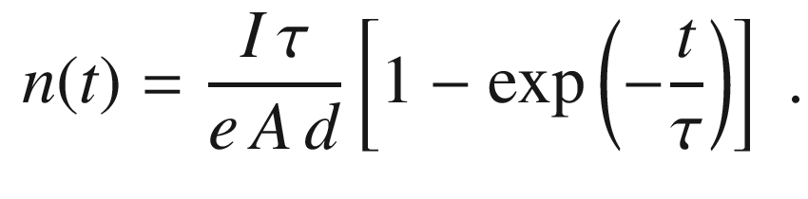

(23.42)

The TOD time to reach the threshold density (using ([23.23](#u116076_4_En_23_Chapter-Equ26))) is

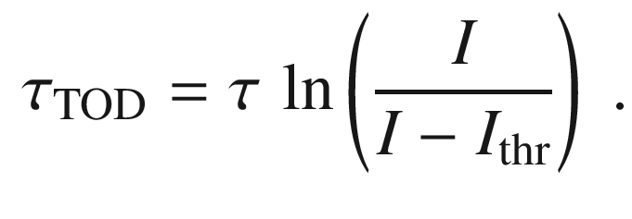

(23.43)

We note that

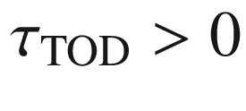

for

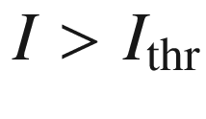

. Such a dependence is found experimentally (Fig. [23.59](#u116076_4_En_23_Chapter-Fig59)). The turn-on delay time decreases with increasing pump current but typically is at least 1 ns. In order to circumvent this limitation for more than about 1 GHz pulse repetition rate, the laser is biased slightly below threshold.

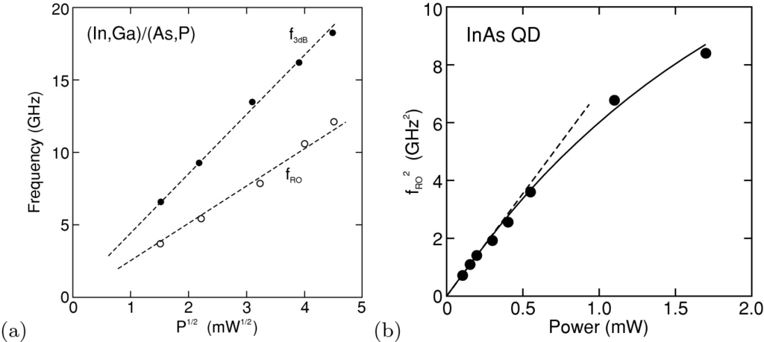

Fig. 23.61

**a** Dependence of small-signal 3 dB cutoff frequency

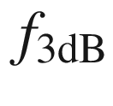

(*filled symbols*) and relaxation oscillation frequency

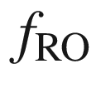

(*empty symbols*) on the square root of the output power *P* for a DFB-laser. Adapted from [2013]. **b** Relaxation oscillation frequency

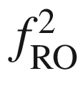

versus power for an InAs/GaAs QD laser. The *solid line* is a model including gain compression (

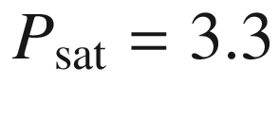

 mW), the *dashed line* is the linear relation ([23.44](#u116076_4_En_23_Chapter-Equ48)) for small power.

Adapted from [2014]

In Fig. [23.60](#u116076_4_En_23_Chapter-Fig60)a, the response (light emission) of a LED to a short current pulse is shown schematically. The monotonously decreasing transient (that is more or less exponential) corresponds to the carrier recombination dynamics. When a laser is excited with a steep (long) current pulse, the response exhibits so-called relaxation oscillations (RO) before the steady-state (cw) intensity level is reached (Fig. [23.60](#u116076_4_En_23_Chapter-Fig60)b).

In the laser, first the carrier density is built up. It surpasses the threshold density that leads to a build-up of the photon density. The laser pulse depletes the carrier density faster below threshold than the current can supply further carriers. Therefore, the laser intensity drops below the cw level. From the solution of the coupled rate equations for the electron and photon densities *n* and *S* ([23.40a](#u116076_4_En_23_Chapter-Equ43),b), the frequency of the relaxation oscillations is found as

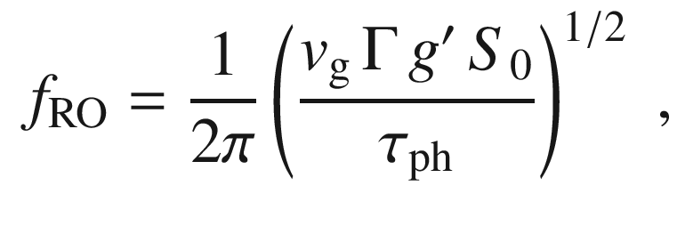

(23.44)

where

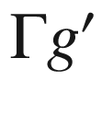

is the differential modal gain as defined in ([23.41](#u116076_4_En_23_Chapter-Equ45)) and

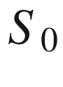

is the steady-state photon density per volume that is proportional to the laser power *P*. The dependence

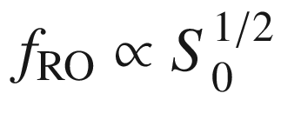

is also found experimentally (Fig. [23.61](#u116076_4_En_23_Chapter-Fig61)a). For higher power the relation

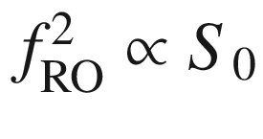

becomes non-linear (Fig. [23.61](#u116076_4_En_23_Chapter-Fig61)b) due to gain compression; in this case



is replaced with

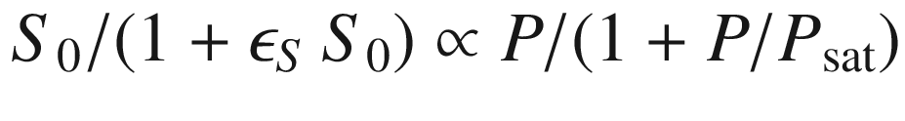

, with

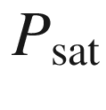

being the saturation power.

**Pattern Response**

For digital data transmission, the laser is driven with pulse sequences (bit patterns). The response to a random bit pattern  is called an ‘eye pattern’ and is shown in Fig. [23.62](#u116076_4_En_23_Chapter-Fig62). The pattern consists of traces of the type shown in Fig. [23.60](#u116076_4_En_23_Chapter-Fig60)b. A clear distinction with well-defined trigger thresholds between ‘on’- and ‘off’-states can only be made if the eye formed by the overlay of all possible traces remains open. From the eye patterns in Fig. [23.62](#u116076_4_En_23_Chapter-Fig62), it can be seen that the RO overshoot can be suppressed by driving the laser with a dc offset current well above threshold.

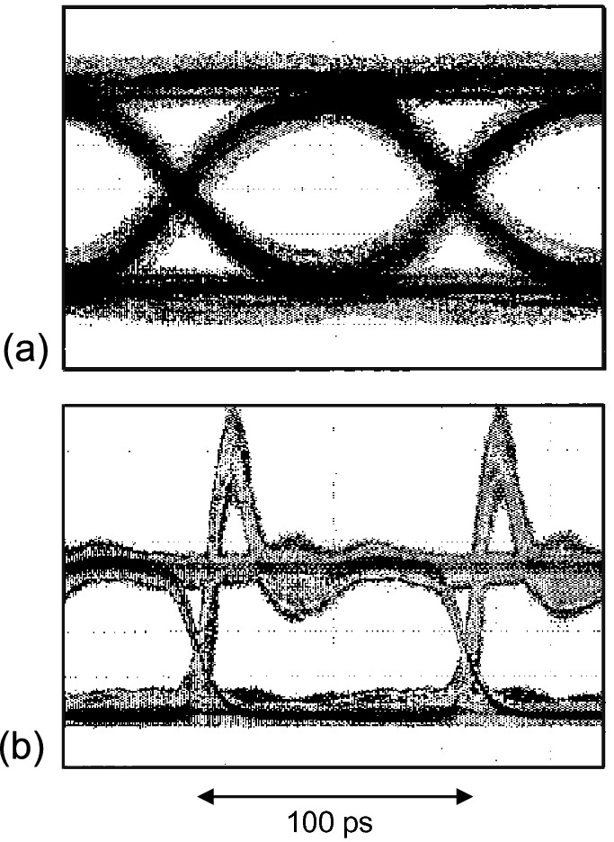

Fig. 23.62

Eye pattern of a single-mode VCSEL in response to a 10 Gb/s random bit pattern. The patterns are measured **a** with an offset current well above threshold and **b** with an offset current above but close to threshold.

Adapted from [2015]

**Small-Signal Modulation**

In small-signal modulation, the injection current *I* is varied periodically by a small amount

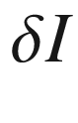

with

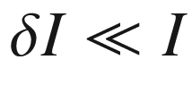

in the lasing regime. The current modulation leads to a corresponding variation of the output intensity. The frequency response is limited by the differential gain and the gain compression coefficient. The frequency response shifts to higher frequency with increasing laser power as shown in Fig. [23.63](#u116076_4_En_23_Chapter-Fig63)b.

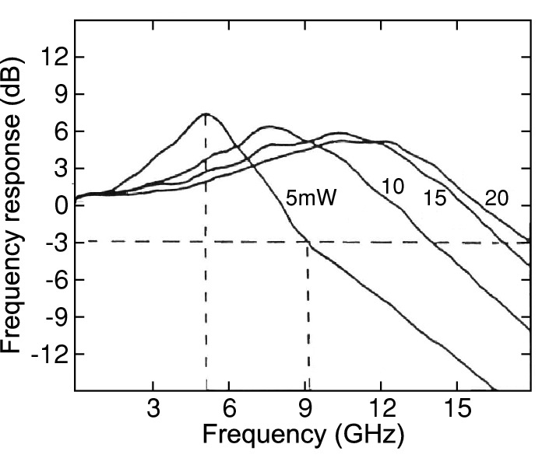

Fig. 23.63

Frequency response of a DFB-laser for various output powers as labeled.

Adapted from [2013]

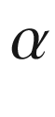

**Factor**

Another important quantity is the

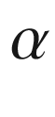

factor, also called the linewidth enhancement factor [2016, 2017]. Due to the coupling of amplitude and phase fluctuations in the laser, the linewidth

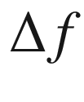

is larger than expected.

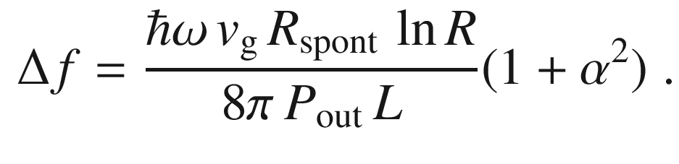

(23.45)

The linewidth enhancement is described via (

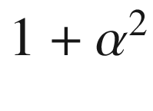

) with

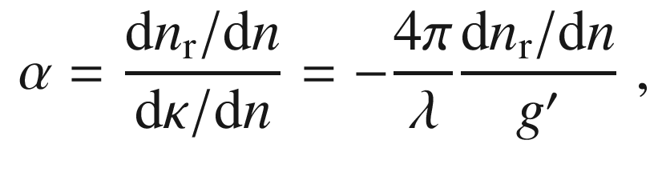

(23.46)

where

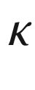

denotes the imaginary part of the index of refraction ([9.​4](The_Physics_of_Semiconductors00004.docx#u116076_4_En_9_Chapter)). Typical values for

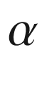

are between 1 and 10. The linewidth is inversely proportional to the output power (Fig. [23.64](#u116076_4_En_23_Chapter-Fig64)).

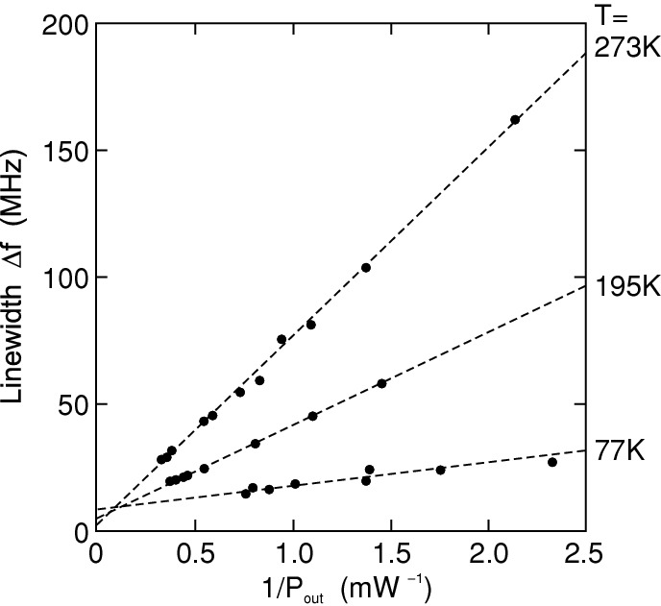

Fig. 23.64

Linewidth

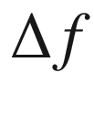

of a cw GaAs/AlGaAs laser diode at various temperatures as a function of the inverse output power

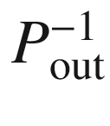

. At room temperature

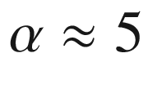

.

Adapted from [2018]

#### 23.4.14 Surface-Emitting Lasers

Surface-emitting lasers emit their beam normal to the surface. They can be fabricated from horizontal (edge-) emitters by reflecting the beam with a suitable mirror into the surface direction. This technology requires tilted facets or micro-optical components but allows for high power per area. In Fig. [23.65](#u116076_4_En_23_Chapter-Fig65), a schematic cross section of a horizontal-cavity surface-emitting laser (HCSEL) and the light emission from an array of 220 such lasers are shown. The laser contains a 45

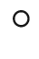

mirror that steers the light through the substrate and a Bragg mirror to provide the cavity mirror. The facet can also be fabricated such that the emission is to the top surface (Fig. [23.66](#u116076_4_En_23_Chapter-Fig66)). Another possibility to couple the beam out of a horizontal cavity is a surface grating.

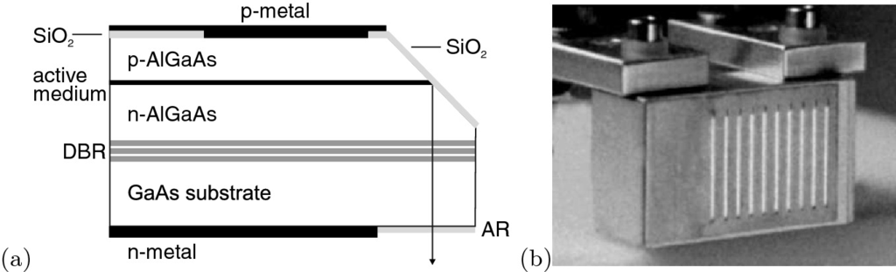

Fig. 23.65

**a** Principle of a surface-emitting laser. Light generated in the active region is internally reflected by the 45

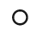

angled mirror and directed through the substrate; ‘AR’: antireflection coating, ‘DBR’: epitaxial Bragg mirror. **b** Light emission from a

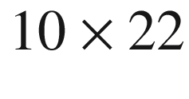

surface-emitting diode array. The light emission appears as stripes due to the broad beam divergence in the vertical direction.

Part **b** reprinted with permission from [2019]

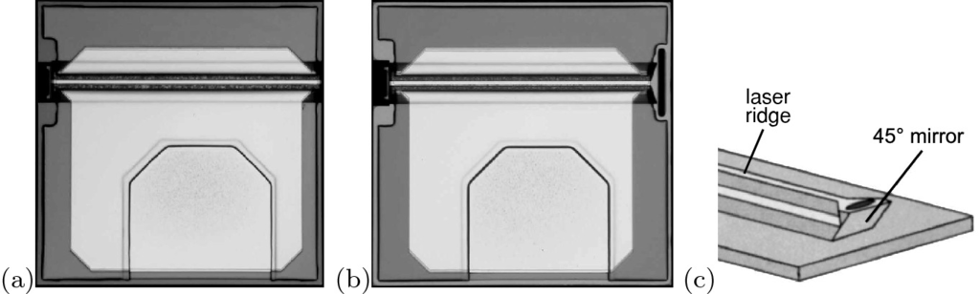

Fig. 23.66

**a** Horizontal Fabry–Perot cavity InP-based laser with 1310 nm emission length and 10 mW output power for modulation at 2.5 GB/s. The right facet is formed as DBR, emission is to the left. The trapezoid area in the center bottom of the image is the bond pad for the top contact. **b** Horizontal-cavity surface-emitting laser. Compared to **a**, the right facet is replaced with a 45

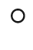

mirror, leading to surface emission. **c** Schematic drawing of the tilted facet. Parts **a** and **b** from [2020]

Now, surface-emitting lasers with vertical-cavity (VCSEL), as shown in Fig. [23.29](The_Physics_of_Semiconductors00008.docx#u116076_4_En_23_Chapter-Fig29)b, will be discussed. A detailed treatment can be found in [2021]. VCSELs are of increasing importance after many issues regarding their technology and fabrication have been solved. VCSEL fabrication is essentially a planar technology and VCSELs can be fabricated as arrays (Fig. [23.68](#u116076_4_En_23_Chapter-Fig68)). An on-wafer test of their properties is possible. They offer a symmetrical (or possibly a controlled asymmetrical) beam profile (Fig. [23.67](#u116076_4_En_23_Chapter-Fig67)) with possible polarization control or fixation.

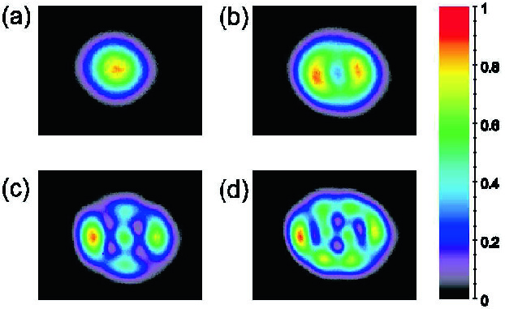

Fig. 23.67

In-plane near field of a VCSEL with 6 µm oxide aperture at various currents, **a** 3.0 mA, **b**, 6.2 mA, **c** 14.7 mA, **d** 18 mA

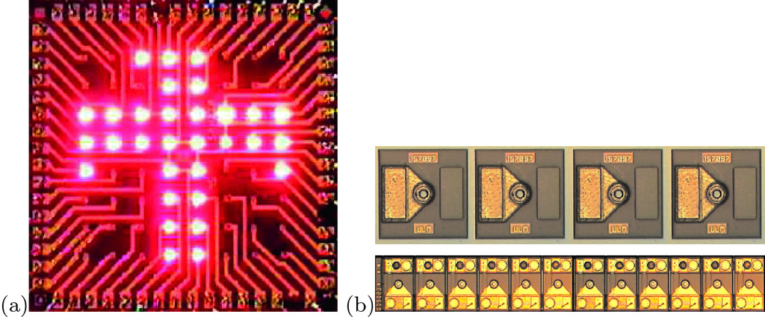

Fig. 23.68

**a**, **b** VCSEL arrays.

Part **a** reprinted from [2022] with permission, part **b** reprinted from [2023] with permission

The cavity is formed by two highly reflecting Bragg mirrors with a distance of

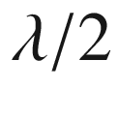

or

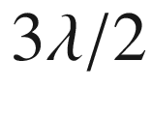

forming a microcavity (see Sect. [19.​1.​7](The_Physics_of_Semiconductors00007.docx#u116076_4_En_19_Chapter)). A high index contrast can be obtained from GaAs/AlAs Bragg mirrors in which the AlAs layers have been selectively oxidized in a hot moist atmosphere. Pure semiconductor Bragg mirrors suffer typically from small index contrast and require many pairs. This poses a problem, e.g. for InP-based VCSELs. In Fig. [23.69](#u116076_4_En_23_Chapter-Fig69), the distribution of light intensity along a

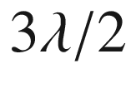

cavity is shown. In the stop band of the mirrors, there is only one optical mode, the cavity mode, that can propagate along the vertical (*z*) direction.

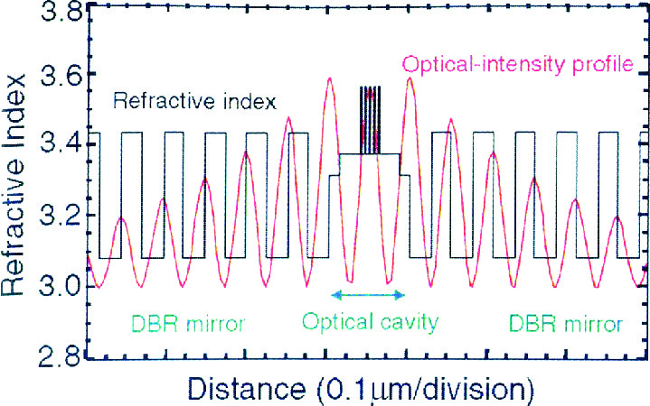

Fig. 23.69

Simulation of the longitudinal distribution of the optical field in a VCSEL structure. The active medium are five quantum wells in the center.

Reproduced from [2024] by permission from the MRS Bulletin

The current path through the active layer can be defined with an oxide aperture. This aperture is fabricated by selective oxidation of an AlAs layer, leaving a circular opening in the center of the VCSEL pillar as shown in Fig. [23.70](#u116076_4_En_23_Chapter-Fig70). The current can be injected through the mirrors if they are doped. Alternatively, the current can be directly fed to the active layer by so-called intracavity contacts.

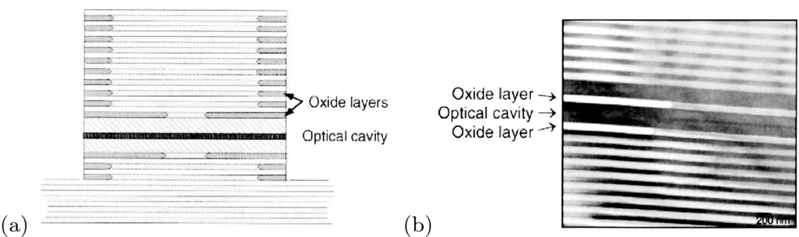

Fig. 23.70

**a** Schematic cross section of VCSEL with oxide aperture, **b** TEM image of cross section.

Reproduced from [2024] by permission from the MRS Bulletin

The emission wavelength of a VCSEL can be shifted via a variation of temperature or pump power. Tuning of the VCSEL emission can also be accomplished by leaving an air gap between the cavity and the upper mirror [2025]. Applying a voltage to the lever arm with the top mirror, the width of the air gap can be varied. This variation leads to a shift of the cavity mode and therefore of the laser emission wavelength (Fig. [23.71](#u116076_4_En_23_Chapter-Fig71)). A VCSEL with air gap and particularly a high contrast Bragg mirror is achieved with InP/air as shown in Fig. [23.72](#u116076_4_En_23_Chapter-Fig72).

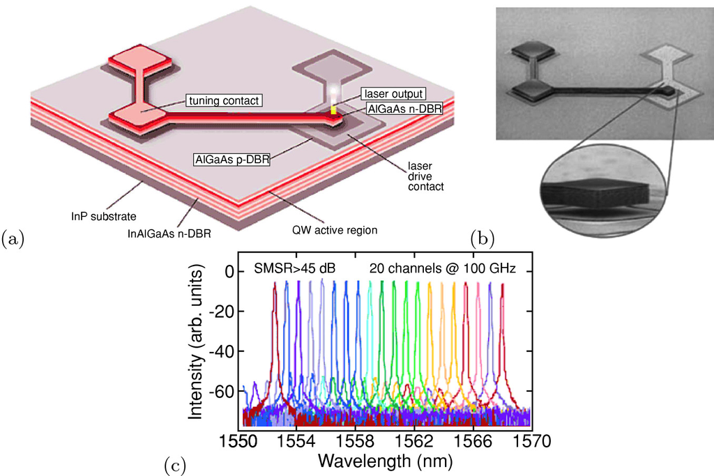

Fig. 23.71

**a** Schematic setup and **b** SEM image of VCSEL with air gap between active layer and top Bragg mirror, **c** spectra for different tuning conditions (via the width of the air gap).

From [2026]

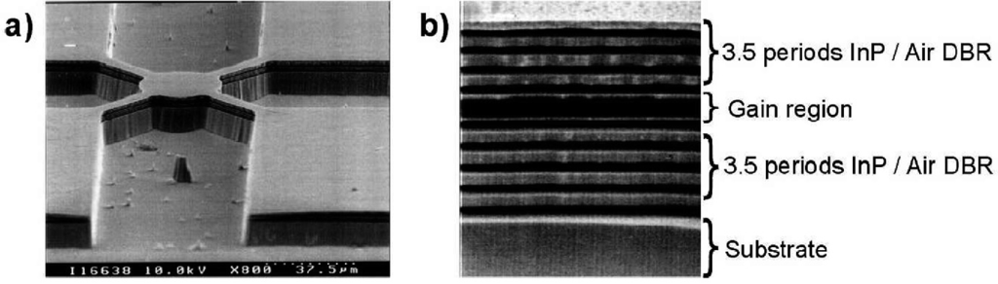

Fig. 23.72

**a** VCSEL with air gap and **b** Bragg mirror with high dielectric contrast InP/air interfaces.

Reprinted with permission from [2027], ©2002 IEEE

#### 23.4.15 Optically Pumped Semiconductor Lasers

An easy way to pump semiconductor lasers is optical pumping. This technique is similar to diode-pumped solid-state lasers (DPSS). A (semiconductor) pump diode illuminates a suitable semiconductor structure (Fig. [23.73](#u116076_4_En_23_Chapter-Fig73)). The resonator is built between the bottom Bragg mirror of the semiconductor and the output coupler. The semiconductor structure contains suitable absorption layers (barriers) that absorb the pump light and quantum wells that emit laser radiation. This radiation is intracavity frequency doubled. In order to reach, e.g., a 488-nm output laser beam, a standard 808-nm pump diode is employed. The InGaAs/GaAs quantum wells are designed to emit at 976 nm. Other design wavelengths of the quantum wells allow for other output wavelengths. This technology allows compact lasers with little heat dissipation [2028]. The optically pumped semiconductor laser (OPSL) is also known as a semiconductor disc laser.

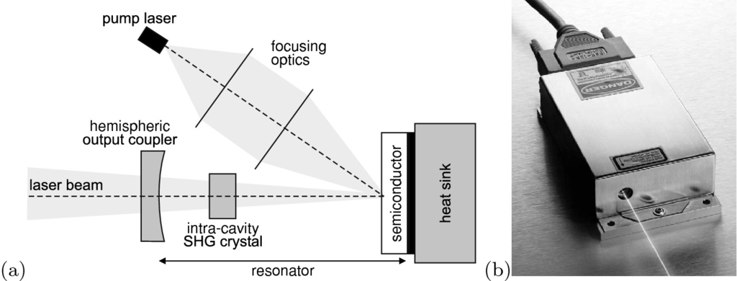

Fig. 23.73

**a** Schematic setup of optically pumped semiconductor laser (OPSL). The semiconductor chip consists of a Bragg mirror on the bottom, multiple quantum wells and an antireflection coating on the top. Adapted from [2028]. **b** OPSL source (488 nm, 20 mW, footprint: 125

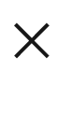

70 mm



).

Reprinted with permission from [2029]

#### 23.4.16 Quantum Cascade Lasers

In a quantum cascade laser (QCL), the gain stems from an intersubband transition. The concept was conceived in 1971 [145, 2032] and realized in 1994 [149]. In Fig. [23.74](#u116076_4_En_23_Chapter-Fig74)a, the schematic conduction-band structure at operation is shown. The injector supplies electrons into the active region. The electron is removed quickly from the lower level in order to allow inversion. The electron is then extracted into the next injector. The laser medium consists of several such units as shown in Fig. [23.74](#u116076_4_En_23_Chapter-Fig74)b. Since every unit can deliver a photon per electron (with efficiency

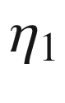

), the total quantum efficiency of *N* units

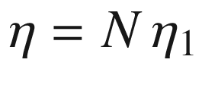

can be larger than 1.

The emission wavelength is in the far- or mid-infrared, depending only on the designed layer thicknesses and *not* on the band gap of the material (Fig. [23.74](#u116076_4_En_23_Chapter-Fig74)d). In the mid-infrared, room-temperature operation has been achieved while operation in the far-infrared requires cooling so far. Extensions to the THz-range and the infrared spectral region (telecommunication wavelengths of 1.3 and 1.55 µm) seem feasible. The cascade laser concept can also be combined with the DFB technology to create single-mode laser emission (Fig. [23.74](#u116076_4_En_23_Chapter-Fig74)d).

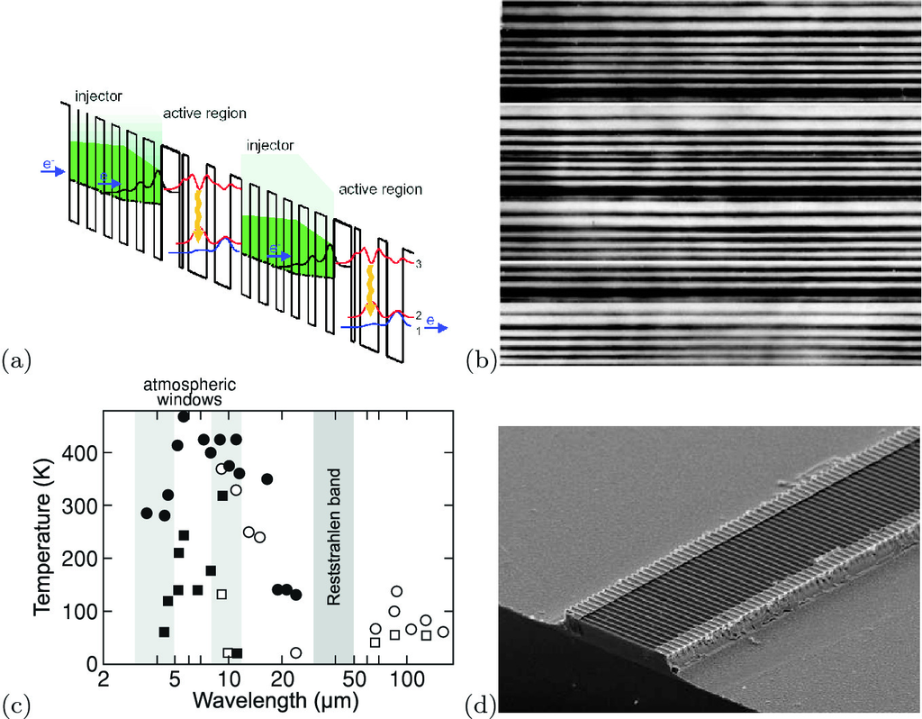

Fig. 23.74

**a** Schematic band diagram of quantum cascade laser. **b** Cross sectional TEM of cascade layer sequence. The periodicity of the vertical layer sequence is 45 nm. From [2030]. **c** Laser emission wavelengths and operation temperatures for various realized quantum cascade lasers (*squares*: cw, *circles*: pulsed operation, *solid symbols*: InP-, *empty symbols*: GaAs-based). Data from [2031]. **d** SEM image of a quantum cascade DFB laser (grating period: 1.6 µm).

From [2031]

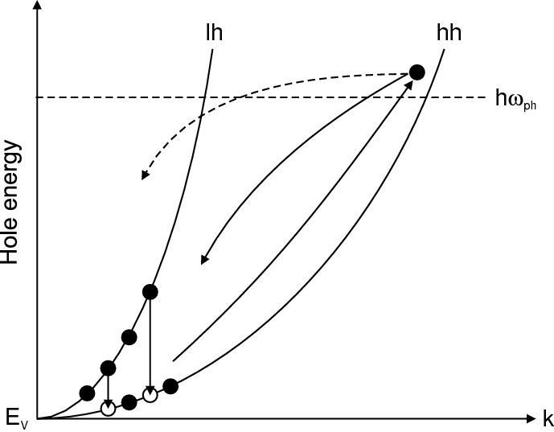

Fig. 23.75

Schematic cycle of hole motion in a hot-hole laser. *Filled* (*empty*) circles represent populated (unpopulated) hole states. The *solid lines* represent streaming motion of heavy hole, the *dashed line* represents scattering into the light hole band. *Arrows* denote radiative intervalence-band transitions

#### 23.4.17 Hot-Hole Lasers

The hot-hole laser, which is mostly realized with p-doped Ge, is based on a population inversion between the light- and heavy-hole valence subbands. The laser operates with crossed electric and magnetic fields (Voigt configuration, typically

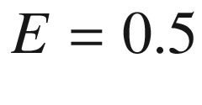

–3 kV/cm,

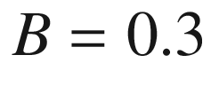

–2 T) and at cryogenic temperatures (

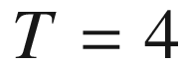

–40 K) [2033–2035].

A significant scattering process of hot carriers is interaction with optical phonons, mainly optical phonon emission. This process has a threshold in carrier energy given by the optical phonon energy. For sufficiently high electric fields and at low temperature, hot carriers accelerate without acoustical phonon interaction (ballistic transport) along the crystallographic direction in which the electric field is applied. These hot carriers reach the optical phonon energy and lose all their energy due to emission of an optical phonon. They accelerate again, repeating this directional motion in momentum space. This motion is called *streaming motion*.

For |*E*/*B*| ratios of about 1.5 kV/cmT, the heavy holes are accelerated up to energies above the optical phonon energy (37 meV in germanium) and consequently are scattered strongly by these phonons. Under these conditions, a few per cent of the heavy holes are scattered into the light-hole band. The light holes remain at much lower energies and are accumulated at the bottom of the light-hole band below the optical phonon energy as sketched in Fig. [23.75](#u116076_4_En_23_Chapter-Fig75). The continuous pumping of heavy holes into the light-hole band can lead to a population inversion. Consequently, laser radiation is emitted from optical (radiative) intervalence-band transitions (cf. Sect. [9.​9.​3](The_Physics_of_Semiconductors00004.docx#u116076_4_En_9_Chapter)). The emission wavelength is in the far-infrared around 100 µm. Typical p-Ge lasers span the frequency range 1–4 THz (300–70 µm) [2036] and deliver 1–10 W peak output power for 1 cm

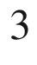

typical active volume.

Since the applied electric field causes considerable heating, the temperature of the laser crystal rises quickly, within a few µs, up to 40 K. Then the laser action stops. Thus the duration of the electric-field excitation is limited to 1–5 µs (limiting the emission power) and the repetition frequency is only a few Hertz due to the necessary cooling. Research is underway towards high duty cycle (possibly cw) operation by using smaller volumes and planar vertical-cavities [2037, 2038].

### 23.5 Semiconductor Optical Amplifiers

If the facets of a laser cavity are antireflection coated, a laser gain medium can be used as a semiconductor optical amplifier (SOA). A textbook on this subject is [2039]. Optical feedback from facets can also be avoided using tilted facets [2040].

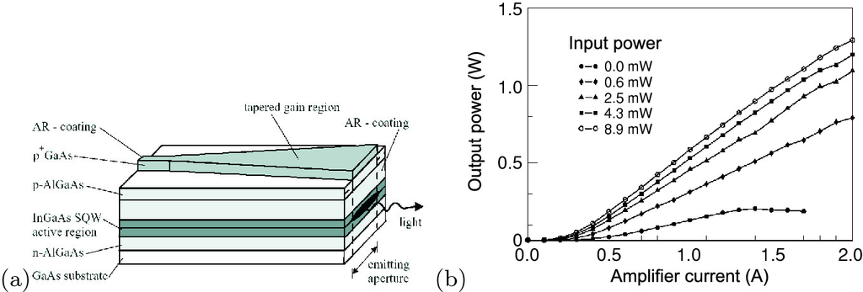

Fig. 23.76

**a** Schematic geometry of tapered semiconductor amplifier. **b** Optical output power versus amplifier current for various values of the optical input power, taper angle was 5

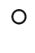

. For zero input power only spontaneous and amplified spontaneous emission is observed.

Reprinted with permission from [2041]

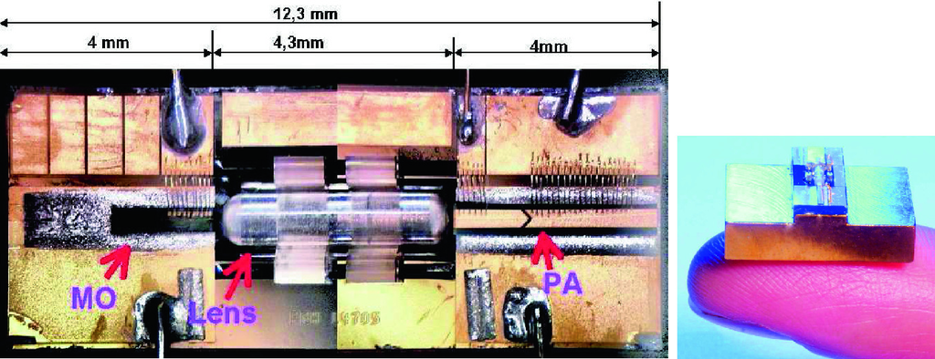

Fig. 23.77

Photographs of a MOPA arrangement of a laser (master oscillator, ‘MO’), glass lens and tapered amplifier (power amplifier, ‘PA’) on a silicon micro-optical ‘bench’.

Reprinted with permission from [2042]

A tapered amplifier geometry, as shown in Fig. [23.76](#u116076_4_En_23_Chapter-Fig76)a, allows for laterally monomode input and a preservation of the lateral beam quality during the propagation of the optical wave through the gain medium. The active medium is an 8-nm compressively strained InGaAs quantum well. A typical taper angle is 5–10

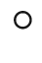

. The input aperture is between 5 and 7 µm. The amplifier length is 2040 µm. More than 20 dB optical amplification can be obtained (Fig. [23.76](#u116076_4_En_23_Chapter-Fig76)b). The self-oscillation is suppressed for currents up to 2 A by AR facet coating of 10

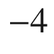

in a 70 nm band. The wall-plug efficiency of the discussed amplifier is up to over 40%. If such an amplifier  is arranged together with a seed laser diode (master oscillator), the setup is called MOPA (master oscillator power amplifier), as shown in Fig. [23.77](#u116076_4_En_23_Chapter-Fig77). A modulated input also leads to a modulated output.

Quantum dot arrays can be a useful gain medium in a SOA [2043, 2044] due to their fast gain dynamics [2045] and broad spectrum (Sect. [23.3.6](The_Physics_of_Semiconductors00008.docx#u116076_4_En_23_Chapter-Sec15)).

Footnotes

[1](The_Physics_of_Semiconductors00008.docx#u116076_4_En_23_Chapter-Fn1_source)

A solid angle

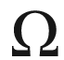

is the ratio of the spherical surface area *A* and the square of the sphere’s radius *r*, i.e.

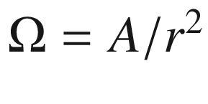

.

[2](The_Physics_of_Semiconductors00008.docx#u116076_4_En_23_Chapter-Fn2_source)

The

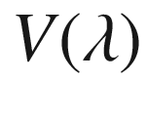

curve has been experimentally determined by letting several observers adjust (decrease) the perceived brightness of a monochromatic light source at 555 nm to that of light sources of the same absolute radiation power at other wavelengths with so-called heterochromatic flicker photometry. The ‘relative sensitivity curve for the CIE Standard Observer’ was determined in 1924. The ‘standard observer’ is neither a real observer nor an average human observer. The curve has shortcomings, e.g., due to the used spectral band width (20–30 nm) of the light sources and the comparison of spectral power instead of the photon flux.

[3](The_Physics_of_Semiconductors00008.docx#u116076_4_En_23_Chapter-Fn3_source)

While photopic vision is due to cones, the scotopic (dark-adapted) vision is due to rods. Rods are more than one thousand times as sensitive as the cones and can reportedly be triggered by individual photons under optimal conditions. Rods predominate in the peripheral vision and are not color sensitive.

[4](The_Physics_of_Semiconductors00008.docx#u116076_4_En_23_Chapter-Fn4_source)

Commission Internationale de l’Éclairage. The color space can be described by different coordinate systems, and the three most widely used color systems, Munsell, Ostwald, and CIE, describe the color space with different parameters. The Munsell system uses hue, value, and chroma and the Ostwald system uses dominant wavelength, purity, and luminance. The more precise CIE system uses a parameter *Y* to measure brightness and parameters *x* and *y* to specify the chromaticity that covers the properties hue and saturation on a two-dimensional chromaticity diagram.

[5](The_Physics_of_Semiconductors00008.docx#u116076_4_En_23_Chapter-Fn5_source)

This definition is motivated by the color vision of the eye. Two light sources will have the same color, even if they have different SPDs, when they evoke the same color impression to the human eye.

[6](The_Physics_of_Semiconductors00008.docx#u116076_4_En_23_Chapter-Fn6_source)

The coloring of the chart is provided for an understanding of color relationships. CRT monitors and printed materials cannot reproduce the full gamut of the color spectrum as perceived in human vision. The color areas that are shown only depict rough categories and are not precise statements of color.

[7](The_Physics_of_Semiconductors00008.docx#u116076_4_En_23_Chapter-Fn7_source)

RGB is an additive color system. However, printing devices use a subtractive color system. This means that the ink absorbs a particular color, and the visible impression stems from what is reflected (not absorbed). When inks are combined, they absorb a combination of colors, and hence the reflected colors are reduced, or subtracted. The subtractive primaries are cyan, magenta and yellow (CMY) and are related to RGB via

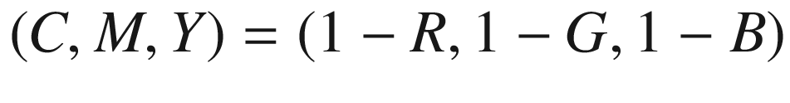

.

[8](The_Physics_of_Semiconductors00008.docx#u116076_4_En_23_Chapter-Fn8_source)

Standard RGB color space as defined mainly by Hewlett-Packard and Microsoft, almost identical to PAL/SECAM European television phosphors.

[9](The_Physics_of_Semiconductors00008.docx#u116076_4_En_23_Chapter-Fn9_source)

National television standard colors, US norm.

[10](The_Physics_of_Semiconductors00008.docx#u116076_4_En_23_Chapter-Fn10_source)

This transition is dipole allowed for Ce and partially forbidden for Eu.

[11](The_Physics_of_Semiconductors00008.docx#u116076_4_En_23_Chapter-Fn11_source)

Penetration of white LEDs into the general lighting market could translate (globally) into cost savings of $

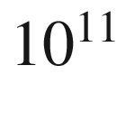

or a reduction of power generation capacity of 120 GW.

[12](The_Physics_of_Semiconductors00008.docx#u116076_4_En_23_Chapter-Fn12_source)

Note that the light extraction efficiency is also important for solar cells, cf. Sect. [22.​4.​3](The_Physics_of_Semiconductors00008.docx#u116076_4_En_22_Chapter).

[13](The_Physics_of_Semiconductors00008.docx#u116076_4_En_23_Chapter-Fn13_source)

The term ‘laser’ is an acronym for ‘light amplification by stimulated emission of radiation’. The amplification relies on stimulated emission, theoretically predicted by Einstein in 1917. The laser concept was first explored in the microwave wavelength region (1954, MASER using ammonia, Ch.H. Townes, Nobel prize 1964). The first optical laser (1958, US patent No. 2,929,922 awarded 1960, A.L. Schawlow, Ch.H. Townes) was the ruby laser developed in 1960 by Th. Maiman. A device is a laser when it emits stimulated light. This light must neither be monochromatic nor be emitted in a narrow, directed beam.

[14](The_Physics_of_Semiconductors00008.docx#u116076_4_En_23_Chapter-Fn14_source)

Or etched facets in possibly any direction.

[15](The_Physics_of_Semiconductors00008.docx#u116076_4_En_23_Chapter-Fn15_source)

Such external cavities can be used for manipulation of the laser properties such as wavelength tuning.

[16](#u116076_4_En_23_Chapter-Fn16_source)

16 million 405 nm laser diodes were shipped in 2006–2008. 85% of those are built into SONY’s PS3, the rest into HD-DVD and other Blu-ray™disc (BD) players.

[17](#u116076_4_En_23_Chapter-Fn17_source)

or due to optical pumping. If electrical contacts are not available, the laser action can be invoked by supplying a high-intensity light beam, possibly in a stripe-like shape. For optically pumped semiconductor lasers see Sect. [23.4.15](#u116076_4_En_23_Chapter-Sec32).

[18](#u116076_4_En_23_Chapter-Fn18_source)

One electron and one hole band are considered; the heavy and light hole bands are taken into account via the mass according to ([6.​73](The_Physics_of_Semiconductors00003.docx#u116076_4_En_6_Chapter)).

[19](#u116076_4_En_23_Chapter-Fn19_source)

A smaller band gap coincides in many cases with a larger index of refraction.

[20](#u116076_4_En_23_Chapter-Fn20_source)

Since

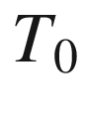

has the dimension of a temperature difference, it can be expressed in



C or K. For the sake of unambiguity it should be given in K.

[21](#u116076_4_En_23_Chapter-Fn21_source)

In order to make better use of the high bandwidth of the optical fiber several information channels with closely lying wavelengths are transmitted.

[22](#u116076_4_En_23_Chapter-Fn22_source)

Note the anomalous positive coefficient

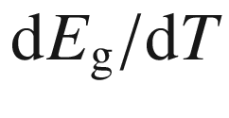

as discussed in Sect. [6.​7](The_Physics_of_Semiconductors00003.docx#u116076_4_En_6_Chapter).

[23](#u116076_4_En_23_Chapter-Fn23_source)

This term can be multiplied by the injection efficiency



to account for leakage currents.

© Springer Nature Switzerland AG 2021

M. Grundmann

The Physics of Semiconductors

Graduate Texts in Physics

<https://doi.org/10.1007/978-3-030-51569-0_24>

## 24. Transistors

Marius Grundmann[1](#u116076_4_En_24_Chapter-Aff11)

(1)

Felix Bloch Institute for Solid State Physics, Universität Leipzig, Leipzig, Germany

Marius Grundmann

Email:

[grundmann@physik.uni-leipzig.de](mailto:grundmann@physik.uni-leipzig.de)

*Frequently, I have been asked if an experiment I have planned is pure or applied research; to me it is more important to know if the experiment will yield new and probably enduring knowledge about nature. If it is likely to yield such knowledge, it is, in my opinion, good fundamental research; and this is much more important than whether the motivation is purely esthetic satisfaction on the part of the experimenter on the one hand or the improvement of the stability of a high-power transistor on the other.*

*W.B. Shockley [2046, 2047]*

## Abstract

The device functionalities of bipolar, heterobipolar and field effect transistors (JFET, MESFET and MOSFET) are explained. Within physical models for drift, diffusion and recombination given earlier in the book, the characteristics of these devices are derived. Remarks on integrated circuits, miniaturization and thin film transistors finish this chapter.

### 24.1 Introduction

Transistors[1](#u116076_4_En_24_Chapter-Fn1) are the key elements for electronic circuits such as amplifiers, memories and microprocessors. Transistors can be realized in bipolar technology (bipolar junction transistor (BJT), Sect. [24.2](#u116076_4_En_24_Chapter-Sec2)) or as unipolar devices using the field effect (field-effect transistor (FET), Sect. [24.3](#u116076_4_En_24_Chapter-Sec14)) [574, 2048]. The equivalent in vacuum-tube technology to the transistor is the triode (Fig. [24.1](#u116076_4_En_24_Chapter-Fig1)a). Transistors can be optimized for their properties in analog circuits such as linearity and frequency response or their properties in digital circuits such as switching speed and power consumption. Transistors for microwave applications are discussed in [1815]. Early commercial models are shown in Fig. [24.2](#u116076_4_En_24_Chapter-Fig2).

### 24.2 Bipolar Transistors

Bipolar transistors consist of a pnp or npn sequence (Fig. [24.3](#u116076_4_En_24_Chapter-Fig3)). The layers (or parts) are named emitter (highly doped), base (thin, highly doped) and collector (normal doping level). The transistor can be considered to consist of two diodes (emitter–base and base–collector) back to back. However, the important point is that the base is sufficiently thin (in relation to its minority carrier diffusion length) and carriers from the emitter (which are minority carriers in the base) can dominantly reach the collector by diffusion.

In Fig. [24.4](#u116076_4_En_24_Chapter-Fig4), the three basic circuits with a transistor are shown. They are classified by the common contact for the input and output circuit. The space charges and band diagram for a pnp transistor in the base circuit configuration are depicted in Fig. [24.5](#u116076_4_En_24_Chapter-Fig5). The emitter–base diode is switched in the forward direction to inject electrons into the base. The base–collector diode is switched in the reverse direction. The electrons that diffuse through the base and reach the neutral region of the collector were transported by the high drift field away from the base.

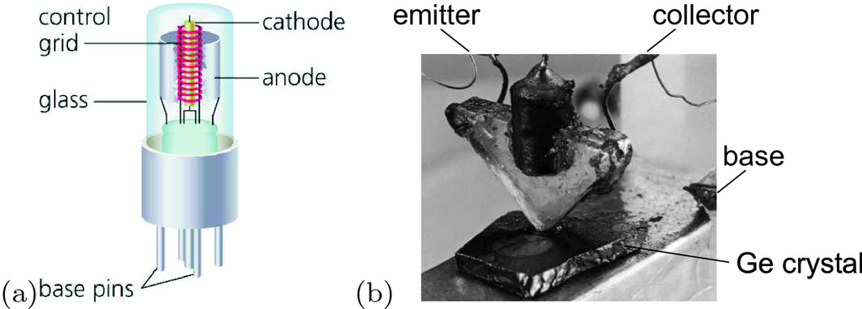

Fig. 24.1

**a** Schematic image of a vacuum triode. The electron current flows from the heated cathode to the anode when the latter is at a positive potential. The flow of electrons is controlled with the grid voltage. **b** Bell Laboratories’ first (experimental) transistor, 1947

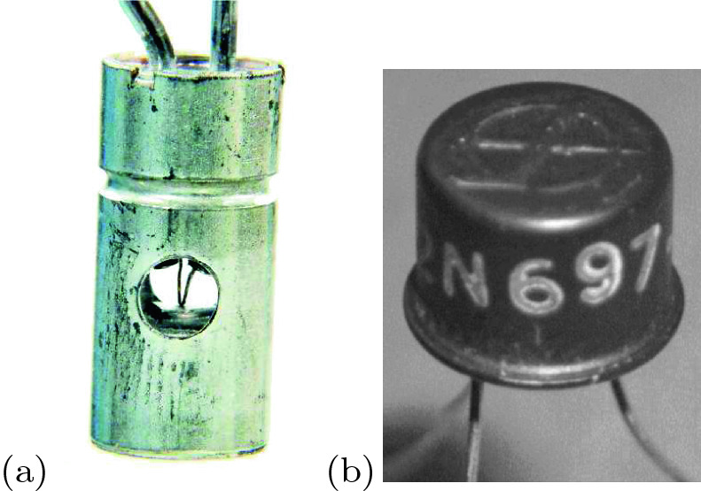

Fig. 24.2

**a** First commercial, developmental (point contact) transistor from BTL (Bell Telephone Laboratories) with access holes for adjustment of the whiskers pressing on a piece of Ge, diameter 7/32"=5 mm, 1948. **b** First high-performance silicon transistor (npn mesa technology), model 2N697 from Fairchild Semiconductor, 1958 (at $200, in 1960 $28.50). The product number is still in use (now $ 0.95)

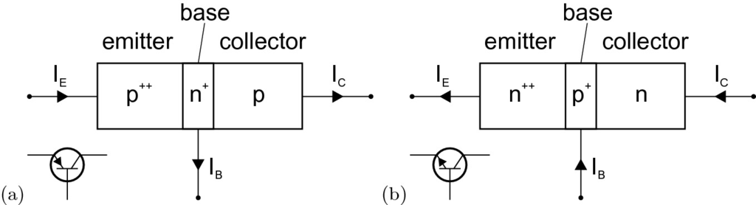

Fig. 24.3

Schematic structure and circuit symbol for **a** pnp and **b** npn transistors

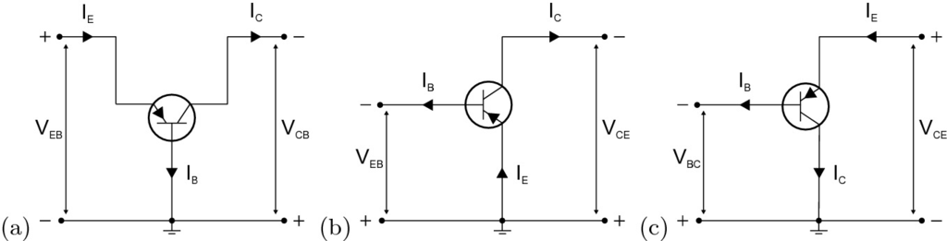

Fig. 24.4

Basic transistor circuits, named after the common contact: **a** Common base circuit, **b** common emitter circuit and **c** common collector circuit

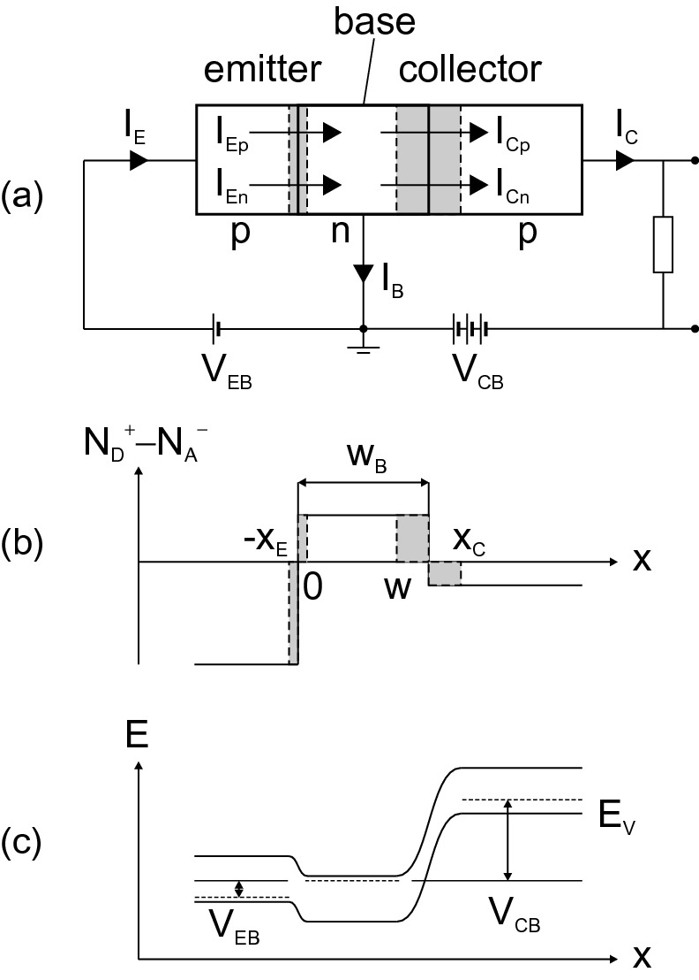

Fig. 24.5

pnp transistor in **a** base circuit. **b** Doping profile and space charges (abrupt approximation) and **c** band diagram for typical operation conditions

#### 24.2.1 Carrier Density and Currents

The modeling of transistors is a complex topic. We treat the transistor on the level of the abrupt junction. As an approximation, we assume that all voltages drop at the junctions. Series resistances, capacities and stray capacities and other parasitic impedances are neglected at this point.

The major result is that the emitter–base current from the forward-biased emitter–base diode will be transferred to the collector. The current flowing from the base contact is small compared to the collector current. This explains the most prominent property of the transistor, the current amplification.

For the neutral part of the base region of a pnp transistor, the stationary equations for diffusion and continuity are

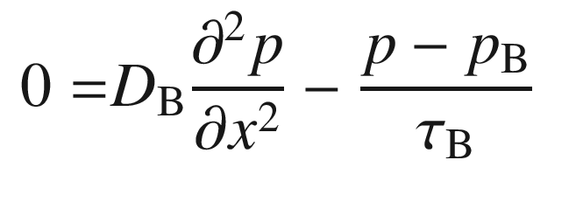

(24.1a)

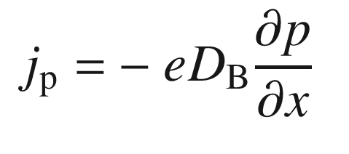

(24.1b)

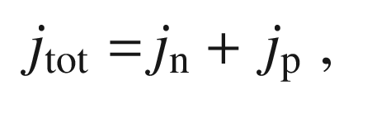

(24.1c)

where

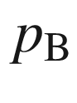

is the equilibrium minority carrier density in the base. From the discussion of the pn-diode, we know that at the boundary of the depletion layer the minority carrier density is increased by

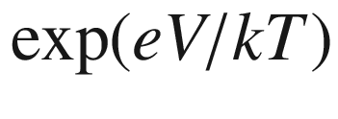

(cf. ([21.​102a](The_Physics_of_Semiconductors00007.docx#u116076_4_En_21_Chapter),b)). At the boundaries of the emitter–base diode (for geometry see Fig. [24.5](#u116076_4_En_24_Chapter-Fig5)a)

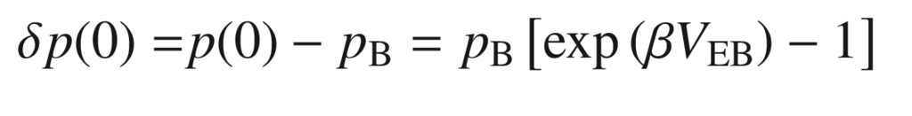

(24.2a)

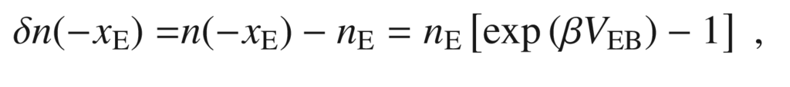

(24.2b)

where

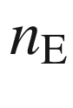

and

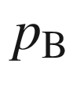

are the equilibrium minority-carrier densities in the emitter and base, respectively. Accordingly, at the boundaries of the base–collector diode we have

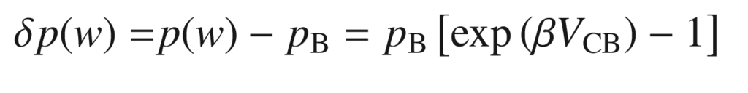

(24.3a)

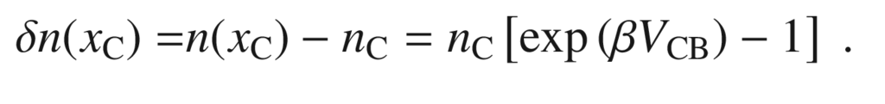

(24.3b)

These are the boundary conditions for the diffusion equations in the p-doped layers and in the neutral region of the n-doped base. For the p-layers (with infinitely long contacts), the solution is (similar to ([21.​128](The_Physics_of_Semiconductors00007.docx#u116076_4_En_21_Chapter))) for

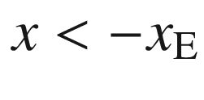

and

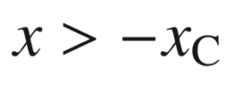

, respectively

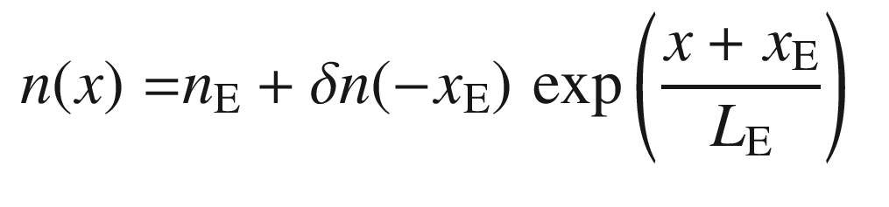

(24.4a)

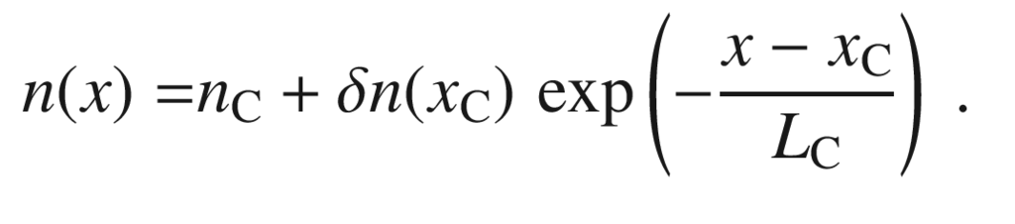

(24.4b)

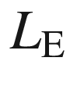

and

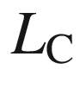

are the minority carrier (electron) diffusion lengths in the emitter and collector, respectively. The solution for the hole density in the neutral region in the base (

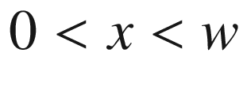

) is

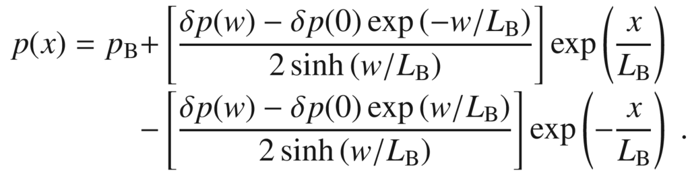

(24.5)

We shall denote the excess hole density at

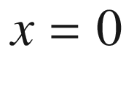

and

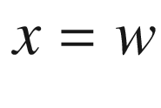

as

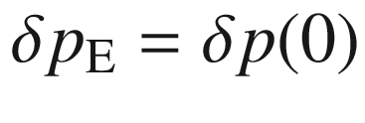

and

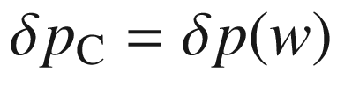

, respectively. Typical (‘normal’) operation condition in the common base circuit is that

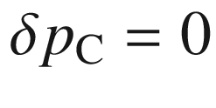

(Fig. [24.8](#u116076_4_En_24_Chapter-Fig8)a). In the ‘inverted’ configuration, the role of emitter and collector are reversed and

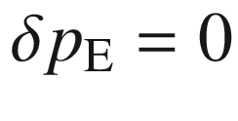

. We can write ([24.5](#u116076_4_En_24_Chapter-Equ10)) also as

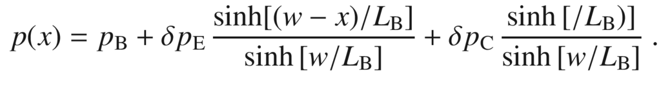

(24.6)

If the base is thick, i.e.

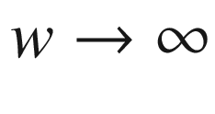

, or at least large compared to the diffusion length (

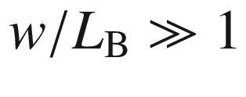

), the carrier concentration is given by

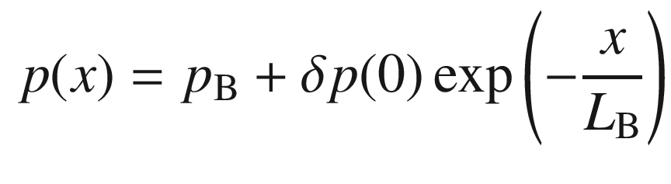

(24.7)

and does not depend on the collector. In this case there is no transistor effect. A ‘coupling’ between emitter and collector currents that are given by the derivative

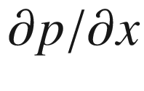

at 0 and *w*, respectively, is only present for a sufficiently thin base.

From ([24.6](#u116076_4_En_24_Chapter-Equ11)), the hole current densities at

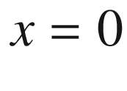

and

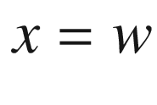

are given as[2](#u116076_4_En_24_Chapter-Fn2)

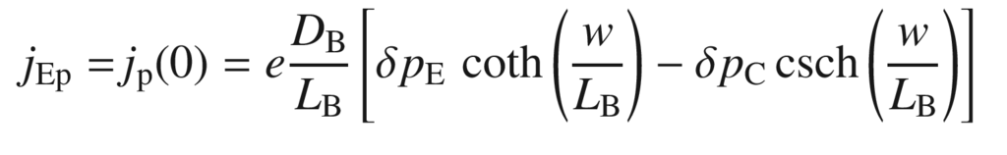

(24.8a)

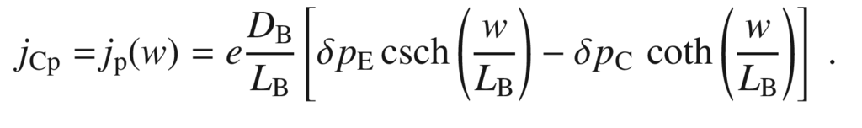

(24.8b)

From ([24.4a](#u116076_4_En_24_Chapter-Equ8),b), the electron current densities at

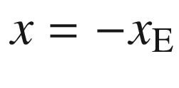

and

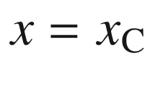

are given (with

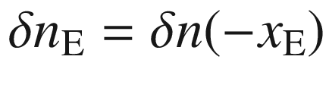

and

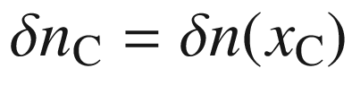

) by

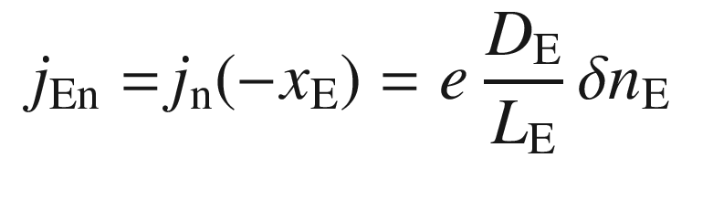

(24.9a)

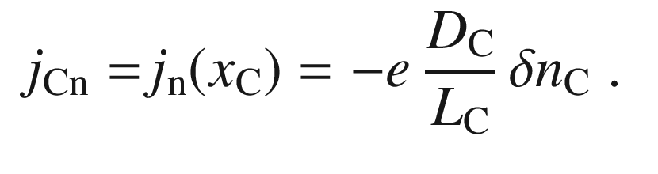

(24.9b)

The emitter current density is (similar to ([21.​131](The_Physics_of_Semiconductors00007.docx#u116076_4_En_21_Chapter)))

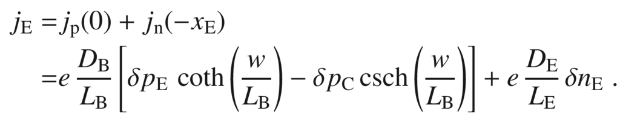

(24.10)

The collector current density is given as

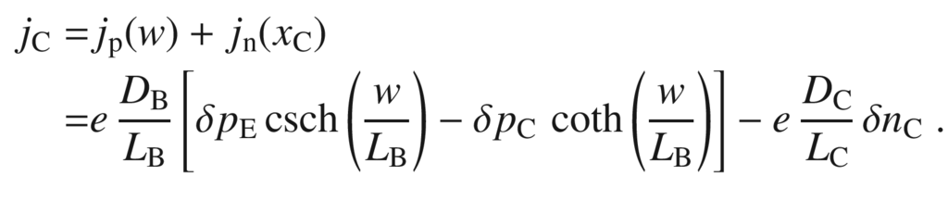

(24.11)

In these equations, only the diffusion currents are considered. Additionally, the recombination currents in the depletion layers must be considered, in particular at small junction voltages.

#### 24.2.2 Current Amplification

The emitter current consists of two parts, the hole current

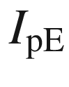

injected from the base and the electron current

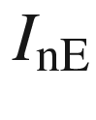

that flows from the emitter to the base (Fig. [24.5](#u116076_4_En_24_Chapter-Fig5)a). Similarly, the collector current is made up from the hole and electron currents

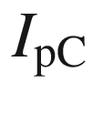

and

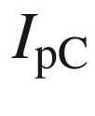

, respectively.

The total emitter current splits into the base and collector currents

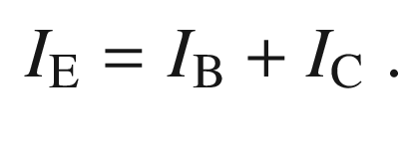

(24.12)

The amplification (gain) in common base circuits

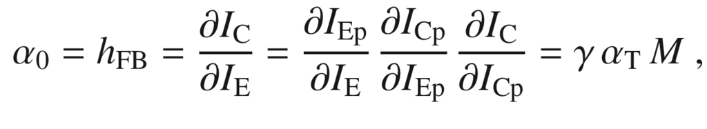

(24.13)

where

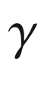

is the emitter efficiency,

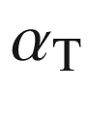

the base transport factor and *M* the collector multiplication factor. Since the collector is normally operated below the threshold for avalanche multiplication,

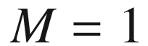

.

The current amplification in the common emitter circuit is

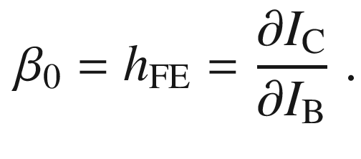

(24.14)

Using ([24.12](#u116076_4_En_24_Chapter-Equ19)), we find

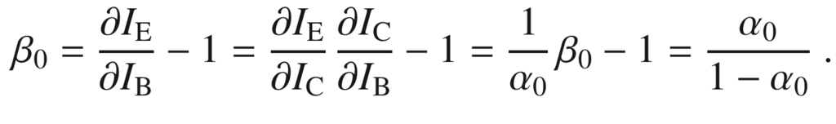

(24.15)

Since

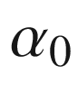

is close to 1 for a well-designed transistor,

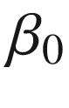

is a large number, e.g.

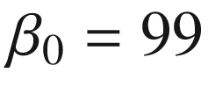

for

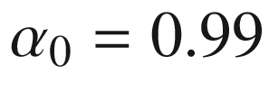

.

The emitter efficiency is (*A* denotes the device area)

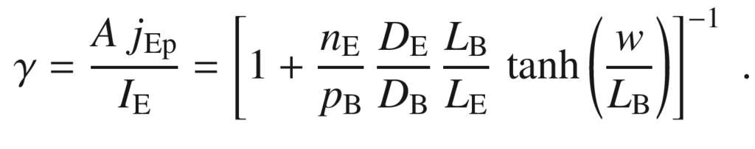

(24.16)

The base transport factor, i.e. the ratio of minority carriers reaching the collector and the total number of injected minority carriers, is (for reverse bias

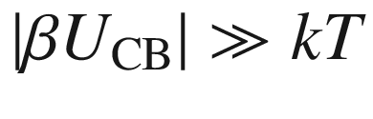

)

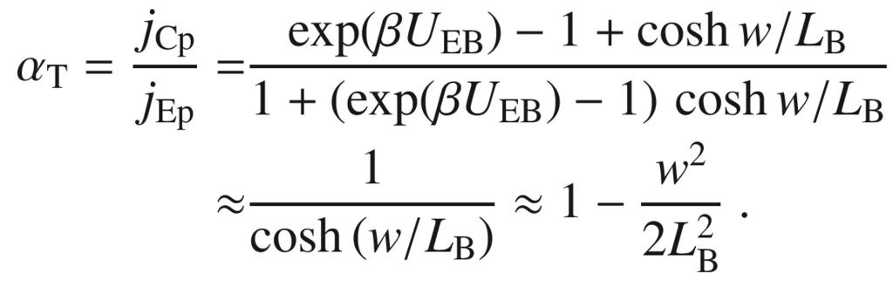

(24.17)

The first approximation is for

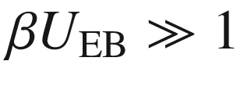

(emitter diode injecting in forward direction), the second approximation is for

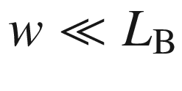

. If the base length is a tenth of the diffusion length, the base transport factor is

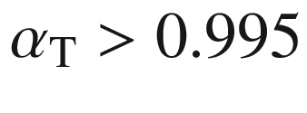

. *M* is also very close to 1; for reverse bias



and

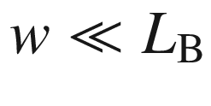

we find

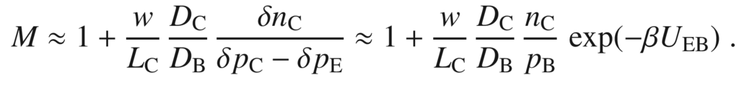

(24.18)

Thus for



,

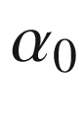

is dominated by

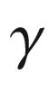

and given as (approximating ([24.16](#u116076_4_En_24_Chapter-Equ23)))

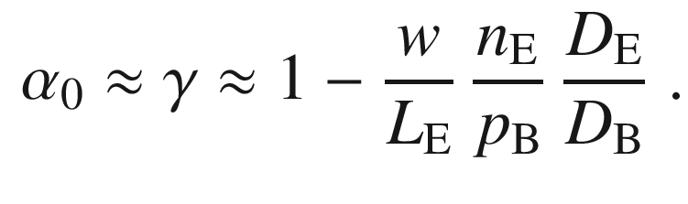

(24.19)

The gain



is then also determined by

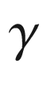

:

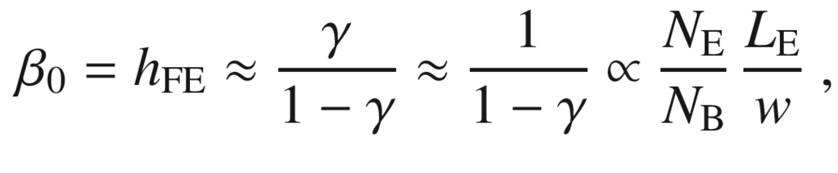

(24.20)

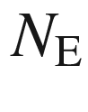

and

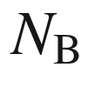

being the doping levels in the emitter and base, respectively. The base and collector current are shown in Fig. [24.6](#u116076_4_En_24_Chapter-Fig6) as a function of the emitter–base voltage, i.e. the voltage at the injection diode. The collector current is close to the emitter–base diode current and displays a dependence

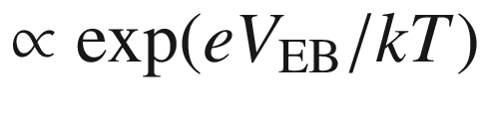

. The base current shows a similar slope but is orders of magnitude smaller in amplitude. For small forward voltages of the emitter–base diode, the current is typically dominated by a nonradiative recombination current that flows through the base contact and has an ideality factor (*m* in Fig. [24.6](#u116076_4_En_24_Chapter-Fig6)) close to 2.

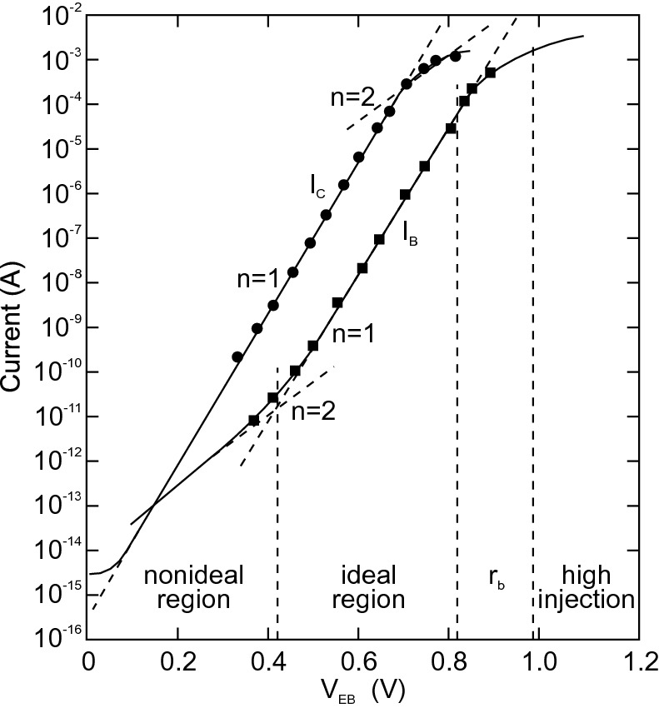

Fig. 24.6

Collector current

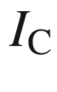

and base current

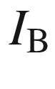

as a function of the emitter–base voltage

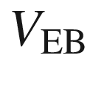

(Gummel plot).

Adapted from [2049]

#### 24.2.3 Ebers-Moll Model

The Ebers-Moll model (Fig. [24.7](#u116076_4_En_24_Chapter-Fig7)) was developed in 1954 and is a relatively simple transistor model that needs, at its simplest level (Fig. [24.7](#u116076_4_En_24_Chapter-Fig7)a) just three parameters. It can (and must) be refined (Figs. [24.7](#u116076_4_En_24_Chapter-Fig7)b,c). The model considers two ideal diodes (‘F’ (forward) and ‘R’ (reverse)) back to back, each feeding a current source. The F diode represents the emitter–base diode and and the R diode the collector–base diode. The currents are

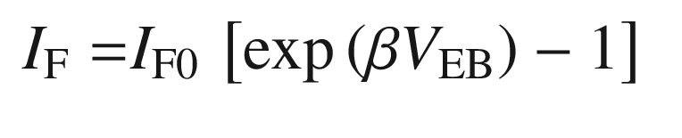

(24.21a)

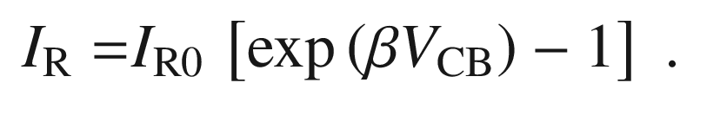

(24.21b)

Using ([24.8a](#u116076_4_En_24_Chapter-Equ13),b)–([24.11](#u116076_4_En_24_Chapter-Equ18)), the emitter and collector currents are

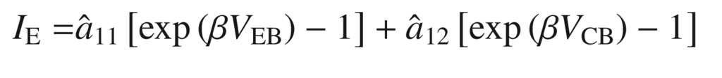

(24.22a)

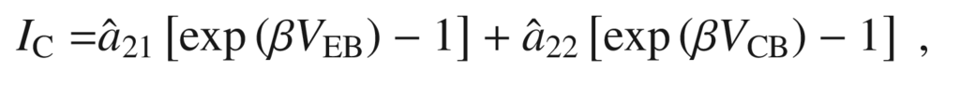

(24.22b)

with

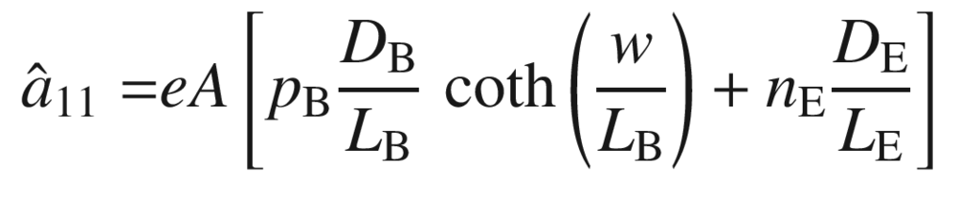

(24.23a)

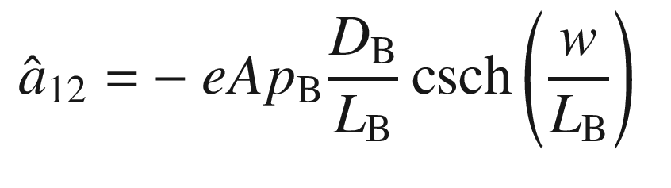

(24.23b)

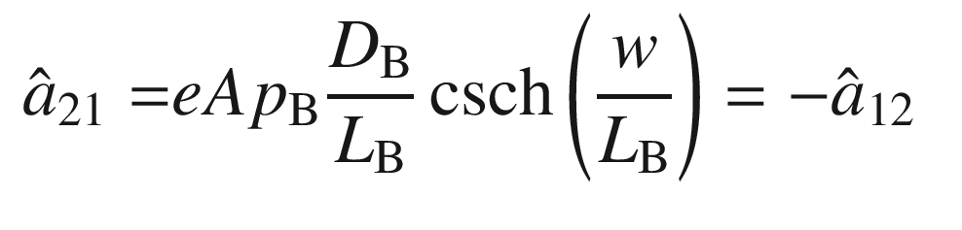

(24.23c)

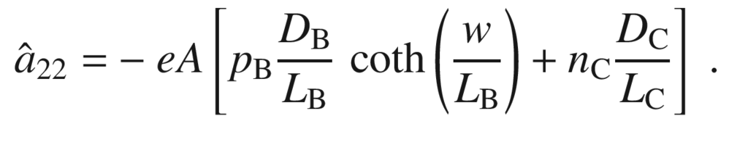

(24.23d)

The currents at the three contacts are

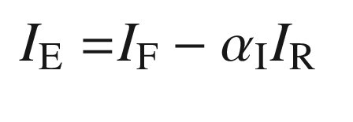

(24.24a)

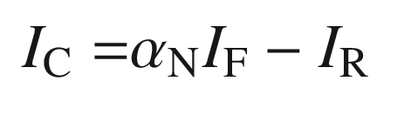

(24.24b)

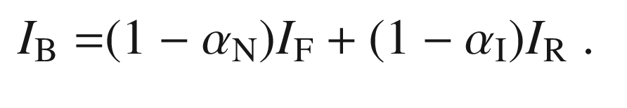

(24.24c)

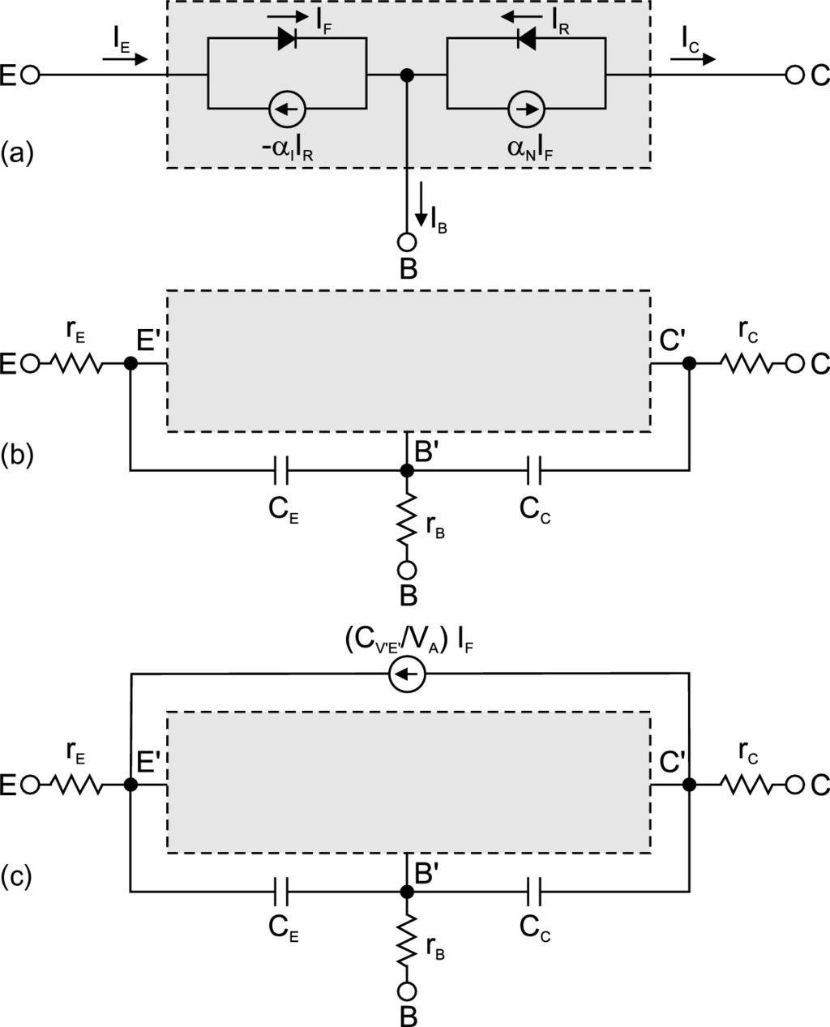

Fig. 24.7

Ebers-Moll model of a transistor, ‘E’: emitter, ‘C’: collector and ‘B’: base. Currents are shown for a pnp transistor. **a** Basic model (*grey area* in **b**, **c**), **b** model with series resistances and depletion-layer capacitances, **c** model additionally including the Early effect (

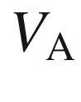

: Early voltage)

The last equation is obtained from ([24.24a](#u116076_4_En_24_Chapter-Equ36),b) using ([24.12](#u116076_4_En_24_Chapter-Equ19)). By comparison with ([24.21a](#u116076_4_En_24_Chapter-Equ28),b) and ([24.23a](#u116076_4_En_24_Chapter-Equ32)–d) we find

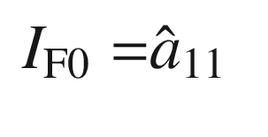

(24.25a)

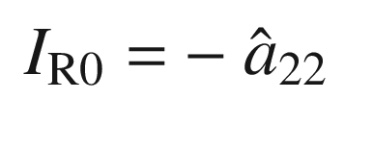

(24.25b)

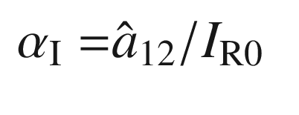

(24.25c)

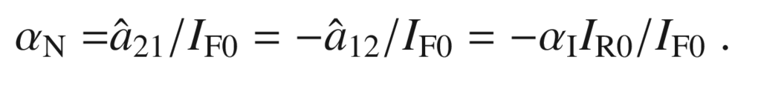

(24.25d)

The constants

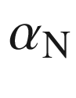

and

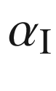

are the forward (‘normal’) (

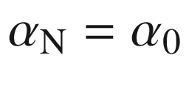

from ([24.13](#u116076_4_En_24_Chapter-Equ20))) and reverse (‘inverted’) gains in the common base circuit, respectively. Both constants are larger than zero. Typically,

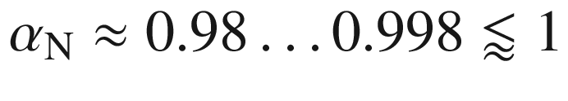

and

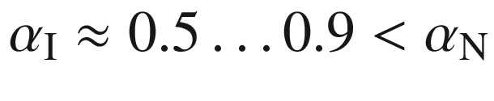

. The model has three independent parameters, e.g.

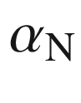

,

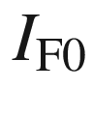

and

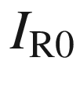

. Equations ([24.24a](#u116076_4_En_24_Chapter-Equ36),b) can be rewritten as

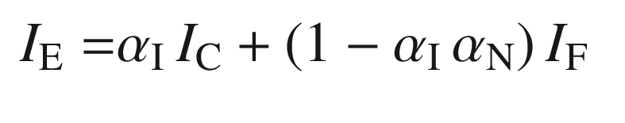

(24.26a)

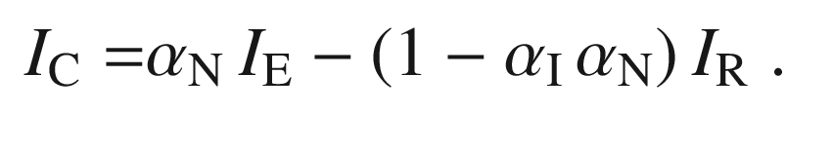

(24.26b)

Under normal operation we have

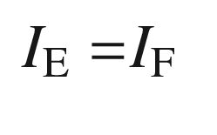

(24.27a)

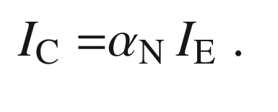

(24.27b)

The model can be refined and made more realistic by including the effect of series resistances and depletion-layer capacitances, increasing the number of parameters to eight. The Early effect (see next section) can be included by adding a further current source. This level is the ‘standard’ Ebers-Moll model with a total of nine parameters. Further parameters can be added. However, as is always the case with simulations, there is a tradeoff between the simplicity of the model and to what detail a real situation is approximated.

#### 24.2.4 Current–Voltage Characteristics

In Fig. [24.8](#u116076_4_En_24_Chapter-Fig8), the hole density in the base (of a pnp transistor) is shown for various voltage conditions. In Fig. [24.9](#u116076_4_En_24_Chapter-Fig9), the *I*–*V* characteristics of a bipolar transistor in common base and common collector circuit are shown. In the common base circuit (Fig. [24.9](#u116076_4_En_24_Chapter-Fig9)a), the collector current is practically equal to the emitter current and is almost independent of the collector–base voltage. From ([24.26b](#u116076_4_En_24_Chapter-Equ44)), the dependence of the collector current on the collector–base voltage is given (within the Ebers-Moll model) as

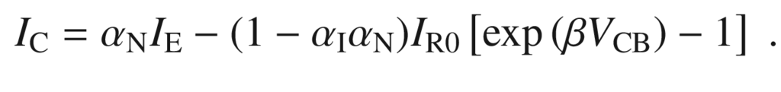

(24.28)

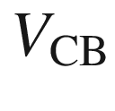

is in the reverse direction. Therefore, the second term is zero for normal operating conditions. Since

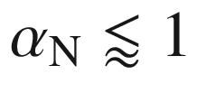

, the collector current is almost equal to the emitter current.

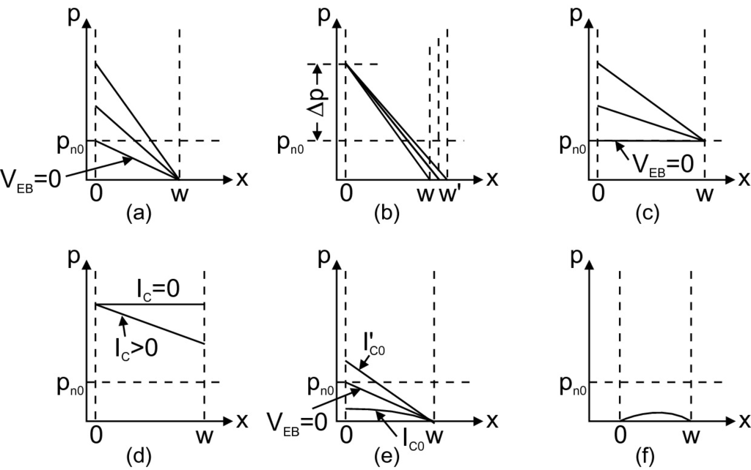

Fig. 24.8

Hole density (linear scale) in the base region (the neutral part of the base ranges from 0 to *w*) of a pnp transistor for various voltages. **a** normal voltages,

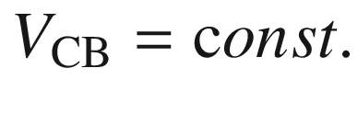

and various

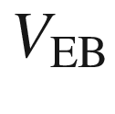

(in forward direction). **b**

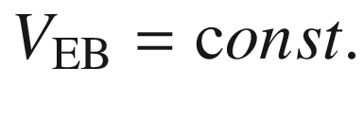

and various values of

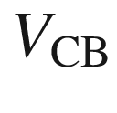

. **c** Various values of

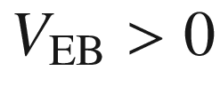

,

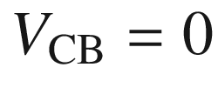

. **d** Both pn-junctions in forward direction. **e** Conditions for

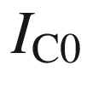

and

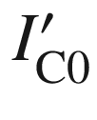

. **f** both junctions in reverse direction.

Adapted from [574]

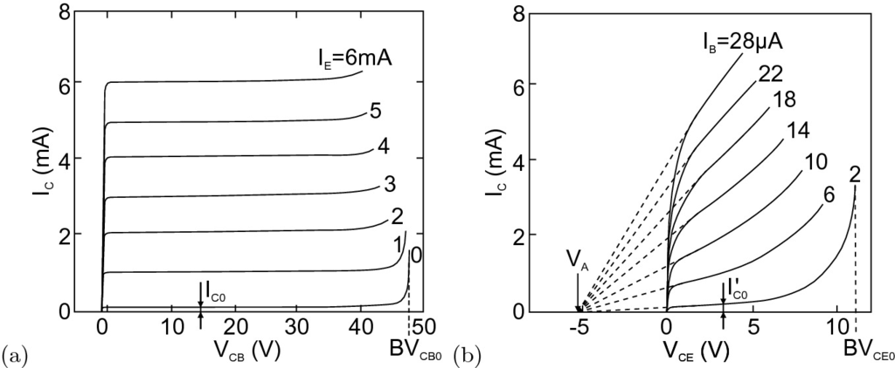

Fig. 24.9

Characteristics (

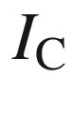

vs.



) of a pnp transistor in **a** common base (CB) circuit (Fig. [24.4](#u116076_4_En_24_Chapter-Fig4)a) for various values of the emitter current as labeled. Adapted from [2050]. **b** Characteristics in common emitter (CE) circuit (Fig. [24.4](#u116076_4_En_24_Chapter-Fig4)b).

Adapted from [2051]

Even at



(the case of (Fig. [24.8](#u116076_4_En_24_Chapter-Fig8)c), holes are extracted from the base since

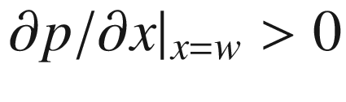

. A small forward voltage must be applied to the collector–base diode in order to make the current zero, i.e.

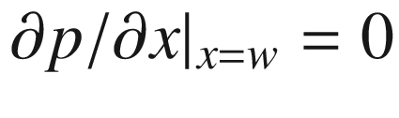

(Fig. [24.8](#u116076_4_En_24_Chapter-Fig8)d). The collector saturation current

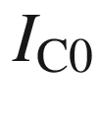

is measured with an open emitter side. This current is smaller than the saturation current of the CB diode, since at the emitter side of the basis a vanishing gradient of the hole density is present (Fig. [24.8](#u116076_4_En_24_Chapter-Fig8)e). This reduces the gradient (and thus the current) at the collector side. The current

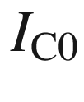

is therefore smaller than the collector current for shorted emitter–base contact (

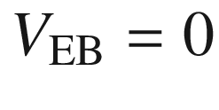

). At high collector voltage, the current increases rapidly at

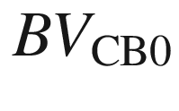

due to breakdown of the collector–base diode. It can also occur that the width of the neutral base region *w* becomes zero (punch-through). In this case, the emitter and collector are short-circuited.

In the common emitter circuit (Fig. [24.9](#u116076_4_En_24_Chapter-Fig9)b), there is a high current amplification

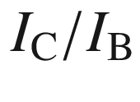

. Note that the collector current is given in mA and the base current in

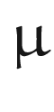

A. The current increases with increasing

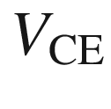

because the base width *w* decreases and

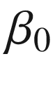

increases. There is no saturation of the *I*–*V* characteristics (Early effect [2052]). Instead, the *I*–*V* curves look as if they start at a negative collector–emitter voltage, the so-called Early voltage

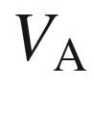

. In the linear regime, the characteristic can be approximated by

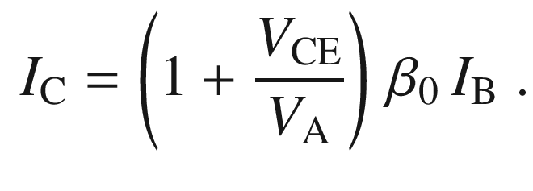

(24.29)

Here,



is the current gain for

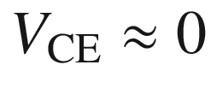

.

The physical reason for the increase of the collector current with increasing

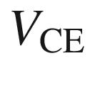

is the increasing reverse voltage at the collector–base diode that causes the so-called ‘base-width modulation’, as shown in Fig. [24.8](#u116076_4_En_24_Chapter-Fig8)b. The expansion of the CB depletion layer leads subsequently to a reduction of the neutral base width *w*. *w* will be smaller and smaller compared to the geometrical base width

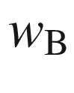

. When *w* is reduced, the common base gain

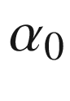

([24.19](#u116076_4_En_24_Chapter-Equ26)) becomes closer to 1 and the current gain increases. Therefore, the collector current increases with

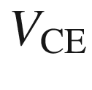

for a given (fixed) base current. The Early voltage is the coefficient of the increase of collector current with



,

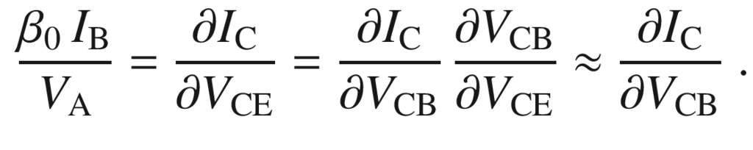

(24.30)

For constant base current, the emitter-base voltage is almost constant and the approximation in ([24.30](#u116076_4_En_24_Chapter-Equ49)) holds. The dependence of the CB depletion layer width on the base side

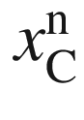

on



is given by ([21.​110a](The_Physics_of_Semiconductors00007.docx#u116076_4_En_21_Chapter)) for a pnp-transistor. Typical values for the Early voltage are 50–300 V. The modeling of the Early effect in the SPICE simulation program is discussed in [2053].

For small collector–emitter voltage, the current quickly drops to zero.



is typically split in such a way that the emitter–base diode is well biased forward and the CB diode has a high reverse voltage. If

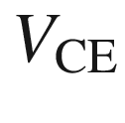

drops below a certain value (

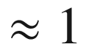

 V for silicon transistors), there is no longer any bias at the CB diode. A further reduction of



biases the CB diode in the forward direction and quickly brings the collector current down to zero.

#### 24.2.5 Basic Circuits

##### 24.2.5.1 Common Base Circuit

In the common base configuration, there is no current amplification since the currents flowing through emitter and base are almost the same. However, there is voltage gain since the collector current causes a large voltage drop across the load resistor.

##### 24.2.5.2 Common Emitter Circuit

The input resistance of the common emitter circuit (Fig. [24.10](#u116076_4_En_24_Chapter-Fig10)b) depends on the emitter–base diode and varies between a value of the order of 100 k

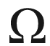

at small current and a few

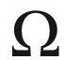

at larger current and high



. The voltage gain is

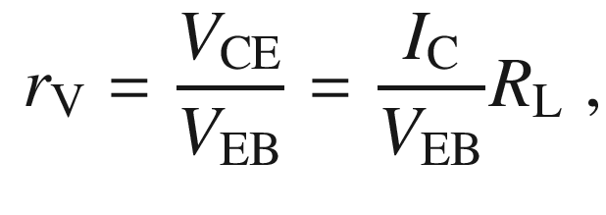

(24.31)

where

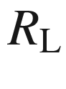

is the load resistance in the output circuit (see Fig. [24.4](#u116076_4_En_24_Chapter-Fig4)b). The ratio

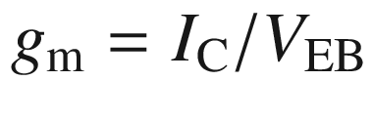

is called the forward transconductance. Also, the differential transconductance

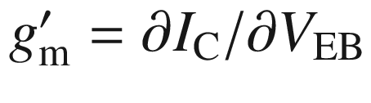

is used. The voltage gain of the common emitter circuit is typically 10

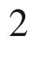

–10

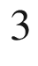

. Since current *and* voltage are amplified, this circuit has the highest power gain.

If the input voltage

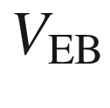

is increased, the collector current rises. This increase causes an increase of the voltage drop across the load resistance

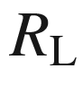

and a decrease of the output voltage



. Therefore, the phase of the input signal is reversed and the amplifier is inverting.

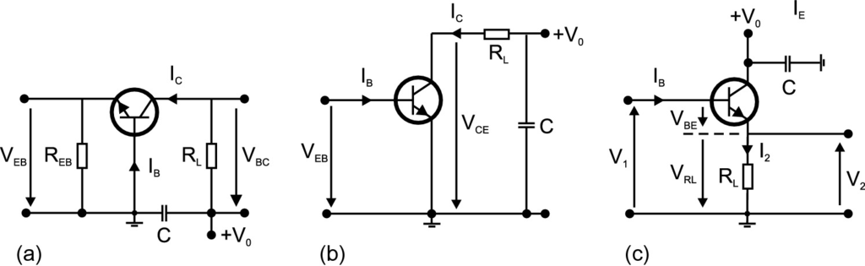

Fig. 24.10

**a** Common base, **b** common emitter and **c** common collector circuits with external loads

##### 24.2.5.3 Common Collector Circuit

In Fig. [24.10](#u116076_4_En_24_Chapter-Fig10)c, the collector is connected to mass for alternating currents. Input and output current flow through the load resistance at which part of the input voltage drops. The input voltage is divided between the load resistor

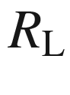

and the emitter–base diode. At the transistor, the voltage

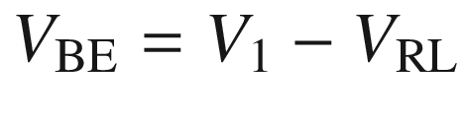

is applied. If the input voltage (

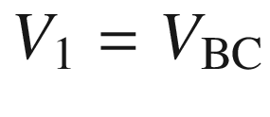

) is increased,

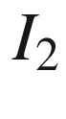

increases. This leads to a larger voltage drop at the load resistor and therefore to a decrease of

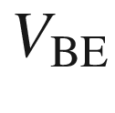

, working against the original increase. The input resistance

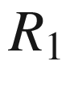

is large despite a small load resistance,

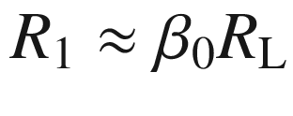

. The input voltage is larger than

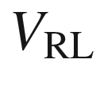

, thus no voltage gain occurs (actually it is a little smaller than 1). The current amplification is

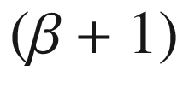

. The output resistance

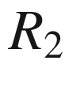

is small,

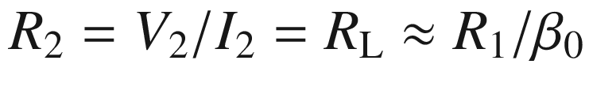

. Therefore, this circuit is also called an impedance amplifier that allows high-impedance sources to be connected low-impedance loads. Since an increase of the input voltage leads to an increase of the output voltage that is present at the emitter, this circuit is a direct amplifier and is also called an emitter follower.

#### 24.2.6 High-Frequency Properties

Transistors for amplification of high-frequency signals are typically chosen as npn transistors since electrons, the minority carriers in the base, have higher mobility than holes. The active area and parasitic capacitance must be minimized. The emitter is formed in the shape of a stripe, nowadays in the 100 nm regime. The base width is in the 10 nm range. High p-doping of GaAs with low diffusion of the dopant is accomplished with carbon. Defects that would short emitter and collector at such thin base width must be avoided.

An important figure of merit is the cutoff frequency

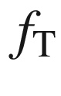

for which

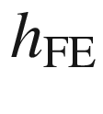

is unity in the common emitter configuration. The cutoff frequency is related to the emitter–collector delay time



 by

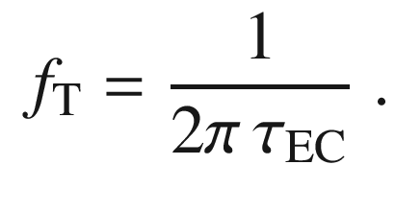

(24.32)

The delay time is determined by the charging time of the emitter–base depletion layer, the base capacitance, and the transport through the base–collector depletion layer. It is favorable if all times are short and similar. It does not help to minimize only one or two of the three processes since the longest time determines the transistor performance.

Another important figure of merit is the maximum frequency with which the transistor can oscillate in a feedback circuit with zero loss. This frequency is denoted by

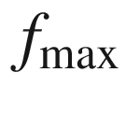

. Approximately,

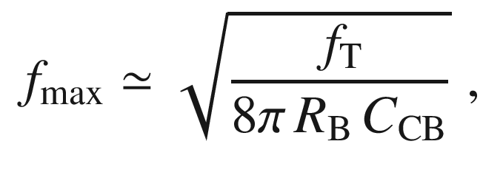

(24.33)

where

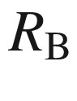

is the base resistance and

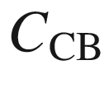

is the collector–base capacitance.

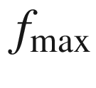

is larger than

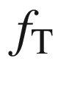

, by a factor of the order of three.

#### 24.2.7 Heterojunction Bipolar Transistors

In a heterojunction bipolar transistor (HBT), the emitter–base diode is formed with a heterostructure diode. The desired functionality is obtained when the emitter is made from the higher-bandgap material and the base from the lower-bandgap material. The schematic band diagram is shown in Fig. [24.11](#u116076_4_En_24_Chapter-Fig11) (see Fig. [21.​59](The_Physics_of_Semiconductors00008.docx#u116076_4_En_21_Chapter-Fig59)c for the emitter–base diode).

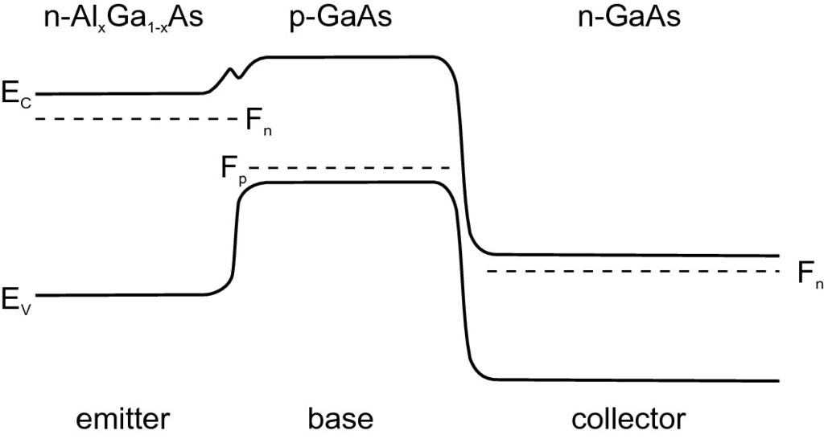

Fig. 24.11

Schematic band diagram of a heterojunction bipolar transistor

The higher discontinuity in the valence band, compared to a homojunction with the base material, provides a higher barrier for hole transport from the base to the emitter. Thus, the emitter efficiency is increased. Another advantage is the possibility for higher doping of the base without loss of emitter efficiency. This reduces the base series resistance and leads to better high-frequency behavior due to higher current gain and a smaller RC time constant. Also, operation at higher temperature is possible when the emitter has a larger band gap. Current InP/InGaAs-based HBTs have cutoff frequencies beyond 30 GHz, SiGe-HBTs beyond 80 GHz. The high-frequency performance is influenced by the velocity-overshoot effect (cf. Sect. [8.​4.​3](The_Physics_of_Semiconductors00004.docx#u116076_4_En_8_Chapter)) [2054].

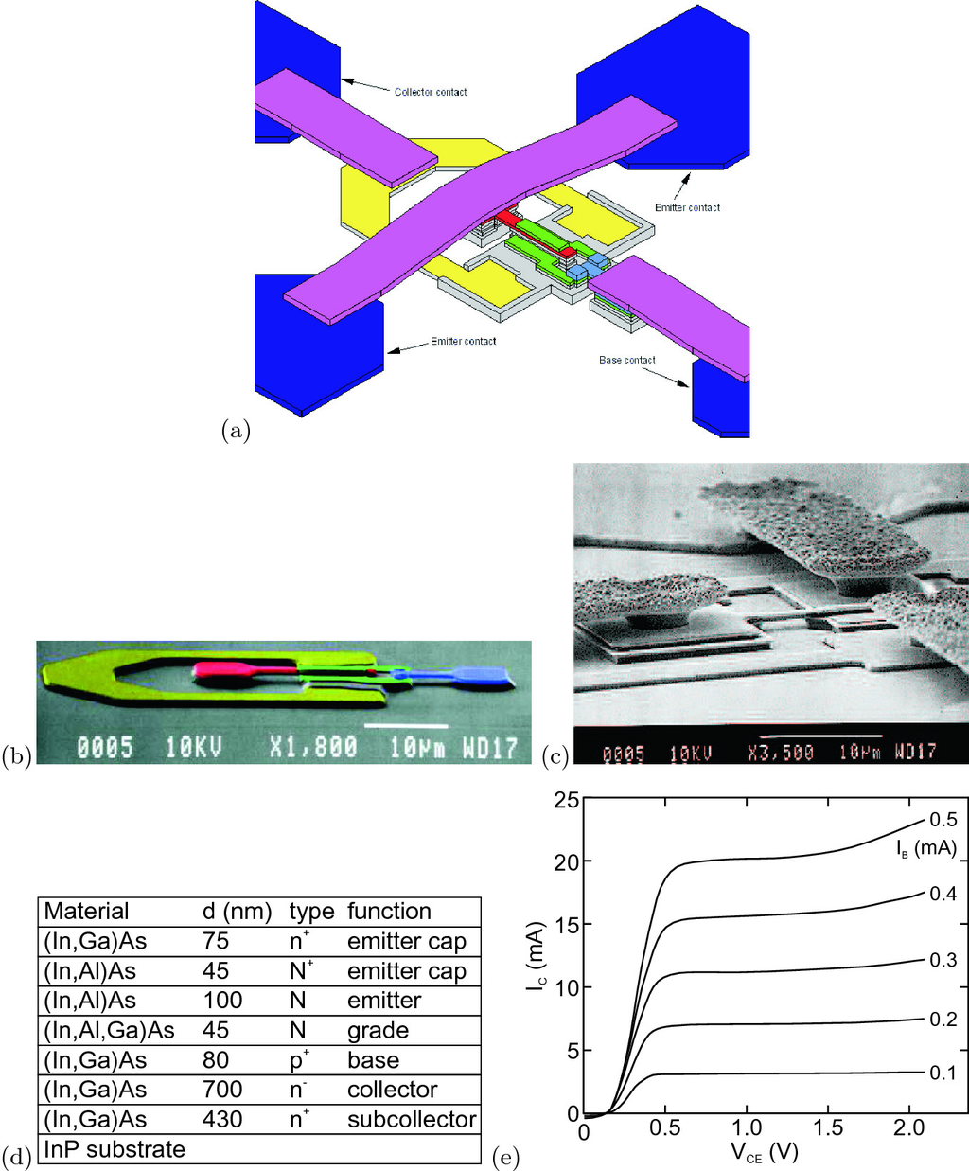

Fig. 24.12

**a** Schematic layout of a high-frequency HBT and SEM images **b** without and **c** with contacts. **d** Epitaxial layer sequence and **e** static performance data.

Parts **a**, **b** from [2055], parts **d**, **e** from [2056]

In Fig. [24.12](#u116076_4_En_24_Chapter-Fig12), an InAlAs/InGaAs HBT is shown [2056]. The cutoff frequency is 90 GHz. For the layer design, a fairly thick collector with low doping was chosen. This design allows a broad depletion layer with fairly small maximum electric field and thus a high breakdown voltage of

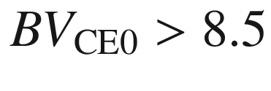

 V. The base is not too thin (80 instead of maybe 60 nm) to reduce the series resistance. A graded region between emitter and base was chosen to avoid a spike occurring in the conduction band (Fig. [21.​59](The_Physics_of_Semiconductors00008.docx#u116076_4_En_21_Chapter-Fig59)b) and keep the turn-on voltage low.

#### 24.2.8 Light-Emitting Transistors

The base current has two components. One is the recombination current in the neutral region of the emitter; this current can be suppressed in the HBT. The other is the recombination in the base region itself.[3](#u116076_4_En_24_Chapter-Fn3) If quantum wells are introduced into the base region, this recombination can occur radiatively between electrons and holes captured into the quantum well (Fig. [24.13](#u116076_4_En_24_Chapter-Fig13)). The spectrum exhibits two peaks from the QWs and the GaAs barrier.

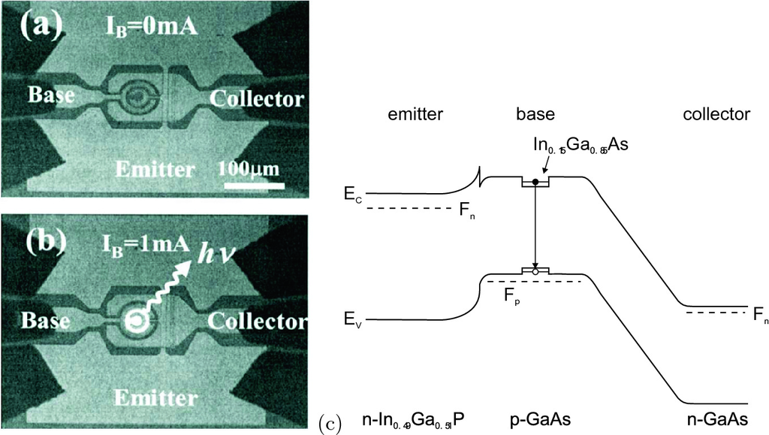

Fig. 24.13

Microscopic image of an InGaP/GaAs HBT with two 5-nm InGaAs/GaAs QWs in the 30-nm wide base at **a** zero base current and **b** at 1 mA base current in the common emitter configuration with Si CCD image of light emission. **c** Schematic band diagram of a HBT with a single InGaAs/GaAs quantum well in the base.

Parts **a**, **b** from [2057], part **c** adapted from [2057]

### 24.3 Field-Effect Transistors

Next to the bipolar transistors, the field-effect transistors (FET) are another large class of transistors. FETs were historically conceptualized first but due to technological difficulties with semiconductor surfaces, realized second. The principle is fairly simple: A current flows through a channel from source to drain. The current is varied via the channel conductivity upon the change of the gate voltage. The gate needs to make a nonohmic contact to the semiconductor. Since the conductivity in the channel is a property related to the majority charge carriers, FETs are called unipolar transistors. FETs feature a higher input impedance than bipolar transistors, a good linearity, and a negative temperature coefficient and thus a more homogeneous temperature distribution. According to the structure of the gate diode we distinguish JFETs, MESFETs and MOSFETs, as discussed in the following:

In the junction FET (JFET), the variation of channel conductivity is accomplished via the extension of the depletion layer of the pn-junction formed by the gate and the channel material (Fig. [24.14](#u116076_4_En_24_Chapter-Fig14)a). The JFET was analyzed by Schottky in 1952 [108] and realized by Dacey and Ross in 1953 [109]. The JFET can be made with a heterostructure gate to improve the frequency response.

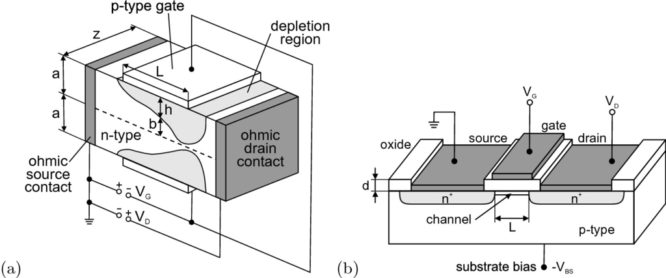

Fig. 24.14

**a** Shockley’s model of a JFET. The *dashed line* represents the middle of the symmetric channel of total thickness 2*a*. The *light grey area* is the depletion layer with thickness *h*. The gate length is *L*. The *dark grey* areas are ohmic metal contacts. Based on [109]. **b** Scheme of a MOSFET with channel length *L* and oxide thickness *d*. The *dark grey* areas are ohmic metal contacts.

Adapted from [574]

In a MESFET, a metal–semiconductor diode (Schottky diode) is used as rectifying contact instead of a pn-diode. Otherwise, the principle is the same as that of the JFET. After the proposal by Mead in 1966 [135], the first (epitaxial) GaAs MESFET was realized by Hooper and Lehrer in 1967 [138]. The MESFET offers some advantages, such as the fabrication of the metal gate at lower temperature than necessary for the (diffusion or epitaxy of the) pn-diode, lower resistance, good thermal contact.

In a MISFET, the gate diode is a metal–insulator–semiconductor diode (Fig. [24.14](#u116076_4_En_24_Chapter-Fig14)b). If the insulator is an oxide, the related FET is a MOSFET. When the gate is put at a positive voltage (for a p-channel), an inversion layer is formed close to the insulator–semiconductor interface. This layer is an n-conducting channel allowing conduction between the two oppositely biased pn-diodes. It can carry a high current. The MOSFET was theoretically envisioned early by Lilienfeld in 1925 [55] and realized only in 1960 by Kahng and Atalla [121].

FETs come in ‘n’ and ‘p’ flavors, depending on the conductivity type of the channel. For high-frequency applications, typically an n-channel is used due to the higher mobility or drift velocity. In CMOS (complementary MOS) technology, both n-FETs and p-FETs are integrated in high density, allowing the effective realization of logic gates with minimized power consumption.

### 24.4 JFET and MESFET

#### 24.4.1 General Principle

The principal characteristic of a JFET is shown in Fig. [24.15](#u116076_4_En_24_Chapter-Fig15). At

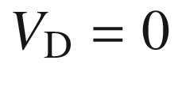

and

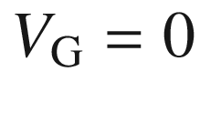

, the transistor is in thermodynamic equilibrium and there are no net currents. Underneath the gate diode, a depletion layer is present. If for zero gate voltage the source–drain voltage is applied to the channel, the current increases linearly. The positive voltage at the drain contact causes the expansion of the depletion layer of the (reversely biased) gate–drain pn-diode. When the two (the upper and the lower) depletion regions meet (pinch-off), the current saturates. The respective source–drain voltage is denoted as

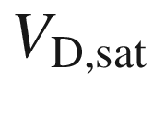

. For high gate–drain (reverse) voltage

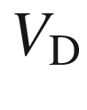

, breakdown occurs with a strong increase of the source–drain current. A variation of the gate voltage

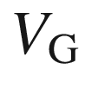

leads to a variation of the source–drain current. A reverse voltage leads to a reduction of the saturation current and saturation at lower source–drain voltage. For a certain gate voltage

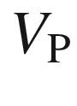

, the pinch-off voltage, no current can flow in the channel any longer since pinch-off exists even for

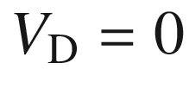

.

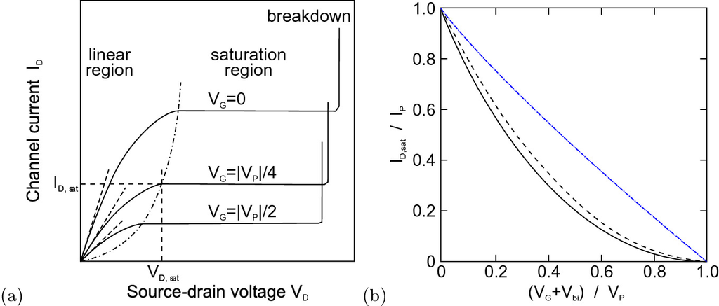

Fig. 24.15

**a** Principal characteristics of a JFET. The channel current

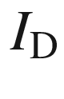

is shown as a function of the source–drain voltage



for three different values of the (absolute value of the) gate voltage

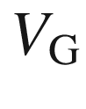

. The saturation values

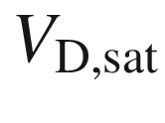

and

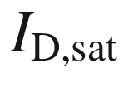

are indicated for one curve. The intersections with the *dash-dotted* line yield the saturation voltage. Adapted from [574]. **b** Transfer behavior of a JFET for two different carrier distributions, homogeneous (*solid* line) and

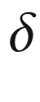

-like (*dashed* line). The *blue, dash-dotted* line is

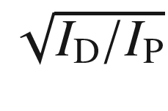

vs. the gate voltage. After [2058, 2059]

#### 24.4.2 Static Characteristics

Here, we will calculate the general static behavior outlined in the previous section. We assume a long channel (

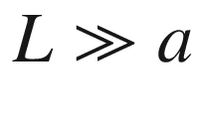

), the abrupt approximation for the depletion layer, the gradual channel approximation, i.e. the depletion layer depth changes slowly along *x*, and a field-independent, constant mobility. In this case, the two-dimensional Poisson equation for the potential distribution *V* can be used by solving it along the *y* direction (channel depth) for all *x*-positions (adiabatic approximation),

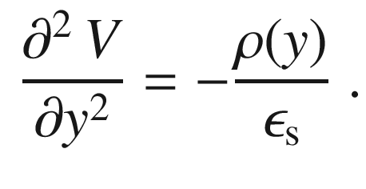

(24.34)

The geometry is shown in the inset of Fig. [24.15](#u116076_4_En_24_Chapter-Fig15)b.

The depth *h* of the depletion layer in the abrupt approximation is given by (cf. ([21.​111](The_Physics_of_Semiconductors00007.docx#u116076_4_En_21_Chapter)), reverse voltages are counted as positive here)

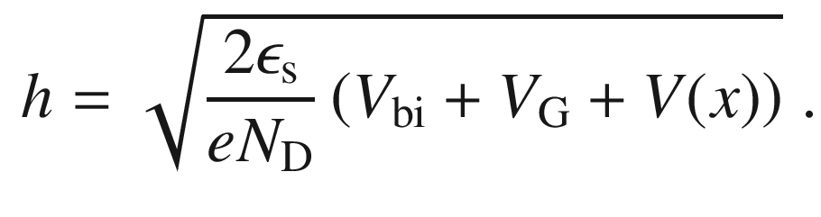

(24.35)

Here, we have assumed homogeneous doping, i.e.

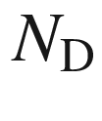

does not depend on *y* (or *x*). The built-in voltage (for a p

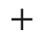

n gate diode) is given by

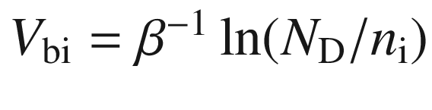

([21.​101a](The_Physics_of_Semiconductors00007.docx#u116076_4_En_21_Chapter)). The voltage *V* is the applied source–drain voltage in relation to the source. The depth of the depletion layer at

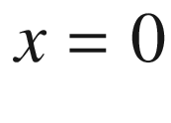

(source) and

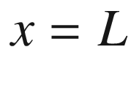

(drain) is given by

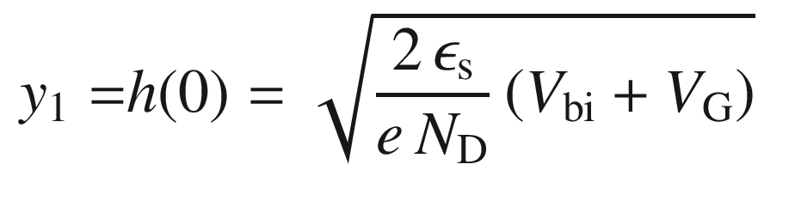

(24.36a)

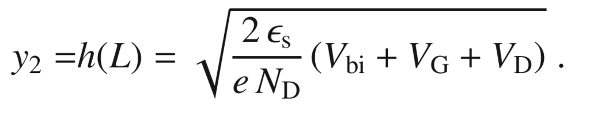

(24.36b)

The maximum value of *h* is *a*. Therefore, the pinch-off voltage

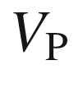

, at which

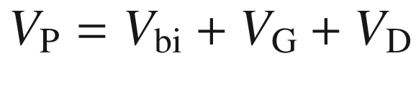

is such that

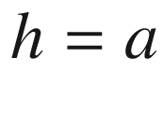

, is given by

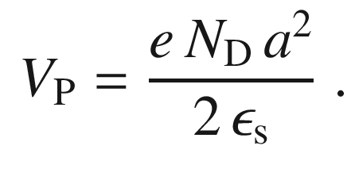

(24.37)

The (drift) current density along *x* is given by (cf. ([8.​54a](The_Physics_of_Semiconductors00004.docx#u116076_4_En_8_Chapter)))

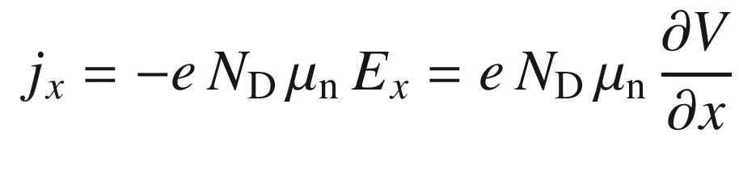

(24.38)

for the neutral part of the semiconductor. Therefore, the current in the upper half of the channel is given by

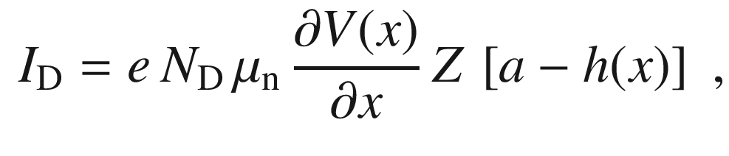

(24.39)

where *Z* is the width of the channel (Fig. [24.14](#u116076_4_En_24_Chapter-Fig14)a). Although it seems that

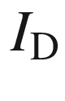

depends on *x*, it is of course constant along the channel due to Kirchhoff’s law.[4](#u116076_4_En_24_Chapter-Fn4) Using the triviality

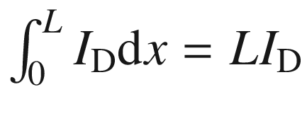

and

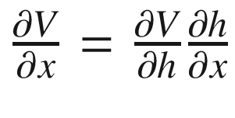

with

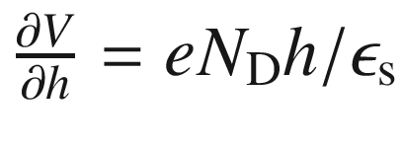

from ([24.35](#u116076_4_En_24_Chapter-Equ54)), we find from ([24.39](#u116076_4_En_24_Chapter-Equ59))

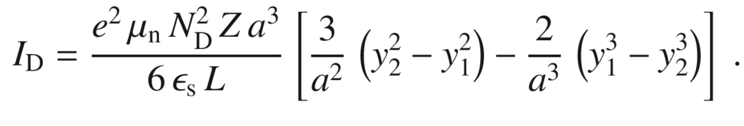

(24.40)

This equation can also be written, using ([24.37](#u116076_4_En_24_Chapter-Equ57)) and

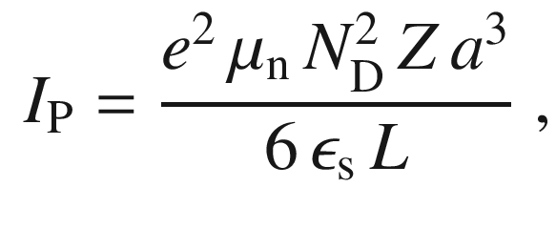

(24.41)

as

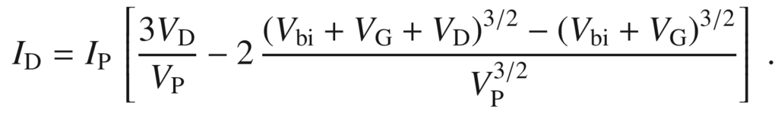

(24.42)

The saturation current is reached for

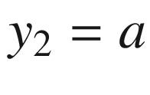

or

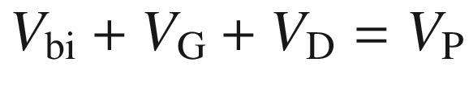

and is given by

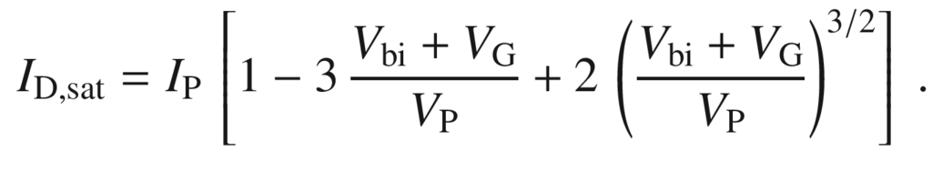

(24.43)

The dependence of the saturation current on

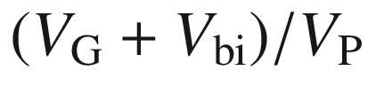

is depicted in Fig. [24.15](#u116076_4_En_24_Chapter-Fig15)b. For the threshold (gate) voltage of

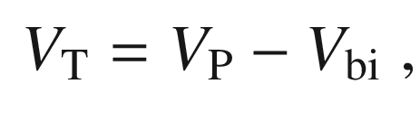

(24.44)

the saturation current is zero since then



.[5](#u116076_4_En_24_Chapter-Fn5) Around the threshold voltage, the drain saturation current is given in lowest order of

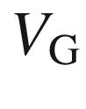

 as

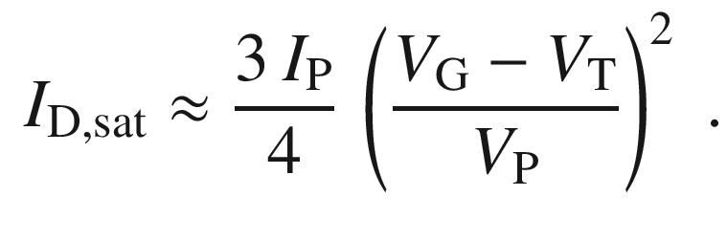

(24.45)

Thus, in order to experimentally determine the threshold voltage,

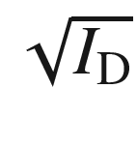

is plotted versus the gate voltage and extrapolated to

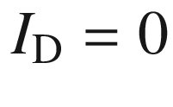

(dash-dotted line in Fig. [24.15](#u116076_4_En_24_Chapter-Fig15) and Fig. [24.16](#u116076_4_En_24_Chapter-Fig16)).

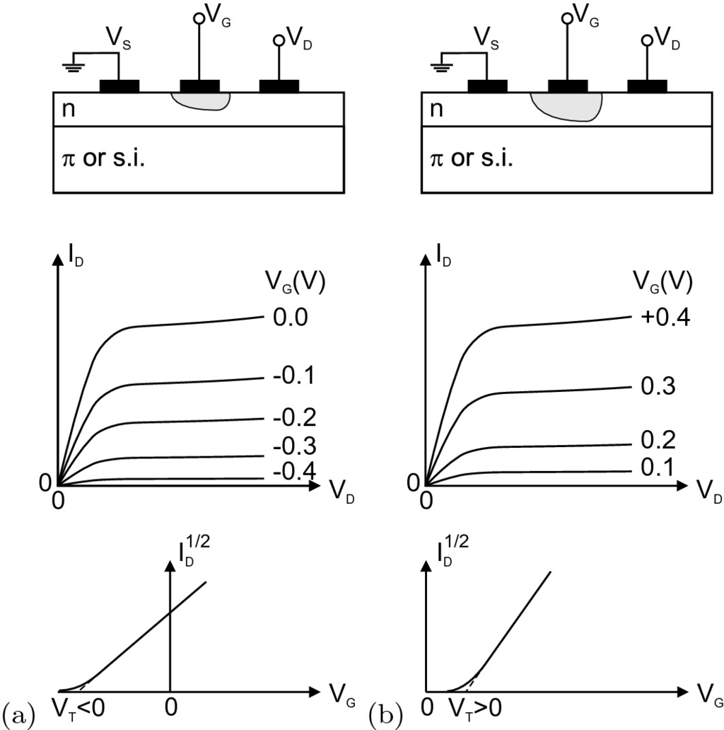

Fig. 24.16

Scheme (*top*),

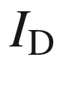

vs.

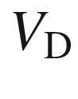

(*center*) and

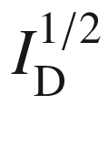

vs.

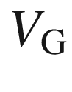

(*bottom*) *I*–*V* characteristics for **a** normally on (depletion) and **b** normally off (accumulation) n-type JFET.

Adapted from [574]

The source–drain voltage at the saturation point decreases with decreasing saturation current, shown as dashed parabola-like line in Fig. [24.15](#u116076_4_En_24_Chapter-Fig15)a.

If the charge-carrier distribution differs from the homogeneous distribution assumed so far, a change of transistor properties arises, as shown in Fig. [24.15](#u116076_4_En_24_Chapter-Fig15)b for a



-like carrier distribution. The *I*–*V* characteristic is slightly less curved, but not linear. A linear characteristic is only achievable in the drift velocity saturation regime (cf. Sect. [24.4.4](#u116076_4_En_24_Chapter-Sec19)).

For high source–drain voltage

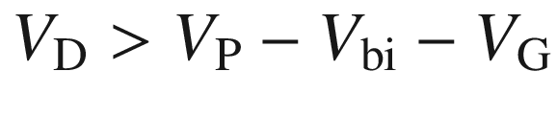

, the current remains essentially at its saturation value. For very high source–drain voltage, breakdown in the gate–drain diode can occur, when the maximum voltage, which is given by

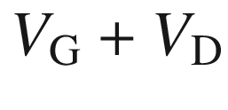

at the end of the channel, is equal to the breakdown voltage

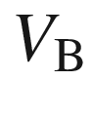

.

The forward transconductance

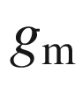

and the drain transconductance

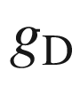

are given by

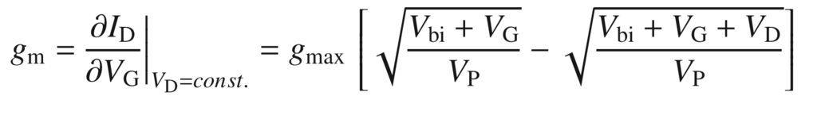

(24.46)

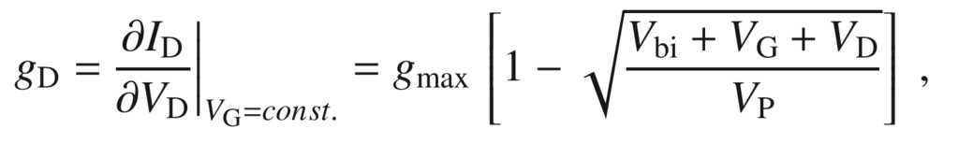

(24.47)

where

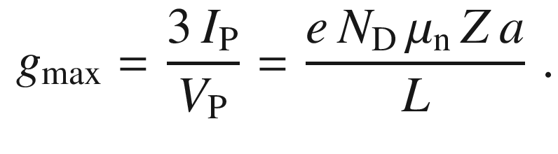

(24.48)

In more detail, the mobility used in ([24.45](#u116076_4_En_24_Chapter-Equ65)), ([24.46](#u116076_4_En_24_Chapter-Equ66)) and ([24.47](#u116076_4_En_24_Chapter-Equ67)) must be distinguished as saturation, field-effect and effective mobility (cmp. more details given for MOSFETs on p. xx).

The drain transconductance for

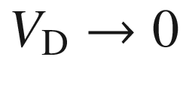

(linear regime, dashed straight lines in Fig. [24.15](#u116076_4_En_24_Chapter-Fig15)a) is given by

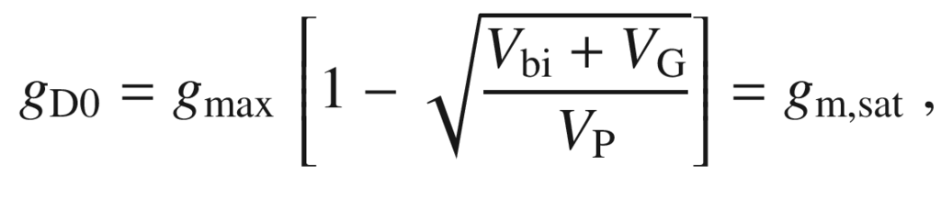

(24.49)

which is equal[6](#u116076_4_En_24_Chapter-Fn6) to the forward transconductance in the saturation regime

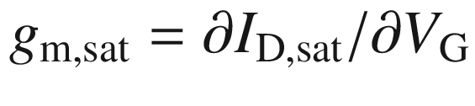

.

#### 24.4.3 Normally On and Normally Off FETs

The JFET discussed so far had an n-conductive channel and was conductive at



. It is termed an ‘n-type, normally on’ (or depletion) FET. If the channel is p-conductive, the FET is called ‘p-type’. A FET that has a nonconductive channel at

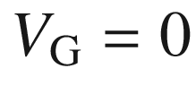

is called ‘normally off’ (or accumulation) FET. In this case, the built-in voltage must be large enough to cause pinch-off. For a positive gate voltage (in the forward direction of the gate–drain diode), current begins to flow. The *I*–*V* characteristics of the four FET-types are depicted in Fig. [24.16](#u116076_4_En_24_Chapter-Fig16). The circuit symbols for the four different FET types are shown in Fig. [24.17](#u116076_4_En_24_Chapter-Fig17).

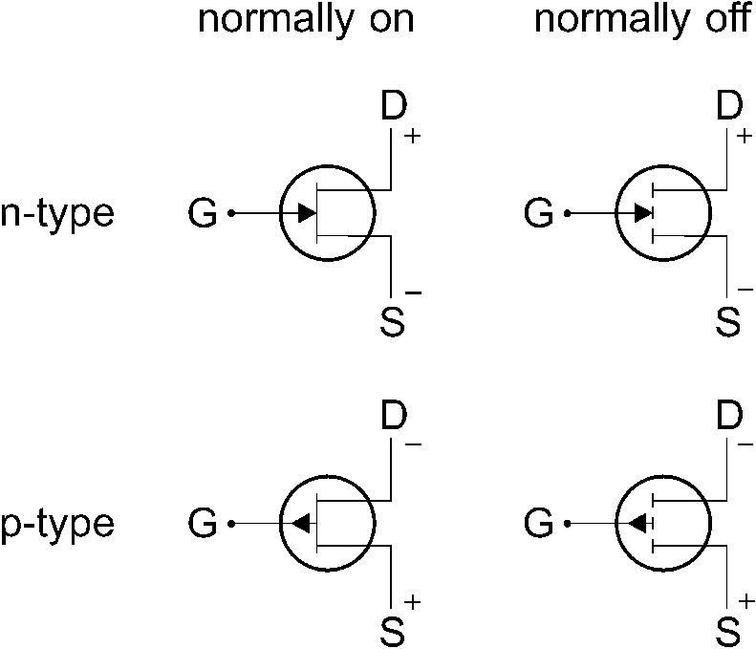

Fig. 24.17

Circuit symbols for various types of FETs

#### 24.4.4 Field-Dependent Mobility

So far, we have considered FETs with long channels (

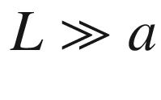

). This situation is often not the case, in particular for high-integration or high-frequency applications. For short channels, the *I*–*V* characteristics exhibit changes. The theory needs to be modified to take into account, among other effects, the electric-field dependence of the mobility (Fig. [8.​13](The_Physics_of_Semiconductors00004.docx#u116076_4_En_8_Chapter-Fig13)) that was discussed in Sect. [8.​4.​1](The_Physics_of_Semiconductors00004.docx#u116076_4_En_8_Chapter).

**Drift-Velocity Saturation**

A material without negative differential mobility, such as Si or Ge, can be described with a drift-velocity model

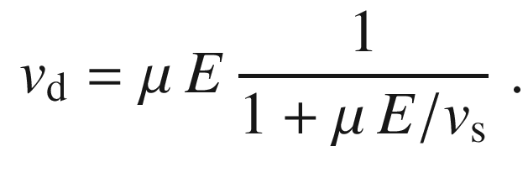

(24.50)

In this model,

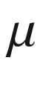

denotes the low-field (ohmic) mobility and

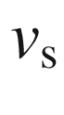

the drift-saturation velocity reached for

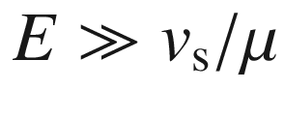

. The fraction in ([24.50](#u116076_4_En_24_Chapter-Equ70)) describes the drift-velocity saturation.

By inserting ([24.50](#u116076_4_En_24_Chapter-Equ70)) into ([24.39](#u116076_4_En_24_Chapter-Equ59)), we obtain (for a n-channel)

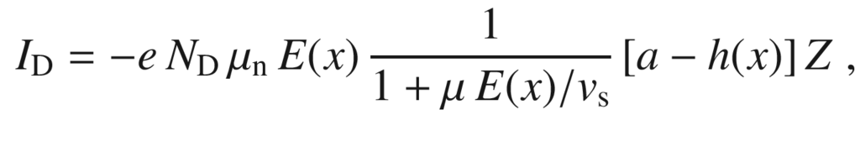

(24.51)

and after a short calculation the drain current is given by (cf. ([24.42](#u116076_4_En_24_Chapter-Equ62)))

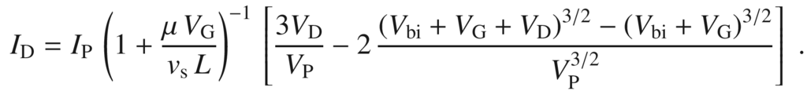

(24.52)

The factor

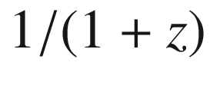

with

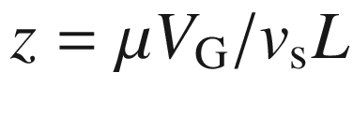

reduces the channel current due to the drift saturation effect. The effect of the parameter *z* is depicted in Fig. [24.18](#u116076_4_En_24_Chapter-Fig18) in comparison to

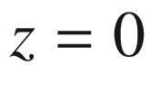

, i.e. without the drift saturation effect (or

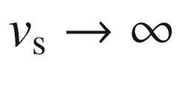

). The forward conductance

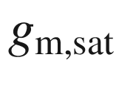

decreases with increasing *z*, as shown in Fig. [24.19](#u116076_4_En_24_Chapter-Fig19).

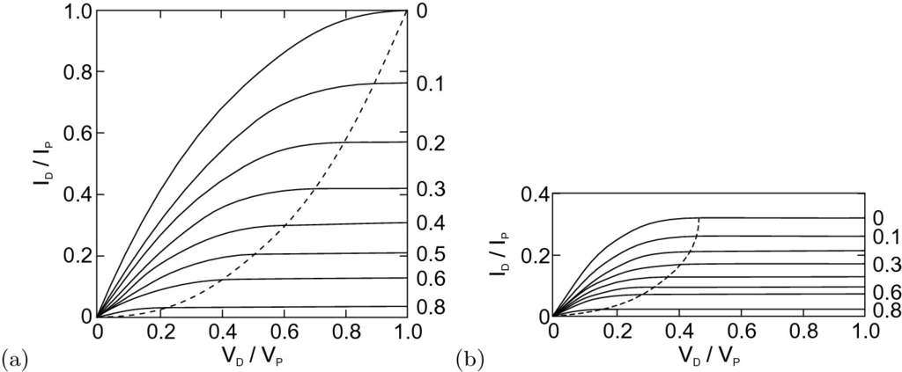

Fig. 24.18

*I*–*V* characteristic **a** without consideration of drift saturation (

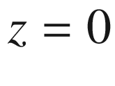

) and **b** with drift saturation (

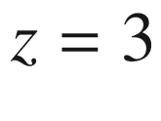

) for various values of

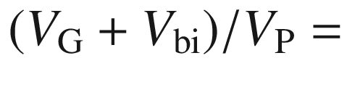

0, 0.1, 0.2, 0.3, 0.4, 0.5, 0.6, 0.8 as indicated at the right side. The intersections of the *dashed line* and the *solid lines* indicate the beginning of saturation.

Adapted from [2060]

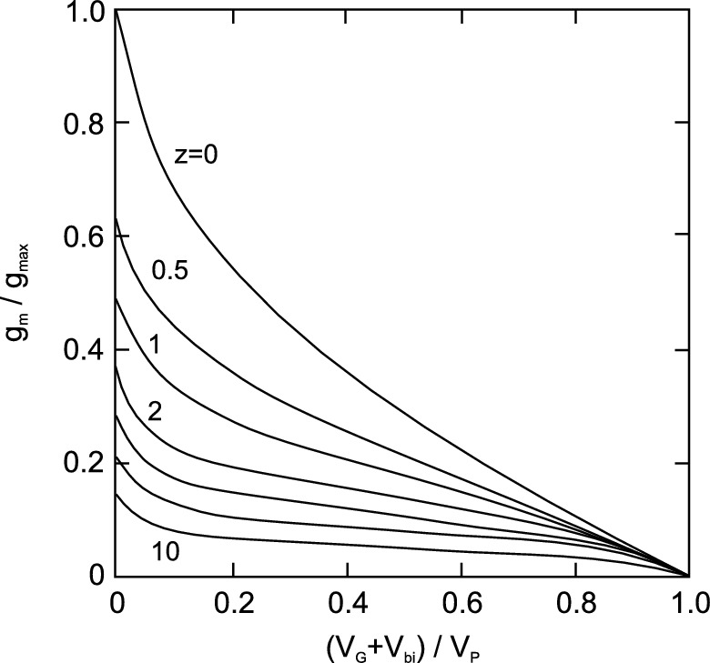

Fig. 24.19

Decrease of (saturated) forward conductance with gate voltage (according to ([24.49](#u116076_4_En_24_Chapter-Equ69))) and parametric dependence on *z* for



, 0.5, 1, 2, 3, 5 and 10.

Adapted from [2060]

**Two-Region Model**

In order to model the GaAs drift velocity vs. field characteristic, a two-region model is used. In the front region of the channel (region I), the field is small enough and a constant mobility

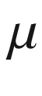

is used. In the back region of the channel (region II) is the high-field region where a constant drift velocity

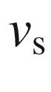

is used. With increasing source–drain voltage, the region II (I) increases (decreases) in length. The relative width of region II is also increased with decreasing channel length.

**Saturated-Drift Model**

Here, the drift velocity is taken everywhere as

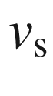

, i.e. complete drift saturation. This is a good approximation for short channels (high fields) that are in current saturation. In this case, the current is given by

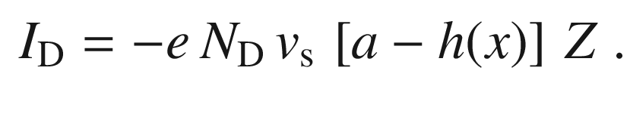

(24.53)

Equation ([24.53](#u116076_4_En_24_Chapter-Equ73)) is valid for homogeneous doping. For other doping profiles, the current is given by

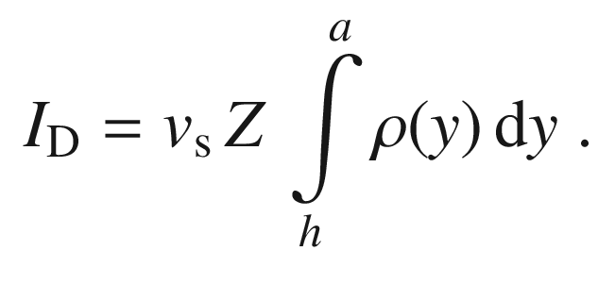

(24.54)

The forward conductance is given by

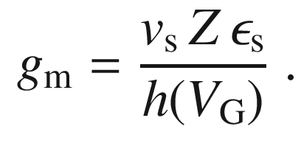

(24.55)

The transistor is more linear if the depletion-layer depth only weakly depends on the gate voltage. This can be accomplished with a doping profile with increasing doping with depth. An increase with a power law and a step-wise or exponential increase lead to a more linear *I*(*V*)-dependence. In the limit of

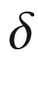

-like doping, a linear

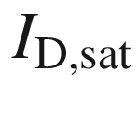

vs.



relation develops. Indeed, FETs with graded or stepped doping profiles exhibit improved linearity and are used for analog circuits.

**Nonequilibrium Velocity**

Below the electric field for which the drift velocity in GaAs peaks, the carriers can be considered to be in equilibrium. If the field is higher, velocity overshoot (Sect.  and Fig. [8.​16](The_Physics_of_Semiconductors00004.docx#u116076_4_En_8_Chapter-Fig16)) occurs. The carriers have a higher velocity (and ballistic transport) before they relax to the lower equilibrium (or steady-state) velocity after intervalley scattering. This effect will shorten the transit time in short-channel FETs.

#### 24.4.5 High-Frequency Properties

Two factors limit the high-frequency performance of a FET: The transit time and the RC time constant. The transit time

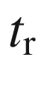

is the time that the carrier needs to go from source to drain. For the case of constant mobility (long channel) and constant drift velocity (short channel), the transit time is given by ([24.56a](#u116076_4_En_24_Chapter-Equ76) and b), respectively.

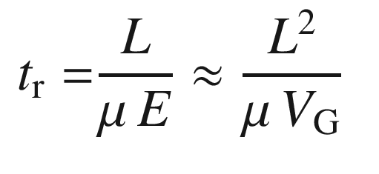

(24.56a)

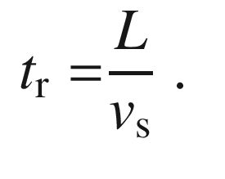

(24.56b)

For a 1-



m long gate in a GaAs FET, the transit time is of the order of 10 ps. This time is typically small compared to the RC time constant due to the capacitance

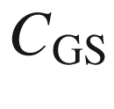

and transconductance. The cutoff frequency is given by

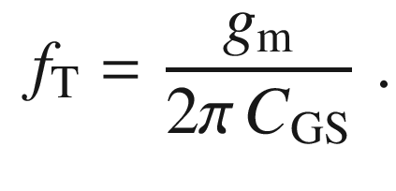

(24.57)

### 24.5 MOSFETs

The MOSFET has four terminals. In Fig. [24.14](#u116076_4_En_24_Chapter-Fig14)b, two n-type regions (source and drain) are within a p-type substrate. The n-type channel (length *L*) forms underneath a MIS diode. A forth electrode sets the substrate bias. The source electrode is considered to be at zero potential. The important parameters are the substrate doping

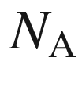

, the insulator thickness *d* and the depth

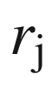

of the n-type regions. Around the MOSFET structure is an oxide to insulate the transistor from neighboring devices.

#### 24.5.1 Operation Principle

When there is no applied gate voltage, only the saturation current of the pn-diode(s) between source and drain flows. In thermodynamic equilibrium (Fig. [24.20](#u116076_4_En_24_Chapter-Fig20)c), the necessary surface potential for inversion at the MIS diode is

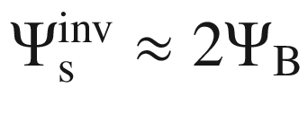

. If there is a finite drain voltage, a current flows and there is no longer equilibrium. In this case, the quasi-Fermi level  of the electrons (or generally of the minority carriers) is lowered and a higher gate voltage is needed to create inversion. The situation at the drain is depicted in Fig. [24.21](#u116076_4_En_24_Chapter-Fig21).

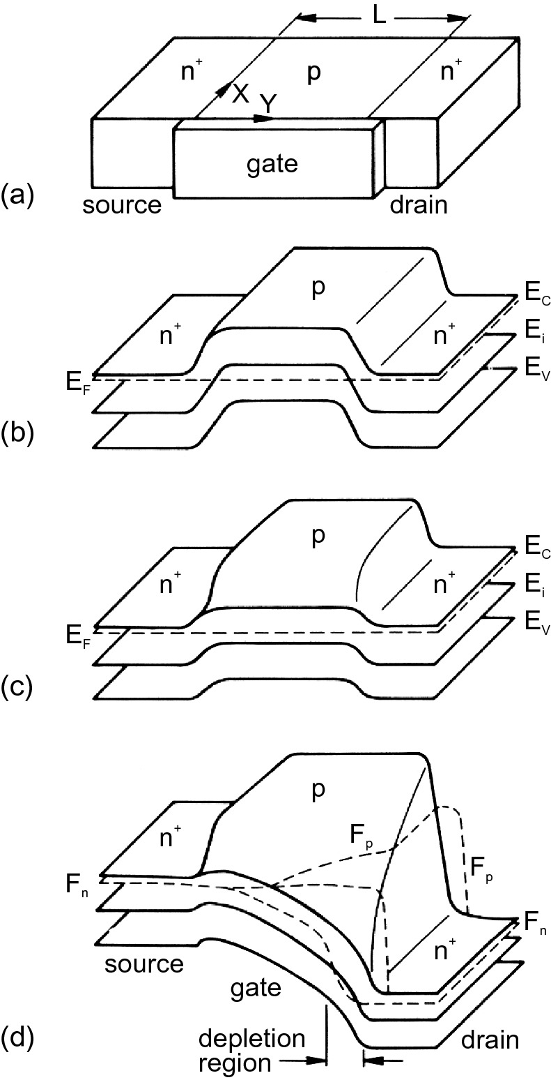

Fig. 24.20

**a** Schematic geometry of a MOSFET and its band diagram for **b** flat-band conditions for zero gate voltage (and



), **c** thermodynamic equilibrium with reverse gate voltage (weak inversion, still

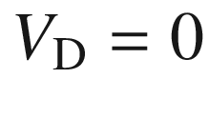

) and **d** nonequilibrium with nonzero drain voltage and gate voltages (with most of the channel being inverted, the depletion region is indicated).

Adapted from [2061]

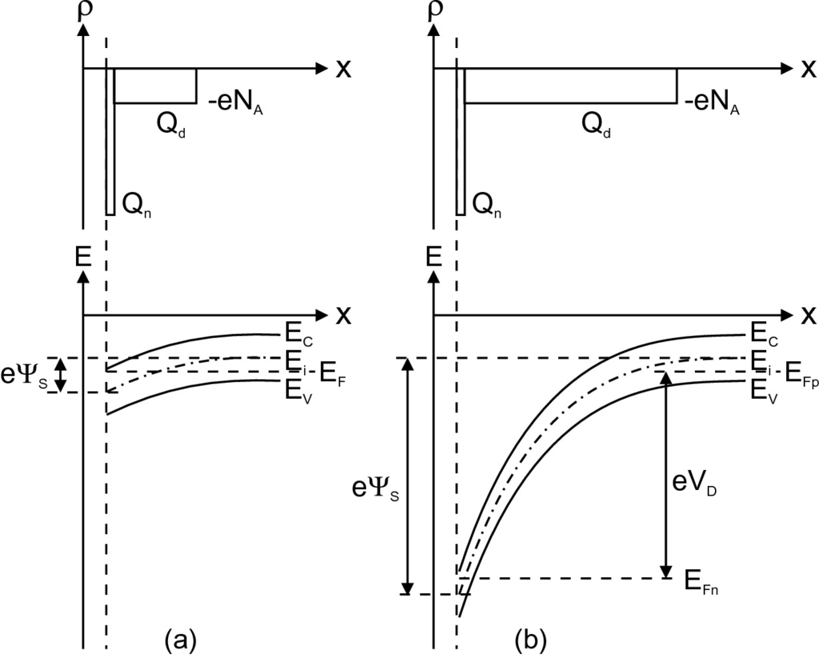

Fig. 24.21

Charge-carrier distribution (*top*) and band diagram (*bottom*) at the inverted p-region of a MOSFET for **a** thermodynamic equilibrium (

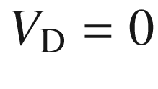

) and **b** nonequilibrium at drain

In nonequilibrium, the depletion layer width is a function of the drain voltage



. In order to reach strong inversion at the drain, the surface potential must be at least

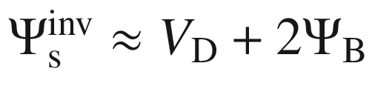

.

If the gate voltage is such that an inversion channel is present from source to drain, a current will flow for a small drain voltage (Fig. [24.22](#u116076_4_En_24_Chapter-Fig22)a). Initially, the current will increase linearly with

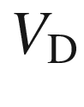

, depending on the conductivity of the channel. With increasing drain voltage, the quasi-Fermi level of the electrons is lowered until, finally at

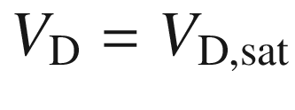

, the inversion channel depth becomes zero (pinch-off at the point denoted with an arrow in Fig. [24.22](#u116076_4_En_24_Chapter-Fig22)b). The current at this condition is denoted as

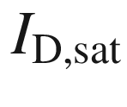

. For a further increase of

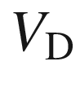

, the pinch-off point moves closer to the source contact and the channel length (inverted region) is shortened (arrow in Fig. [24.22](#u116076_4_En_24_Chapter-Fig22)c). The voltage at the pinch-off point remains

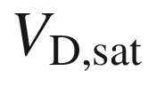

and thus the current in the channel remains constant at

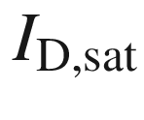

.

#### 24.5.2 Current–Voltage Characteristics

We assume now that the potential *V*(*y*) varies along the channel from

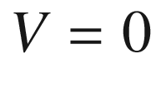

at

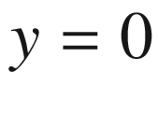

to

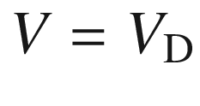

at

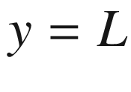

. In the gradual-channel approximation, the voltage drop

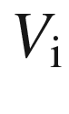

across the oxide is

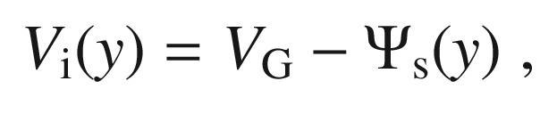

(24.58)

where

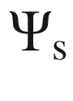

is the surface potential in the semiconductor (see Fig. [21.​34](The_Physics_of_Semiconductors00007.docx#u116076_4_En_21_Chapter-Fig34)). The total charge induced in the semiconductor (per unit area) is, using ([21.​92](The_Physics_of_Semiconductors00007.docx#u116076_4_En_21_Chapter)), given by

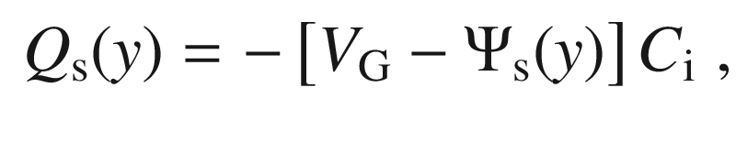

(24.59)

with

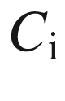

being the insulator capacitance (per unit area), as given in ([21.​93](The_Physics_of_Semiconductors00007.docx#u116076_4_En_21_Chapter)).

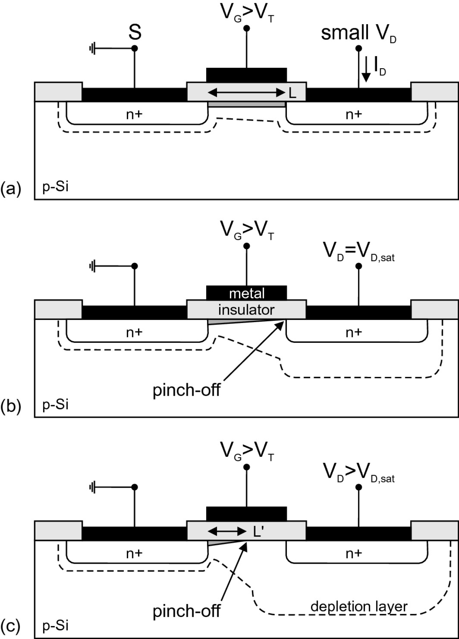

Fig. 24.22

**a** MOSFET with inverted channel (*dark grey*) of length *L* for small source–drain voltage

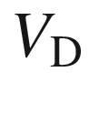

in linear regime, **b** at the start of saturation at pinch-off, **c** in the saturation regime with reduced channel length

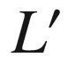

. The pinch-off point is denoted by an arrow in **b** and **c**. The *dashed lines* denote the extension of the depletion region.

Adapted from [574]

The inversion surface potential can be approximated by

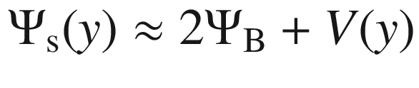

(see Fig. [24.21](#u116076_4_En_24_Chapter-Fig21)). With ([21.​97](The_Physics_of_Semiconductors00007.docx#u116076_4_En_21_Chapter)) the depletion-layer charge is

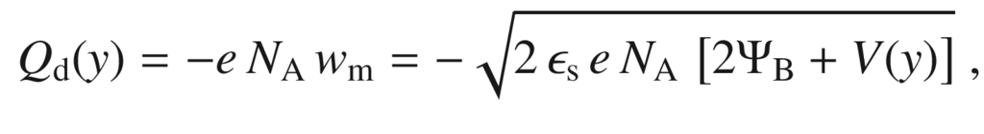

(24.60)

such that, using ([24.59](#u116076_4_En_24_Chapter-Equ80)), the inversion layer charge is

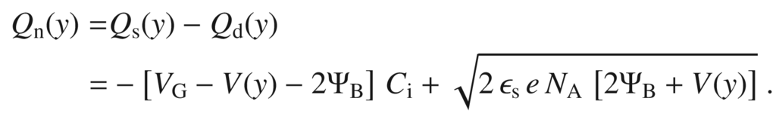

(24.61)

For the calculation of the drain current, we consider the increase of channel resistance

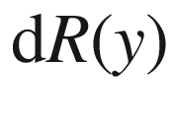

along a line element

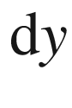

of the channel. The integral of the conductivity over the cross section *A* of the channel (width *Z*) is

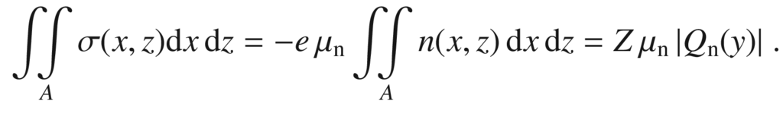

(24.62)

Therefore,

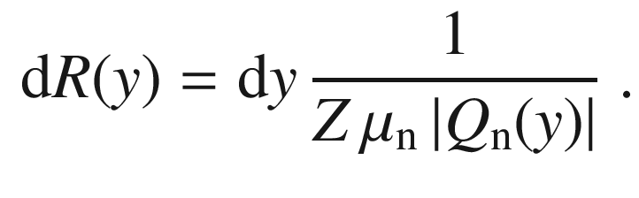

(24.63)

Here we have assumed that the mobility is constant along the channel, i.e. not field dependent. The change of voltage across the line element

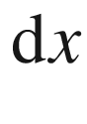

 is

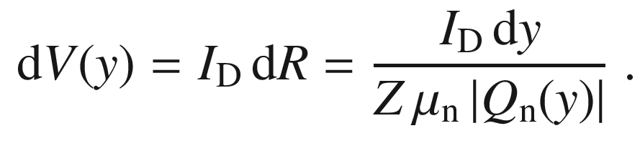

(24.64)

We note the drain current is independent of *x*. Using ([24.61](#u116076_4_En_24_Chapter-Equ82)) and performing the integral of ([24.64](#u116076_4_En_24_Chapter-Equ85)) from

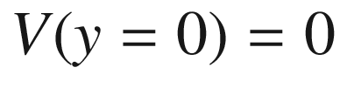

to

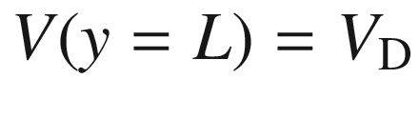

, we find

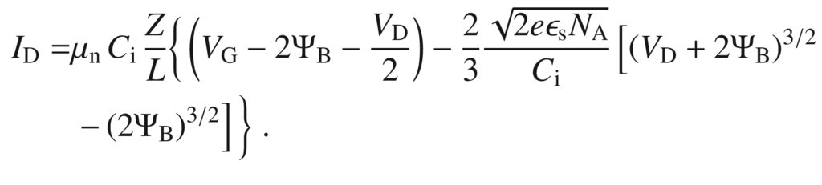

(24.65)

This characteristic is depicted in Fig. [24.23](#u116076_4_En_24_Chapter-Fig23)a. In the linear regime (small drain voltage,

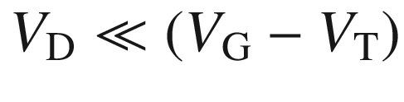

), the drain current is given by

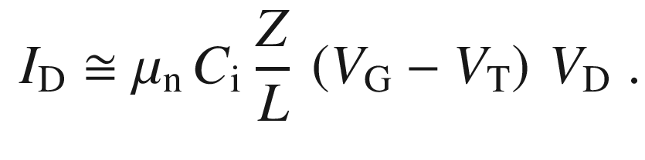

(24.66)

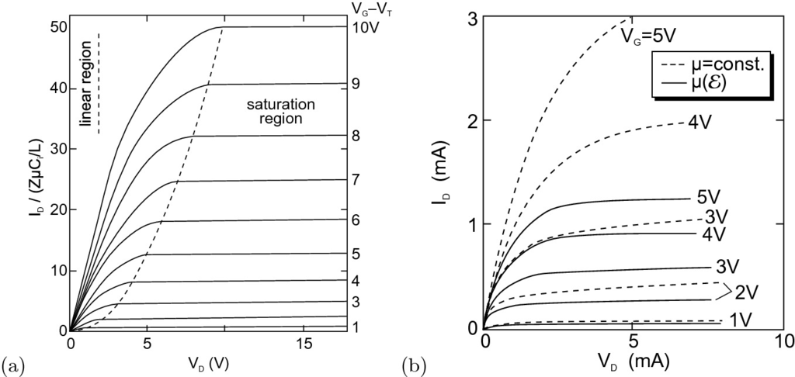

Fig. 24.23

**a** Idealized *I*–*V* characteristics for a MOSFET with constant mobility. The *dashed line* visualizes the drain (saturation) voltage for which the current is equal to

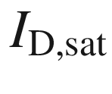

. The *solid lines* are for various values of the gate voltage

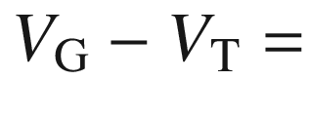

1–10 V. Adapted from [574] **b** *I*–*V* characteristics taking into account the effect of field-dependent mobility (*solid lines*) in comparison to the constant-mobility model (*dashed lines*) for various gate voltages as labeled.

Adapted from [2062]

The threshold voltage

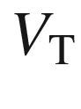

, i.e. the gate voltage for which the channel is opened and a current can flow, is given for small drain voltage (linear regime) by

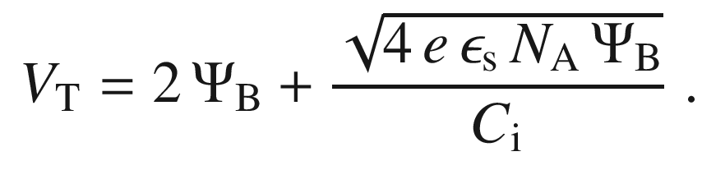

(24.67)

The transconductances in the linear regime are easily obtained as (cmp. ([24.46](#u116076_4_En_24_Chapter-Equ66)), ([24.47](#u116076_4_En_24_Chapter-Equ67)))

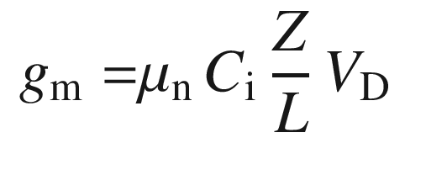

(24.68a)

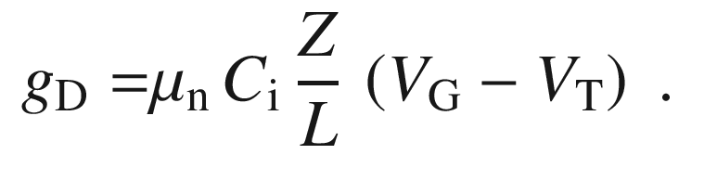

(24.68b)

The mobility extracted from evaluation of a characteristic using ([24.68b](#u116076_4_En_24_Chapter-Equ90)) is termed *effective* mobility (

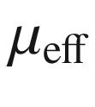

). The mobility extracted from ([24.68a](#u116076_4_En_24_Chapter-Equ89)) is termed *field effect* mobility (

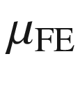

). The experimentally measured field effect mobility is typically smaller than the effective mobility. The difference between the effective and the field effect mobility is related to the gate voltage dependence of the effective mobility; in the linear regime,

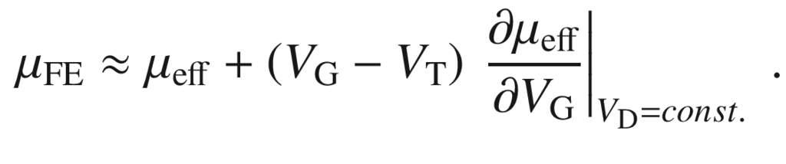

(24.69)

The saturation current is approximately

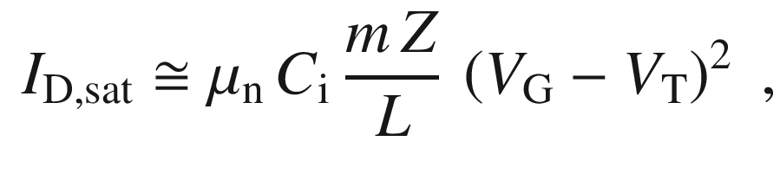

(24.70)

where *m* depends on the doping concentration and is about 0.5 for low doping. The mobility extracted from ([24.70](#u116076_4_En_24_Chapter-Equ92)) is termed *saturation* mobility (



). Due to the neglect of the gate voltage dependence in the definition for the saturation mobility, the experimental results usually yield

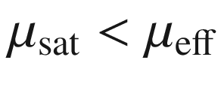

. For low p-doping of the substrate, the threshold voltage in ([24.70](#u116076_4_En_24_Chapter-Equ92)) for the saturation regime is also given by ([24.67](#u116076_4_En_24_Chapter-Equ88)). At higher doping, the threshold voltage becomes dependent on the gate voltage.

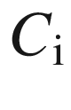

denotes the insulator capacitance

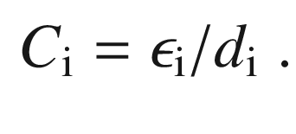

(24.71)

The forward transconductance in the saturation regime is

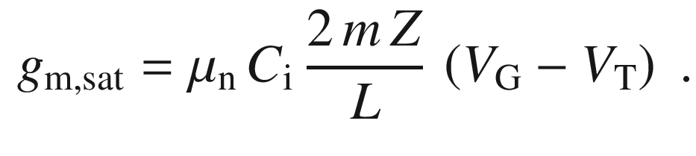

(24.72)

For constant drift velocity (Fig. [24.23](#u116076_4_En_24_Chapter-Fig23)b for field-dependent mobility), the saturation current is given by

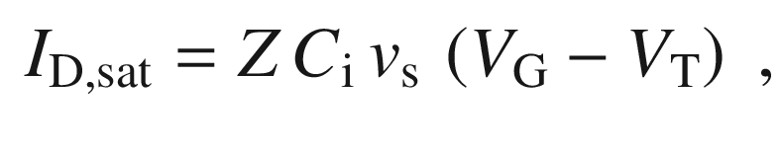

(24.73)

and the forward transconductance in the saturation regime is

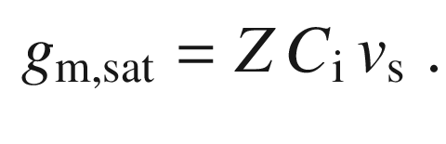

(24.74)

We note that the transistor properties depend on and can be separated into the geometry factor (*Z*/*L*) and the material properties (

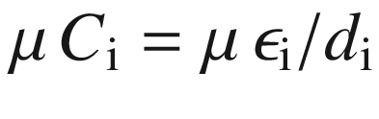

).

The threshold voltage can be changed by the substrate bias

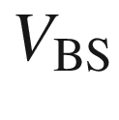

as (

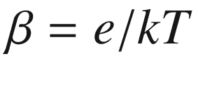

)

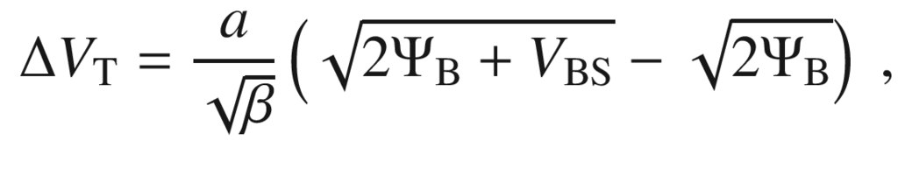

(24.75)

with (

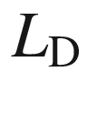

being the Debye length (cf. [21.​85b](The_Physics_of_Semiconductors00007.docx#u116076_4_En_21_Chapter)))

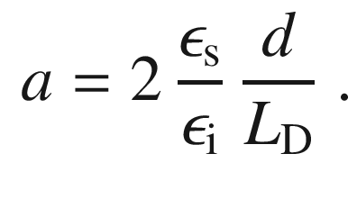

(24.76)

Experimental data are shown in Fig. [24.24](#u116076_4_En_24_Chapter-Fig24). For a Si/SiO



gate diode,

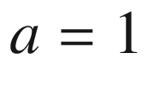

for, e.g.,

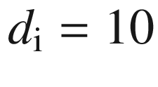

 nm and

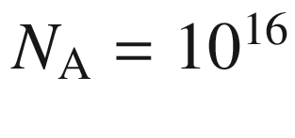

 cm

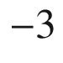

. For gate voltages below

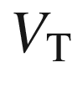

, the current is given by the diffusion current, similar to a npn transistor. This regime is important for low-voltage, low-power conditions. The related drain current is termed the *subthreshold* current and is given by

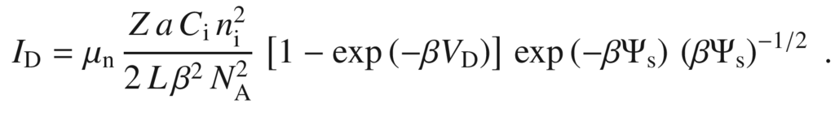

(24.77)

The drain current therefore increases exponentially with



, as shown in Fig. [24.24](#u116076_4_En_24_Chapter-Fig24).



is approximately linear proportional to

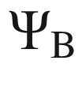

:

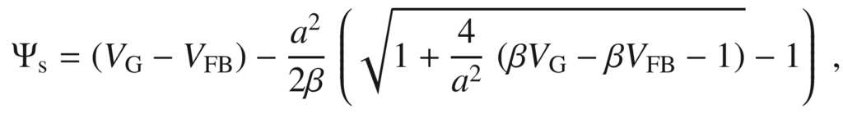

(24.78)

where

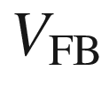

is the flat-band voltage of the gate MIS diode. The drain current is independent of

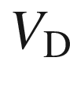

for

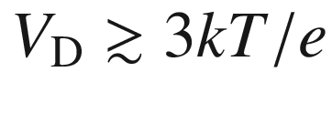

.

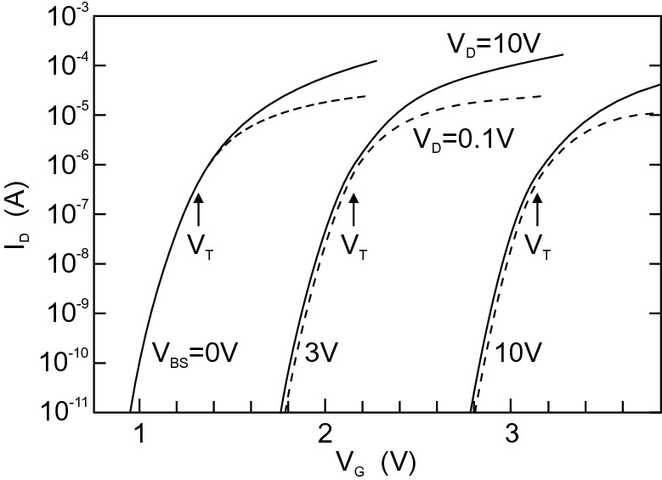

Fig. 24.24

Experimental subthreshold *I*–*V* characteristic of a MOSFET device with long channel (15.5

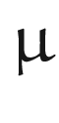

m). *Solid lines* for

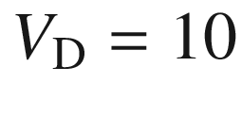

 V, *dashed lines* for

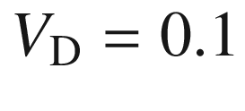

 V.

Adapted from [2063]

#### 24.5.3 MOSFET Types

MOSFETs can have an n-type channel (on a p-substrate) or a p-channel (on an n-type substrate). So far, we have discussed the normally off MOSFET. If there is a conductive channel even without a gate voltage, the MOSFET is normally on. Here, a negative gate voltage must be applied to close the channel. Therefore, similar to the JFET, a total of four different types of MOSFET exist, see Fig. [24.25](#u116076_4_En_24_Chapter-Fig25).

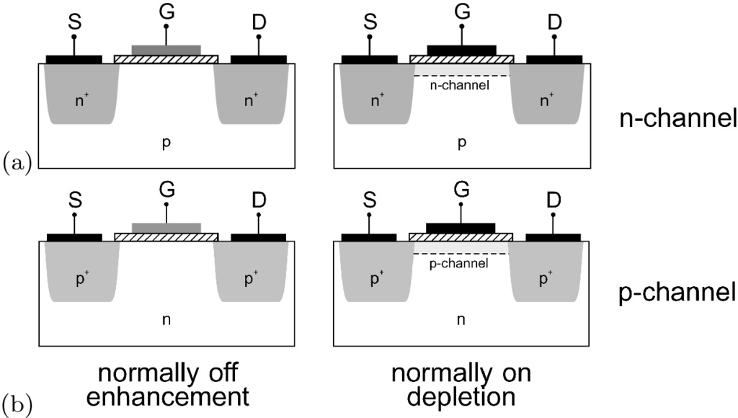

Fig. 24.25

The four MOSFET types. **a** Enhancement and **b** depletion type with n-channel (*top row*) and p-channel (*bottom row*)

#### 24.5.4 Complementary MOS

Complementary metal–oxide–semiconductor technology (CMOS) is the dominating technology for highly integrated circuits. In such devices, MOSFETs with n-channel (NMOS) and p-channel (PMOS) are used on the same chip. The basic structure of logic circuits, the inverter, can be realized with a pair of NMOS and PMOS transistors, as shown in Fig. [24.26](#u116076_4_En_24_Chapter-Fig26)a with two normally off transistors. The load capacitor represents the capacitance of the following elements.

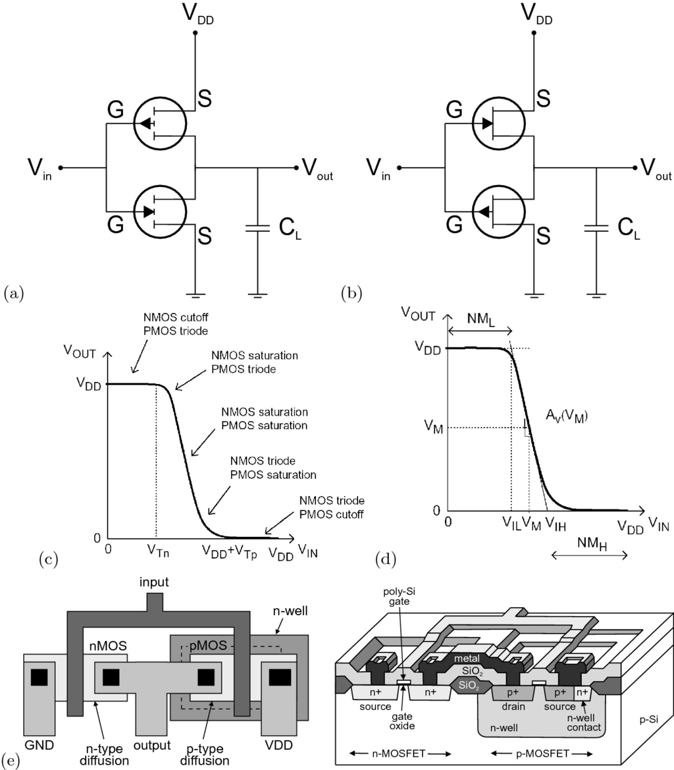

Fig. 24.26

Circuit diagram of **a** inverter with n-type (bottom) and p-type (normally off, enhancement mode) FETs and **b** inverter with p-type (bottom) and n-type (normally on, depletion mode) FETs. **c** Inverter characteristic with the transistor thresholds indicated, **d** inverter characteristic with middle voltage

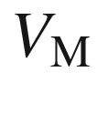

indicated. NM

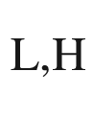

denotes the low- and high-noise margins, respectively, i.e. the voltage by which the input voltage can fluctuate without leading to switching. **e** Composite layout (*left panel*) and cross-sectional view (*right panel*) of CMOS inverter.

Part **e** adapted from [2064]

If the input voltage is

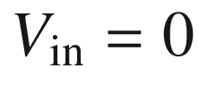

, the NMOS transistor is nonconductive (‘off’). The (positive) voltage

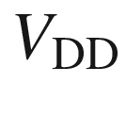

is at the PMOS transistor source, thus the gate is negative in relation to the source and the transistor is conductive (‘on’) since

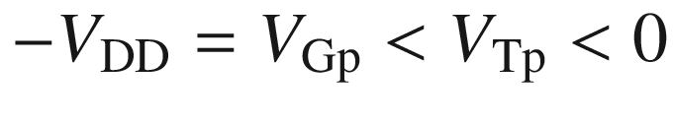

(see Fig. [24.25](#u116076_4_En_24_Chapter-Fig25)). The current flows through the capacitor that becomes charged to

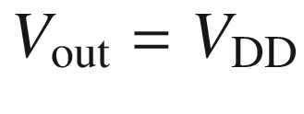

. The current then subsides, since



at the PMOS becomes zero. If the input voltage is set to

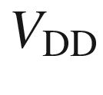

, the NMOS transistor has a positive gate–source voltage larger than the threshold

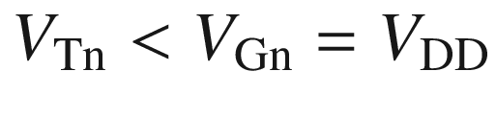

and becomes conductive. The charge from the capacitor flows over the NMOS to ground. The PMOS transistor has zero gate–source voltage and is in the ‘off’ state. In this case, the voltage

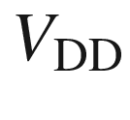

drops entirely across the PMOS and the capacitor is uncharged with

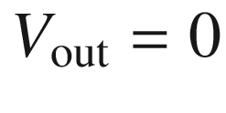

.

In both its logic states, the CMOS inverter does not consume power. No current[7](#u116076_4_En_24_Chapter-Fn7) flows in either of the two steady states since one of the two transistors is in both cases in the ‘off’ state. Current flows only during the switching operation. Therefore, the CMOS scheme allows for low power consumption.

The middle voltage for which

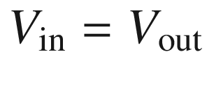

can be calculated from the MOSFET characteristics. Both are, for this condition, in saturation and the currents are given by (cf. ([24.70](#u116076_4_En_24_Chapter-Equ92)))

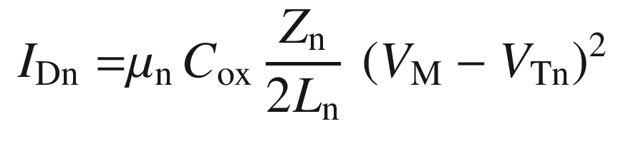

(24.79a)

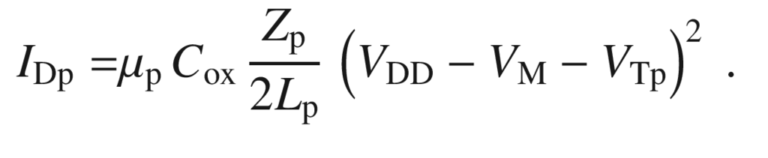

(24.79b)

With

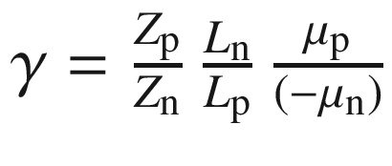

, we find from

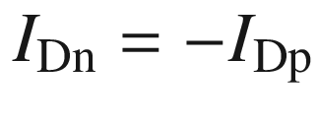

,

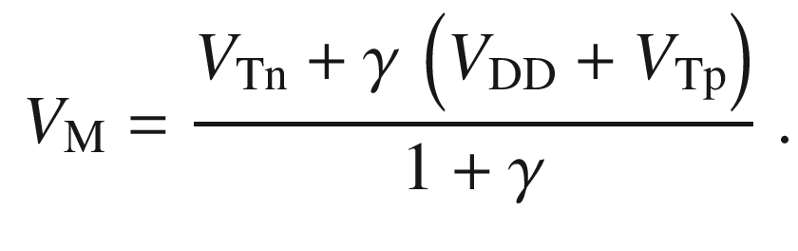

(24.80)

As gate material, often polycrystalline silicon (poly-Si) is used (cf. Fig. [21.​29](The_Physics_of_Semiconductors00007.docx#u116076_4_En_21_Chapter-Fig29)). It is used instead of metals because its work function matches that of silicon closely. Also, poly-Si is more resistant to temperature. Despite its high doping, the resistance of poly-Si is two orders of magnitude larger than that of metals. Since it is easily oxidized, it cannot be used with high-*k* oxide dielectrics.[8](#u116076_4_En_24_Chapter-Fn8)

For optimized ohmic contacts on the n- and p-Si, different metals are used to create a small barrier height (Fig. [21.​23](The_Physics_of_Semiconductors00007.docx#u116076_4_En_21_Chapter-Fig23)a) and low contact resistance (cf. Sect. [21.​2.​6](The_Physics_of_Semiconductors00007.docx#u116076_4_En_21_Chapter)). Figure [24.27](#u116076_4_En_24_Chapter-Fig27) visualizes the band edges of silicon in relation to the work functions of various metals (see Table [21.​2](The_Physics_of_Semiconductors00007.docx#u116076_4_En_21_Chapter-Tab2)). For example, the work function of titanium matches the electron affinity of n-Si closely. However, a direct deposition of Ti on Si results in a Schottky barrier of 0.5 eV [1690]. A surface passivation with a group-VI element such as Se can help reduce this value to 0.19 eV [2065].

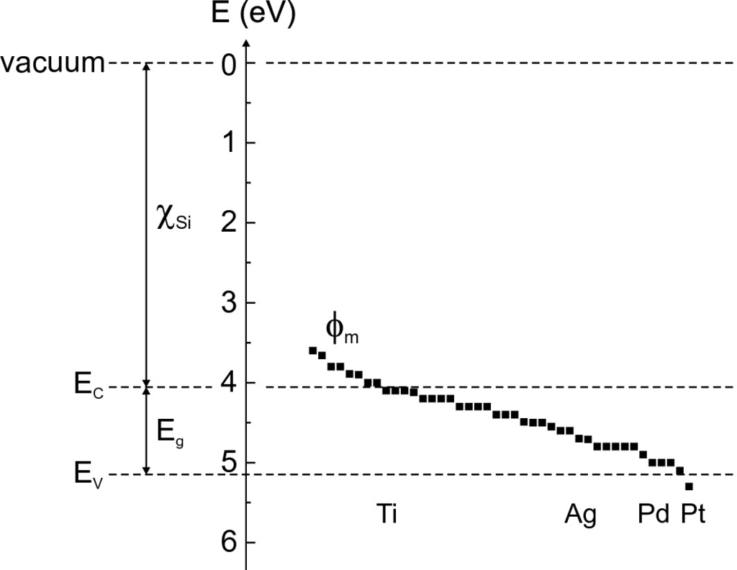

Fig. 24.27

Silicon band edges in relation to different metals and their work functions

In the latest generation of CMOS ICs the PMOS (NMOS) device has a built-in compressive (tensile) channel strain for modifying the effective mass (cf. Sect. [6.​12.​2](The_Physics_of_Semiconductors00003.docx#u116076_4_En_6_Chapter)), both allowing higher drive current due to higher mobility. A detailed treatment can be found in [2066].

#### 24.5.5 Large-Scale Integration

**Historic Development**

Compared to the first computers on the basis of vacuum tubes (triodes), e.g. ENIAC (Fig. [24.28](#u116076_4_En_24_Chapter-Fig28)), today’s devices are extremely miniaturized and need many orders of magnitude less power per operation. ENIAC needed 174 kW of power. A comparable computing power was reached in 1971 with the few cm

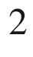

large Intel 4004 microprocessor (Fig. [24.29](#u116076_4_En_24_Chapter-Fig29)b) consuming only several Watts with 2300 transistors. In 2004 about 42 million transistors were integrated in the Pentium 4 microprocessor (Fig. [24.30](#u116076_4_En_24_Chapter-Fig30)). Also, memory chips started to become highly integrated (Fig. [24.29](#u116076_4_En_24_Chapter-Fig29)a).

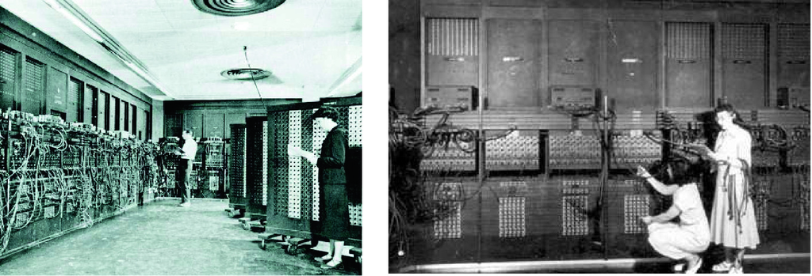

Fig. 24.28

ENIAC, the first electronic computer (J.P. Eckert, J.W. Mauchly, 1944/5). The images show only a small part of the 18 000 vacuum tubes

The development of electronic circuit integration is empirically described by Moore’s ‘law’ [2067] that has been valid since the 1970s. According to this law, the number of transistors doubles every 20 months (Fig. [24.31](#u116076_4_En_24_Chapter-Fig31)a). At the same time, the performance has been improved by an increase of the clock speed (Fig. [24.31](#u116076_4_En_24_Chapter-Fig31)b).[9](#u116076_4_En_24_Chapter-Fn9)

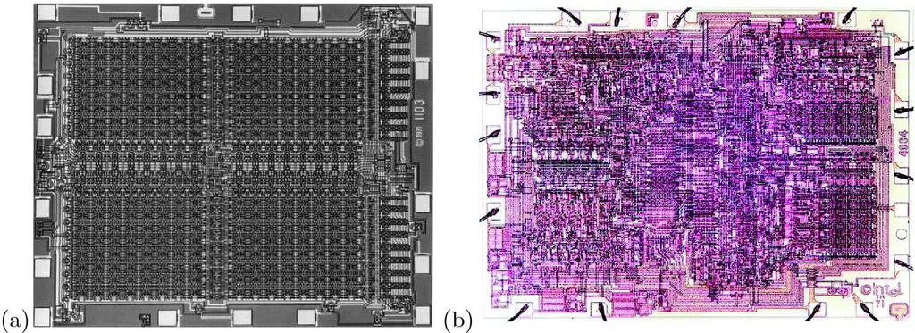

Fig. 24.29

**a** Intel

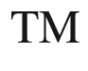

1103 1 KByte (1024 memory cells) dynamic random access memory (RAM), arranged in four grids with 32 rows and columns (1970), chip size: 2.9

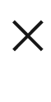

3.5 mm

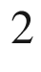

. **b** Intel

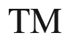

4004 microprocessor (1971), chip size: 2.8

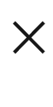

3.8 mm

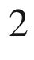

, circuit lines: 10

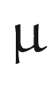

m, 2, 300 MOS transistors, clock speed: 108 kHz

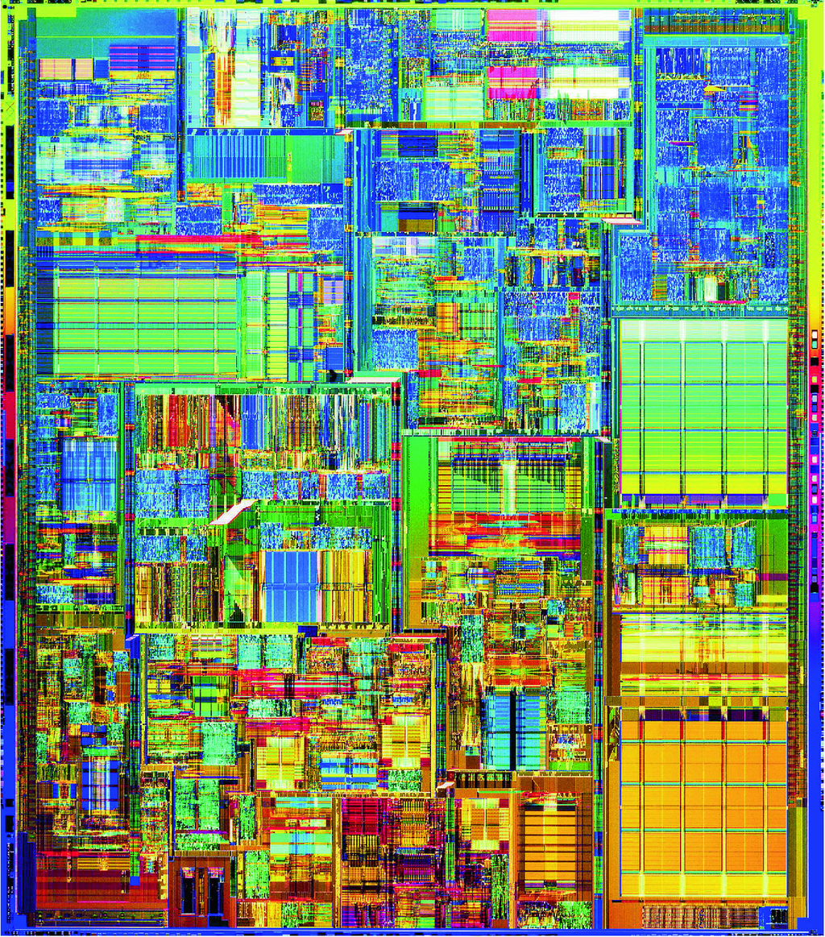

Fig. 24.30

The Intel

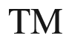

Pentium 4 microprocessor (2000), circuit lines: 0.18

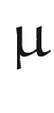

m, 42 million transistors, clock speed: 1.5 GHz

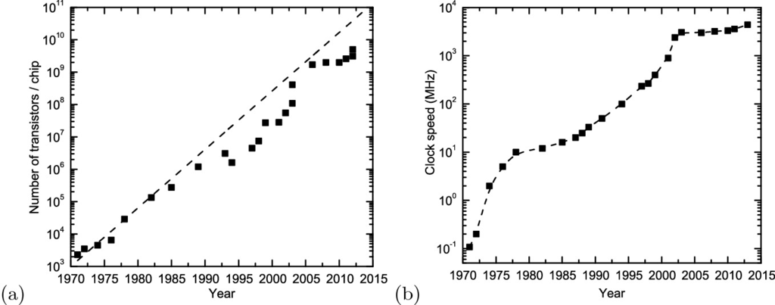

Fig. 24.31

**a** Moore’s law on the exponential increase of transistors per chip (for Intel



processor chips). *Dashed line* corresponds to doubling in 20 months. **b** Historical increase of maximum clock speed, *dashed line* is guide to the eye. Note the almost constant rate of 10 MHz from the mid-1970s to the mid-1980s and another plateau developing after 2000

**Interconnects**

Moore’s second law says that the cost of production also doubles for each new chip generation and is currently (2004) in the multi-billion US$ range. Most of the cost saved by integration is due to efficient *wiring* (interconnects) of the components, in 2004 (65 nm node) in eight layers above the active elements (transistors and capacitors) (Fig. [24.33](#u116076_4_En_24_Chapter-Fig33)), in 2008 (45 nm node) in eleven layers. Plane-view images of the first three layers of the interconnects are shown in Fig. [24.34](#u116076_4_En_24_Chapter-Fig34). The Cu interconnects are fabricated with the so-called damascene process [2068–2070]. Barrier layers (e.g. TaN or TiN) are required to avoid out-diffusion of Cu into the silicon or other parts of the circuit. Three effects limit the conductivity: The interconnect metal line width and height approaches the mean free path of carriers (

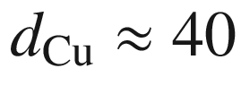

 nm) [715, 2071], grain boundary scattering can limit mobility since grain size is reduced for thinner lines, and the (high resistivity) barrier reduces space for the conductive part of the metal line. In Fig. [24.32](#u116076_4_En_24_Chapter-Fig32) the increase of the resistivity of copper with reduced dimension is shown as a function of film thickness *t* and for a 100 nm-film as a function of line width *w*. In a simplified approach, the line resistivity

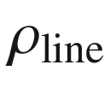

is given as [2071]

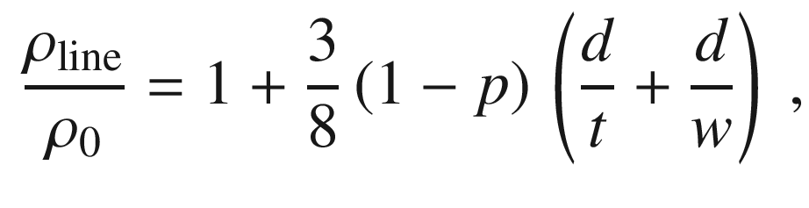

(24.81)

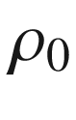

denoting the bulk resistivity (

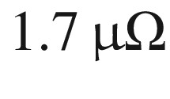

 cm for Cu), *d* being the mean free path ([8.​7](The_Physics_of_Semiconductors00004.docx#u116076_4_En_8_Chapter)) and *p* being the electron scattering parameter (

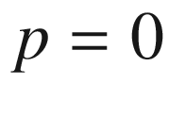

for diffuse scattering).

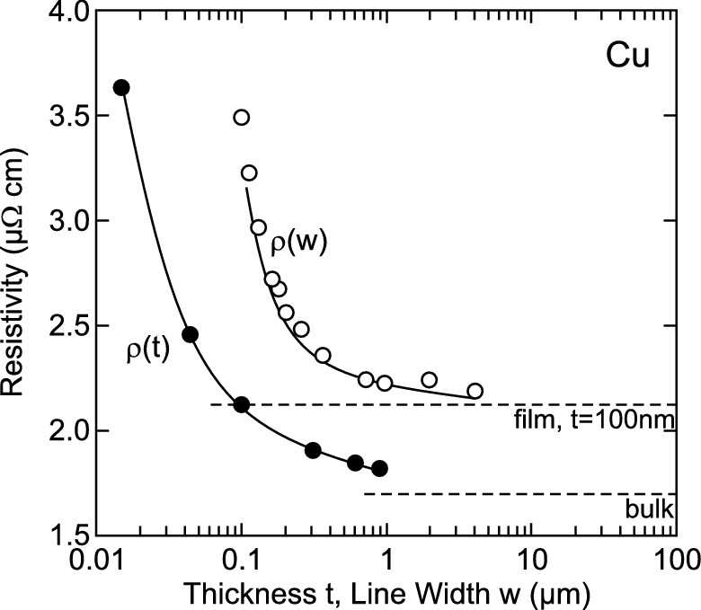

Fig. 24.32

Resistivity of copper at room temperature for various film thickness (*solid circles*), and for a 100 nm-film as a function of line width *w* (*empty circles*). *Solid lines* are theoretical dependence according to ([24.81](#u116076_4_En_24_Chapter-Equ104)). The *dashed lines* indicate the limits for bulk material (

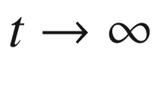

) and for large line thickness (

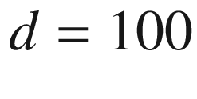

 nm,



).

Adapted from [2071]

In order to achieve the best high frequency performance the material between the metal interconnects should have low dielectric constant (‘low-k’ dielectric). Alternative materials to the standard SiO



(

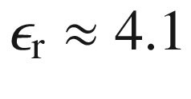

) are investigated such as SiOF (

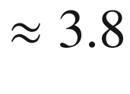

), SiCOH (

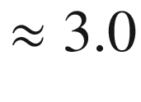

), porous materials (

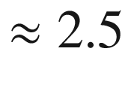

) and air gaps [2072].

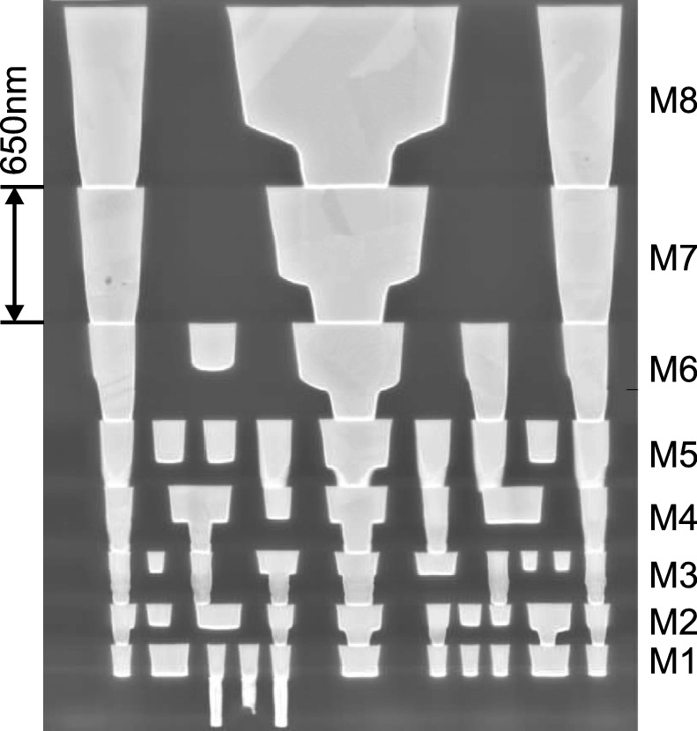

Fig. 24.33

Cross section through a logic chip (65 nm technology, 35 nm gate length) with eight layers of dual damascene Cu interconnects (M1–M8) with low-*k* carbon-doped oxide (

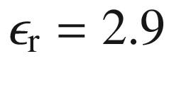

) inter-level dielectric above the active elements.

Adapted from [2073]

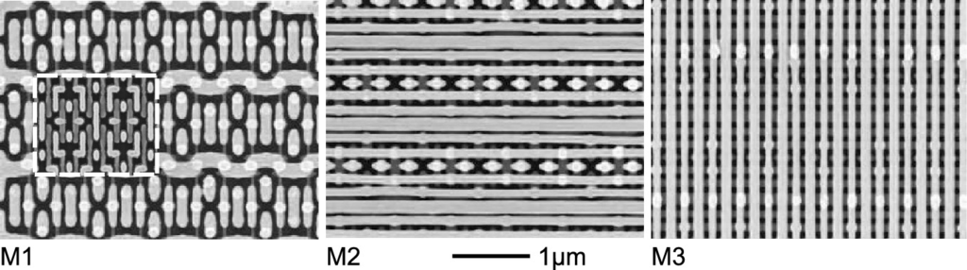

Fig. 24.34

Plane-view of the first three interconnect layers of a 45 nm node SRAM array (Intel



 Xeon



). In the image of the M1 layer the gate layer metal connects are shown in the *inset*, framed with a *white dashed line*.

Adapted from [2074]

**CMOS Scaling**

Using planar technologies, LSI (large-scale integration), VLSI (very large-scale integration), ULSI (ultra large-scale integration) and further generations of devices have been conceived, driven by high-density electronic memory devices. Subsequently also logic devices are produced with reduced device size.

The increase of the number of transistors per area requires the scaling of their geometrical properties. This impacts many other properties of the transistor and their scaling needs to be considered as well. From a general perspective, the physical properties scale while the thermal energy *kT* remains constant for room-temperature electronics.

If channel width *Z* and channel length *L*  of a transistor are scaled down by a factor of

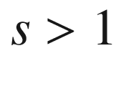

,

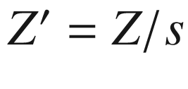

and

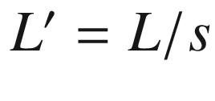

, the area obviously scales as

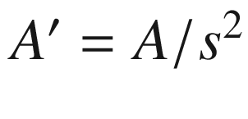

. In subsequent transistor generations

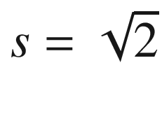

, i.e. doubling of the number of devices per area. In order to maintain the aspect ratio of the device also the oxide thickness (

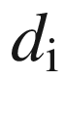

) is scaled,

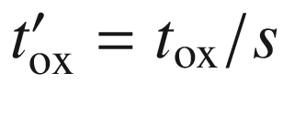

(‘classical scaling’).

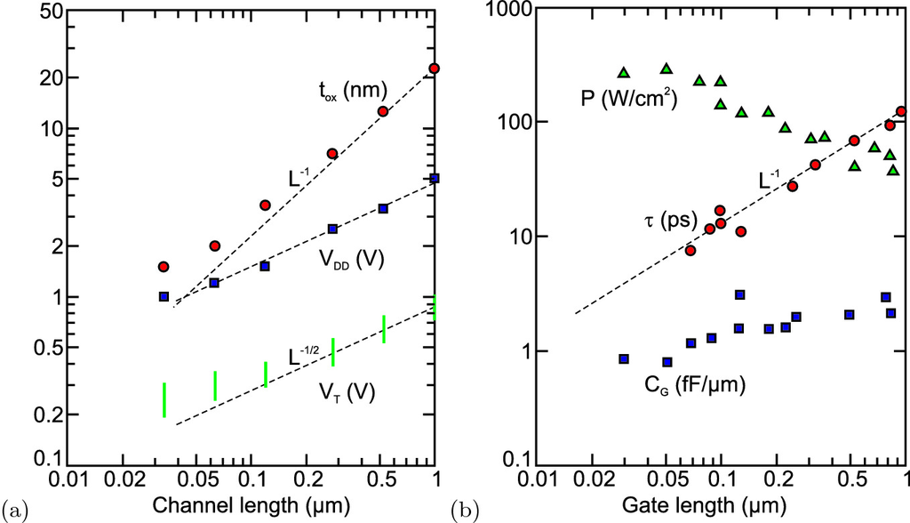

Fig. 24.35

Scaling of MOSFET parameters gate oxide thickness

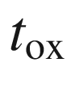

, power supply voltage



(across source–drain), threshold voltage

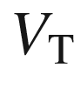

, total power loss per area *P*, gate capacitance per channel width

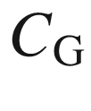

and inverter delay

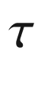

, the time required to propagate a transition through a single inverter driving a second, identical inverter, commonly used as a means of gauging the speed of CMOS transistors.

Data for **a** from [2075] and for **b** selected from [2076]

The ultimate design criteria are maximum temperature and maximum power loss. The maximum temperature needs to be obeyed, the worst case usually taken as 100

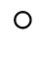

C. The power loss per area, e.g. heating, needs to stay constant at an appropriate maximum level around 200 kW/m

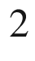

(Fig. [24.35](#u116076_4_En_24_Chapter-Fig35)b) unless higher (and more expensive) efforts on cooling are made. At the same time the device performance needs to be maintained if not improved, e.g. for lower power dissipation in battery operated devices. Very important is the reduction of operation voltage

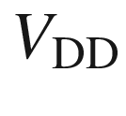

in order to keep electric fields and power consumption small enough (Fig. [24.35](#u116076_4_En_24_Chapter-Fig35)). The power consumption in stand-by mode

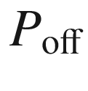

depends on



and the subthreshold (off) current

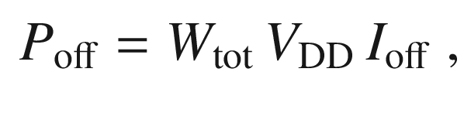

(24.82)

where

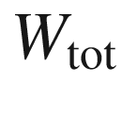

is the total width of the turned-off devices and

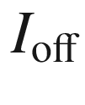

is the average off-current per device per width. The latter increases exponentially with reduced threshold voltage

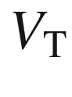

,

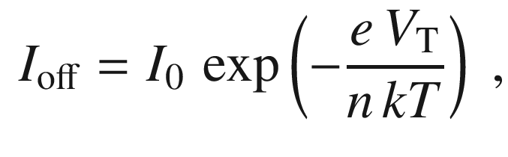

(24.83)

with ideality factor

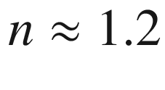

and

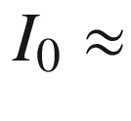

 1–10



A/

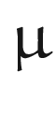

m [2075]. A well-functioning MOSFET requires a ratio of

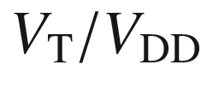

of

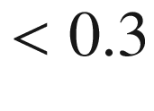

.

The power consumption in active mode

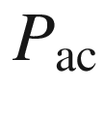

depends also on the clock speed (frequency *f*) that increases with higher integration due to shorter gate length,

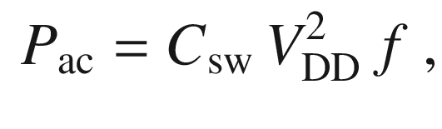

(24.84)

where

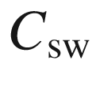

is the total node capacitance being charged and decharged in a clock cycle.

Historically the oxide thickness has been reduced less than the channel length [2075] (Fig. [24.35](#u116076_4_En_24_Chapter-Fig35)a) leading to increased local fields. The reduction of the physical gate oxide thickness is limited due to gate leakage through tunneling [2077]. While for a gate voltage of 1.5 V and oxide thickness

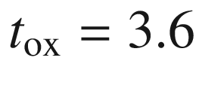

 nm the leakage current is only about

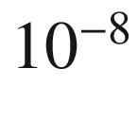

 A/cm

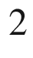

, it is about 1 A/cm



for

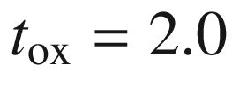

 nm and about

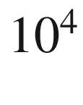

 A/cm

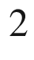

for

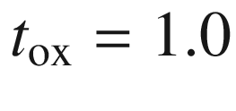

 nm. Obviously variations of oxide thickness are more harmful at small average thickness. 1.2 nm physical SiO



thickness has been used in the 90 nm (gate length) logic node.

The technological solution for further reduction of oxide thickness is the use of geometrically thicker layers, to suppress tunneling, with higher dielectric constant (‘high-k dielectrics’), e.g. HfO



[2078], to maintain reasonable gate capacitance per gate width

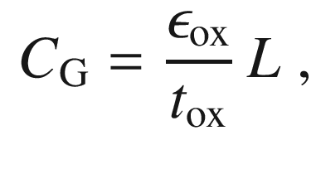

(24.85)

(cmp. ([24.71](#u116076_4_En_24_Chapter-Equ93))) at a value of about 1.0–1.5 fF/



m (Fig. [24.35](#u116076_4_En_24_Chapter-Fig35))b. For the 45 nm technology node a 0.7-fold reduction in electrical oxide thickness was achieved while reducing gate leakage

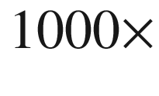

for the PMOS and

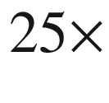

for the NMOS transistors [2079].

**Materials**

The electronics industry is based on silicon as the material for transistors. However, many other materials are incorporated in the technology. Traditionally silicon dioxide gate oxide is used, silicon nitride for insulation layers and polysilicon for gate contacts. For wiring aluminum has been used. Silicides were introduced as contact materials around 1986.

Progress was made with copper interconnects (IBM, 1997), replacing aluminum. The better electrical and heat conductivity could previously not be used since Cu is a deep level in Si (cf. Fig. [7.​6](The_Physics_of_Semiconductors00003.docx#u116076_4_En_7_Chapter-Fig6)). The key to success was an improved barrier technology based on amorphous TaN- or TiN-based barrier layers to prevent the diffusion of Cu into the silicon and dielectric layers. The first chip from series production, incorporating the Cu technology, was the PowerPC 750 (400 MHz) in 1998. Since 2000 high-k, i.e. large

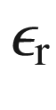

, Hf-containing gate dielectrics are used (Fig. [24.36](#u116076_4_En_24_Chapter-Fig36)). HfO



has a dielectric constant of 25–30. 45 nm node technology probably uses HfZrO, HfSiO or HfSiON [2080] gate dielectrics with

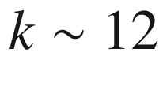

and an electrical thickness of

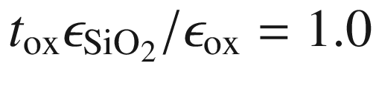

 nm.

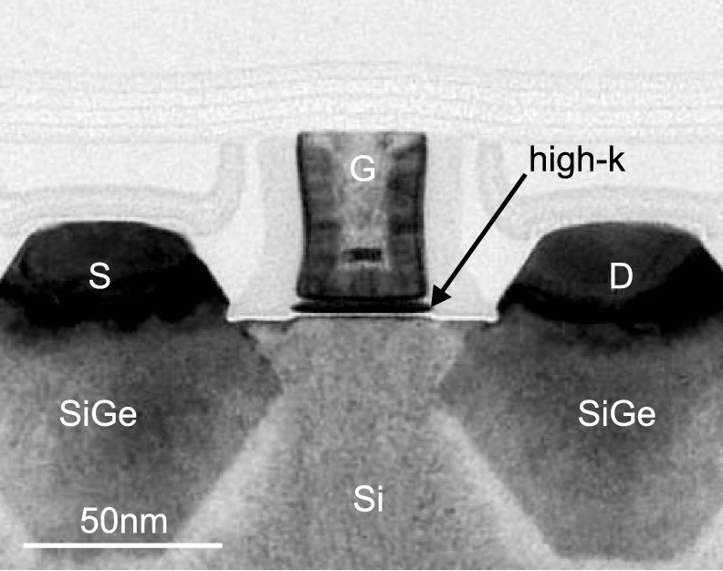

Fig. 24.36

Cross-section TEM image of 45 nm node PMOS transistor with high-k Hf-containing gate oxide (*dark*) above a thin SiO



layer (*white*). The role of the stressor SiGe pockets is explained in Fig. [24.35](#u116076_4_En_24_Chapter-Fig35).

Adapted from [2081]

Germanium is reintroduced into mainstream semiconductor technology via SiGe stressors in the source and drain for PMOS. Uniaxial compressive strain in the channel region leads to 30% increased saturation current [2082] mostly due to reduced effective masses [749, 2083, 2084] (Sect. [8.​3.​14](The_Physics_of_Semiconductors00004.docx#u116076_4_En_8_Chapter)) for 90 nm transistors. Similarly, uniaxial tensile strain in NMOS, introduced by SiN caps or more recently tensile trench contacts [2079], allows for 10% higher saturation current [2082] (Fig. [24.37](#u116076_4_En_24_Chapter-Fig37)). The enhanced electron mobility is due to strain-induced splitting of the X-valley and change of electron mass [2085]. Further improvement to 18% (NMOS) and 50% (PMOS) increase in



compared to unstrained Si have been made in 65 nm transistors [2073].

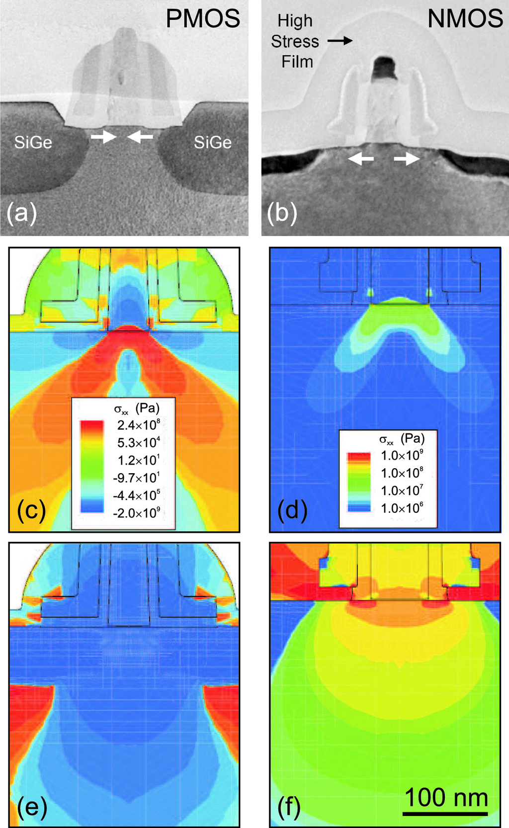

Fig. 24.37

Cross-section TEM images of strained **a** PMOS and **b** NMOS transistors. Adapted from [2086]. **c**–**f** Modelling of strain distribution: PMOS without **c** and with **e** Si

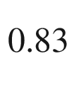

Ge

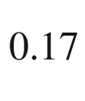

pockets, NMOS without **d** and with **f** tensile cap layer.

Adapted from [2087]

The end of the miniaturization has been theoretically predicted many times and for various feature sizes. Today, only fundamental limits such as the size of an atom seems to limit circuit design.[10](#u116076_4_En_24_Chapter-Fn10) Such limits (and the effects in nanostructures in the few-nm regime) will be reached beyond 2010, projected at about 2020. Up to then, it is probable that at least a few companies will follow the road map for further miniaturization, as laid out by the Semiconductor Industry Association[11](#u116076_4_En_24_Chapter-Fn11) (SIA).

#### 24.5.6 Tunneling FETs

A decisive parameter for FET performance is low leakage current. With shrinking device dimensions it increases rapidly for conventional FET design. A novel type of FET has thus been conceptualized, the tunneling FET (TFET) [2088]. It is a lateral p-i-n diode with a MOS gate (Fig. [24.38](#u116076_4_En_24_Chapter-Fig38)). The leakage current is minimized due to the reverse biased p-i-n structure. A low leakage current (per gate width) of less than

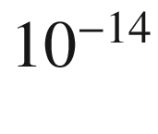

 A/

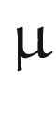

m has been realized [2089, 2090]. The channel current is due to band-to-band tunneling as in an Esaki diode (Sect. [21.​5.​9](The_Physics_of_Semiconductors00007.docx#u116076_4_En_21_Chapter)) and can be controlled by the gate voltage [2091]. The surface tunneling junction is close to the source electrode. The use of germanium instead of silicon allows further performance enhancements [2092].

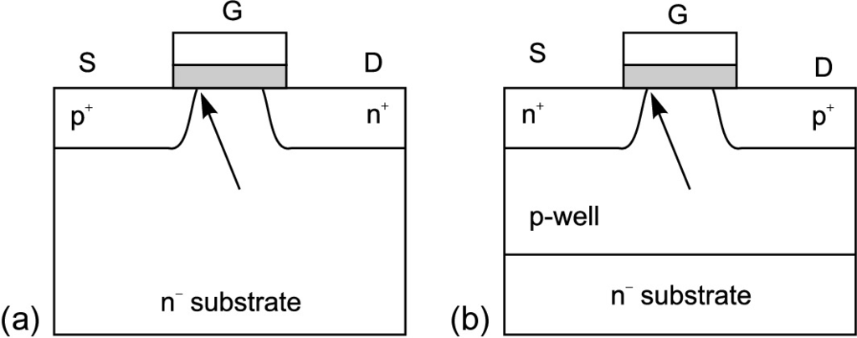

Fig. 24.38

Schematic of a **a** n-type and **b** p-type tunneling FET (TFET). D is reversely biased, i.e. positive for NTFET and negative for PTFET. The *grey areas* represent the gate oxide, the *arrows* denote the spatial position of tunneling (surface tunneling juction) for sufficient (NTFET: positive, PTFET: negative) gate voltage

#### 24.5.7 Nonvolatile Memories

**Floating Gate Memories**

When the gate electrode of a MOSFET is modified in such a way that a (semi-)permanent charge can be stored in the gate, a nonvolatile electronic memory can be fabricated. In the floating-gate structure (Fig. [24.39](#u116076_4_En_24_Chapter-Fig39)a), an insulator–metal–insulator structure is used where charge is stored in the metal and cannot escape through the insulating barriers. The ‘metal’ is often realized by poly-Si. In the MIOS structure (Fig. [24.39](#u116076_4_En_24_Chapter-Fig39)b), the insulator–oxide interface is charged. The charge can be removed by UV light (EPROM, erasable programmable read-only memory) or by a sufficient voltage across the oxide at which the charge carriers can tunnel out (Fowler–Nordheim tunneling) (EEPROM, E



PROM, electrically erasable programmable read-only memory).

Nowadays, a special type of EEPROM is used for the so-called *flash* memories. The stored gate charge causes a change in the MOSFET threshold voltage and is designed to switch between the on and off state. The storage time of the charge can be of the order of 100 years. Since tunneling limits the charge retention, the oxide must be sufficiently thick. In Fig. [24.40](#u116076_4_En_24_Chapter-Fig40) a cross section of a 4 Gb, 73 nm SLC (single-level cell) flash memory is shown. The lower insulator (tunneling oxide at the channel) consist of 7.2 nm SiO



, the upper insulator (insulator 1 in Fig. [24.39](#u116076_4_En_24_Chapter-Fig39)a) is a 18 nm thick oxide/nitride/oxide (ONO) stack. The floating gate has a

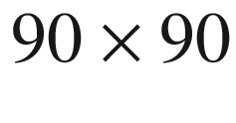

 nm



footprint, is about 86 nm high and consists of two polysilicon layers.

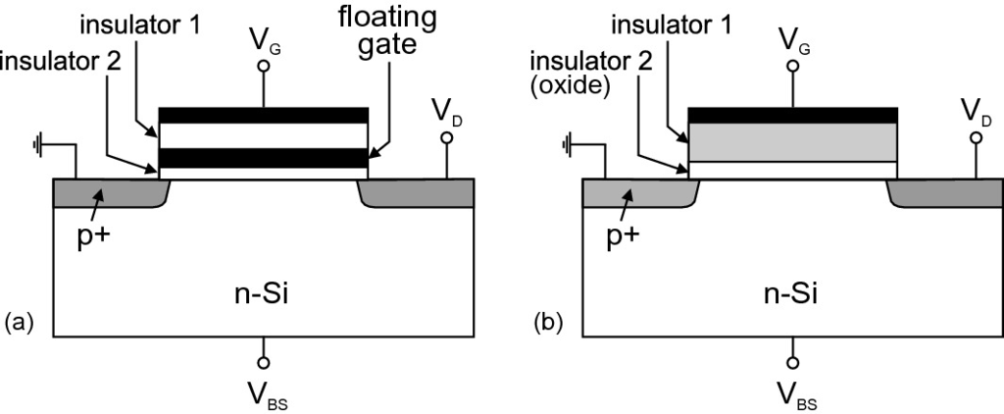

Fig. 24.39

MOSFET with **a** floating gate and **b** MIOS structure

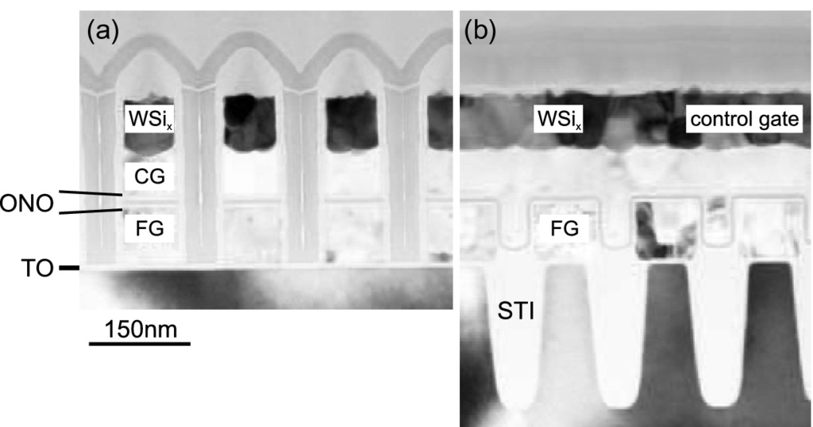

Fig. 24.40

Cross sections **a** perpendicular and **b** parallel to the control gate line of a 4 Gb, 73 nm SLC flash memory (Samsung K9F4G08U0M). ‘CG’ denotes the control gate, ‘FG’ the floating gate, ‘TO’ the tunneling oxide, ‘ONO’ the oxide/nitride/oxide insulator stack, and ‘STI’ the shallow trench insulation.

Adapted from [2074]

In a SLC memory the floating gate has two states, a certain charge value and the erased state. In a MLC (multi-level cell) the gate can store several charge states which can be sensed as different logic states, e.g.

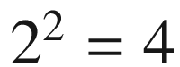

states. This increases the storage density, lowering cost per bit, but also increases the complexity. Typical endurance of SLC is at least 10

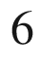

program–erase cycles. SLC cells so far have about ten times higher endurance (possible number of read–write cycles) and lower power consumption than MLC. Generally SLC flash memory is considered industrial grade and MLC flash is considered consumer grade. Recently also triple level cells (TLC), storing 3 bit (8 states) are commercialized, however the increased storage density comes at high cost of reliability [2093].

The ultimate limit, explored currently, is to use a single electron charge to cause such an effect in the single-electron transistor (SET).

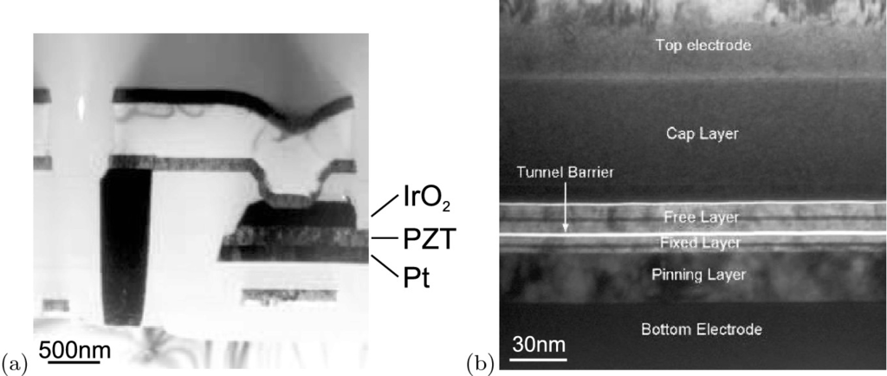

Fig. 24.41

**a** Cross-section TEM image of a cell from a Ramtron 4 Mb FeRAM. The information is stored in the electric polarization of a polycrystalline Pb(Ti



Zr

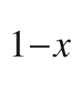

)O



(PZT) island, contacted on the bottom and top with platinum and iridium oxide, respectively. Adapted from [2074]. **b** Cross-section TEM of the magnetic tunneling junction from a Freescale 4.2 Mb MRAM, located between the M4 and M5 interconnect layers. The magnetization of the free layer can be switched, that of the fixed layer remains constant.

Adapted from [2074]

**Future Concepts**

Memory concepts beyond the storage of free charges include information storage via

the static polarization in a ferroelectric material (either crystalline or polymer) (FeRAM [2094], Fig. [24.41](#u116076_4_En_24_Chapter-Fig41)a) which can be switched by an electric field.

the phase change between amorphous and polycrystalline phases in a chalcogenide layer (typically GeSb [2095] or Ge



Sb



Te



, GST [2096, 2097] with an

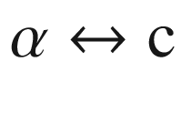

transition, Fig. [24.42](#u116076_4_En_24_Chapter-Fig42)) upon local heating (similar to a rewritable DVD) and the related change is resistivity (PCM, phase change memory).

the storage of magnetization direction (MRAM [2098, 2099]) and subsequent resistance change of a magneto-tunneling junction (MTJ) whose resistance depends on the relative magnetization (parallel or perpendicular) of two magnetic layers separated by a thin tunneling insulator (Fig. [24.41](#u116076_4_En_24_Chapter-Fig41)b). The largest TMR (tunnel-magnetoresistance) effect has been achieved with MgO as insulator [2099]. The magnetization of the bottom magnetic layer of the MTJ is fixed. The magnetization directions

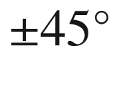

are written into the free layer with the magnetic fields of two perpendicular high current wires in two subsequent back-end interconnect layers sandwiching the MTJ.

resistance change based on solid electrolytes (PMC, programmable metallization cell memory). The lowering of the resistance is attained by the reduction of ions in a fairly high resistivity electrolyte (e.g. from the system Cu,Ag–Ge–Se,S,O [2100, 2101] or oxides [2102]) to form a conducting bridge between the electrodes. The resistance is returned to the high value via the application of a reverse bias that results in the breaking of the conducting pathway.

resistance change in transition metal oxides such as perovskites, e.g. SrTiO



:Cr [2103, 2104] or NiO:Ti (RRAM). Electrical pulses of opposite polarity switch the resistance reversibly between a high- and a low-resistance state. Oxygen-vacancy drift modulates the valence of the mixed-valence transition-metal ion (e.g. Ti

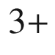

–Ti

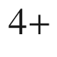

) and thus the conducting state [2105].

a molecular configuration change (e.g. redox reaction) between crossed wire lines (molecular electronics [2106–2108].

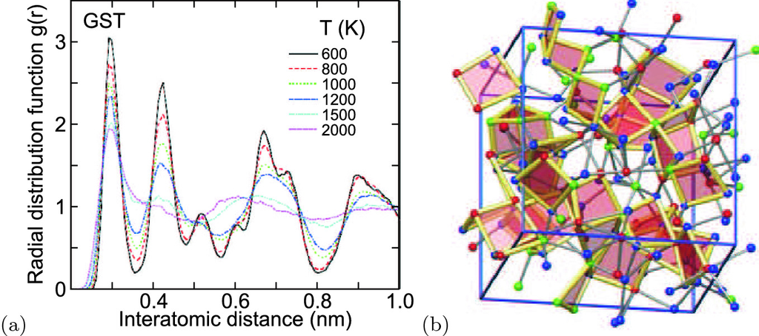

Fig. 24.42

**a** Radial distribution function of ions in Ge



Sb



Te



(GST) for various temperatures (cmp. Fig. [3.​14](The_Physics_of_Semiconductors00002.docx#u116076_4_En_3_Chapter-Fig14)b). Adapted from [2096]. **b** Atom arrangement in the amorphous phase of GST with square units highlighted that nucleate crystallization.

Adapted from [2097]

#### 24.5.8 Heterojunction FETs

Several types of field-effect transistors have been devised that use heterojunctions (HJFET).

**HIGFET**

As conducting channel, the two-dimensional electron gas at an undoped heterointerface is used. Such a transistor is called a heterojunction insulating gate FET (HIGFET). With forward or backward gate voltage, an electron or hole gas can be created (channel enhancement mode), as visualized in Fig. [24.43](#u116076_4_En_24_Chapter-Fig43). Thus, a complementary logic can be realized. However, the p-channel suffers from low hole mobility.

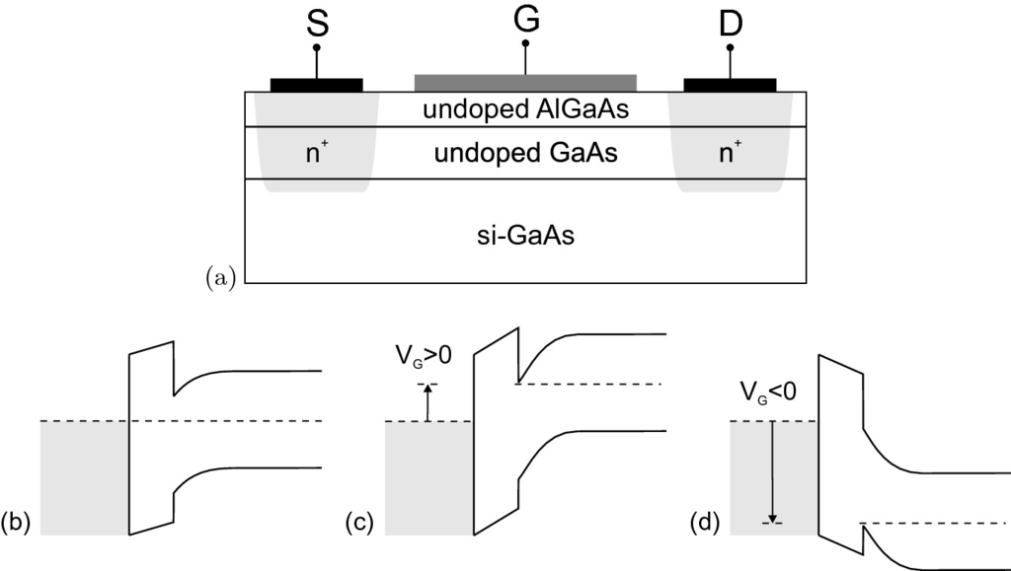

Fig. 24.43

**a** Scheme of a HIGFET structure with metal gate and undoped AlGaAs/GaAs heterointerface on semi-insulating GaAs. The source and drain contacts are n-doped such that this structure can be used as an n-HIGFET (see part **c**). **b** Band diagram for zero gate voltage. **c** Band diagram for positive gate voltage and n-channel, **d** for negative gate voltage and p-channel

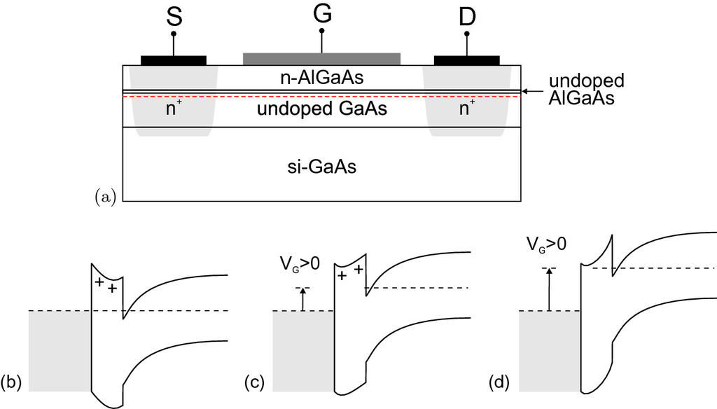

Fig. 24.44

**a** Scheme of a HEMT structure with n-AlGaAs/GaAs heterointerface on semi-insulating GaAs. The source and drain contacts are n-doped such that this structure can be used as an n-channel (normally-on) HEMT. The *horizontal dashed line* represents schematically the position of the 2DEG at the heterointerface on the GaAs side. **b** Band diagram at zero gate voltage. **c** Band diagram at positive gate voltage, increase of channel carrier concentration. **d** Band diagram at even larger positive gate voltage, formation of conducting channel in the AlGaAs layer

**HEMT**

If the top wide-bandgap layer is n-doped, a modulation-doped FET (MODFET) is made (see Sect. [12.​3.​4](The_Physics_of_Semiconductors00005.docx#u116076_4_En_12_Chapter)). This structure is also called a HEMT (high electron mobility transistor) or TEGFET (two-dimensional electron gas FET) (Fig. [24.44](#u116076_4_En_24_Chapter-Fig44)). A thin undoped AlGaAs spacer layer is introduced between the doped AlGaAs and the undoped GaAs to reduce impurity scattering from carriers that tunnel into the barrier. With increasing gate voltage, a parallel conduction channel in the AlGaAs is opened. The natural idea would be to increase the Al fraction in the AlGaAs to increase the quantum-well barrier height. Unfortunately, the barrier height is limited to 160 meV for an aluminum concentration of about 20%. For Al content higher than about 22%, the DX center (cf. Sect. [7.​7.​6](The_Physics_of_Semiconductors00003.docx#u116076_4_En_7_Chapter)) forms a deep level such that the apparent ionization energy increases drastically and no shallow donors can be used for modulation doping. An improvement for the barrier conduction problem is the use of

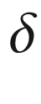

-doping [2109], i.e. the introduction of a highly doped thin (mono-)layer (Fig. [24.45](#u116076_4_En_24_Chapter-Fig45)), which results in higher channel carrier concentration.

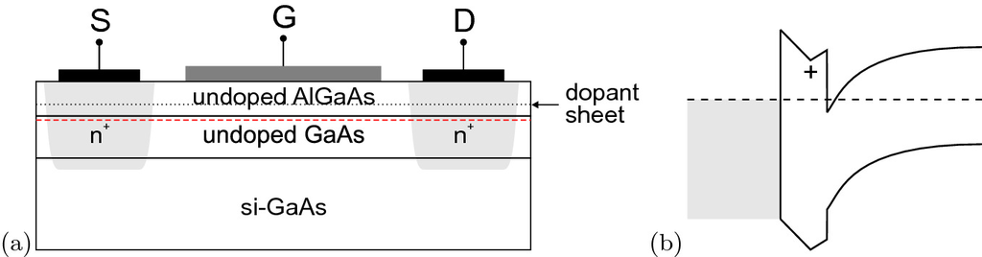

Fig. 24.45

**a** Scheme of a



-doped HEMT structure with AlGaAs/GaAs heterointerface on semi-insulating GaAs. The source and drain contacts are n-doped such that this structure can be used as an n-channel HEMT. The *horizontal dashed line* represents schematically the position of the 2DEG in the GaAs layer. **b** Band diagram at zero gate voltage

**Pseudomorphic HEMTs**

Instead of increasing the height of the barrier, the depth of the well can be increased by using a low-bandgap material. On GaAs substrate, InGaAs is used (Fig. [24.46](#u116076_4_En_24_Chapter-Fig46)). However, strain is introduced in this case and the InGaAs layer thickness is limited by the onset of dislocation formation (cf. Sect. [5.​4.​1](The_Physics_of_Semiconductors00002.docx#u116076_4_En_5_Chapter)) (which reduces the channel mobility and the device reliability). For In

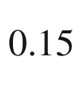

Ga

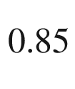

As (thickness about 10–20 nm), a total barrier height of about 400 meV can be obtained. A barrier height of 500 meV can be reached with an InAlAs/InGaAs structure on InP (Fig. [24.47](#u116076_4_En_24_Chapter-Fig47)). The InAlAs does not suffer from the problem related to DX centers. The channel indium concentration is typically 50%. The mobility increases with increasing indium concentration. This InP-based HEMT structure is widely used in satellite receivers for its excellent high-speed and low-noise properties in the 100–500 GHz range and beyond.

However, the InP technology is economically less favorable than GaAs due to smaller available substrate size and higher cost (2001: 4" InP substrate: $ 1000, 6" GaAs substrate: $ 450).

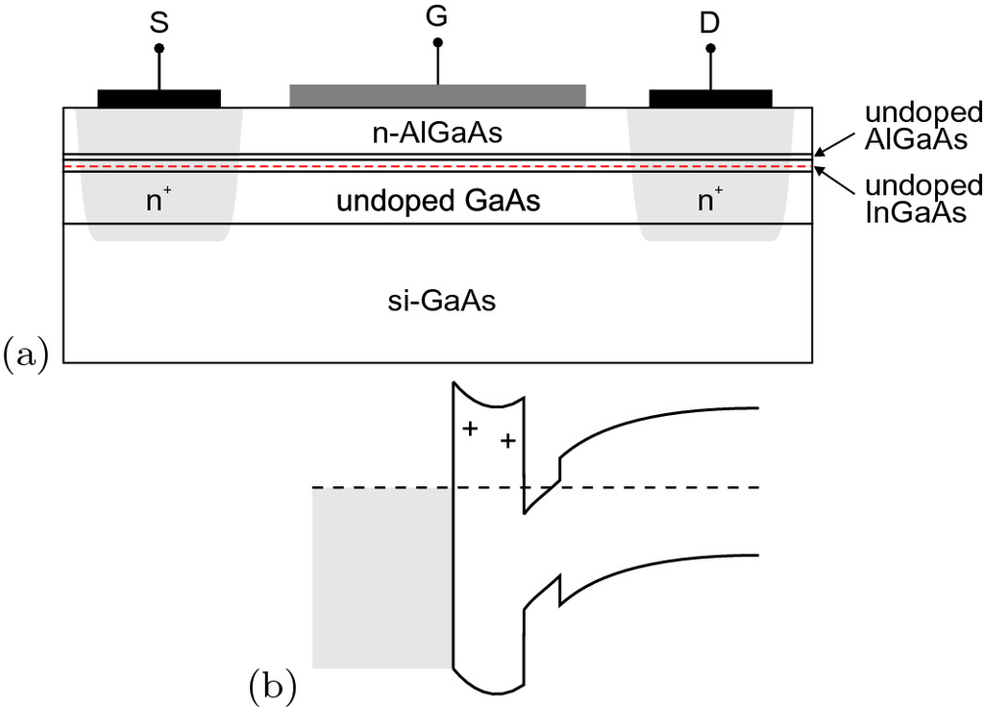

Fig. 24.46

**a** Scheme of a PHEMT structure with n-AlGaAs/InGaAs heterointerface on semi-insulating GaAs. The source and drain contacts are n-doped such that this structure can be used as an n-channel HEMT. The *horizontal dashed line* represents schematically the position of the 2DEG in the InGaAs layer. **b** Band diagram at zero gate voltage

**Metamorphic HEMTs**

A unification of the InAlAs/InGaAs structure with the best figure of merit and the GaAs substrate is achieved with the metamorphic HEMT (MHEMT). Here, a relaxed buffer is used to bring the in-plane lattice constant from that of GaAs to about that of InP. It is key that the defects occurring are confined to the relaxed buffer and do not enter the active device structure (see Fig. [24.48](#u116076_4_En_24_Chapter-Fig48)). The relaxed buffer is typically about 1

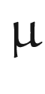

m thick. It can be grown, e.g., with a graded In



(Ga,Al)

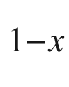

As layer with

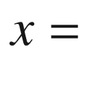

0–42% or with a stepped structure with piecewise constant indium concentration in each layer. It is important that a smooth interface of the channel is achieved in order to avoid additional scattering mechanisms. For high-frequency operation, the fabrication of a small gate length is important, as shown in Fig. [24.49](#u116076_4_En_24_Chapter-Fig49) for a 70-nm gate of a

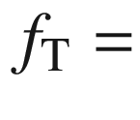

293 GHz,

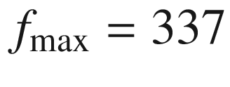

 GHz transistor [2110]. SiGe channels, providing higher mobility than pure Si, can be fabricated using graded or stepped SiGe buffer layers on Si substrate. With such Si-based MHEMTs frequencies up to 100 GHz can be achieved.

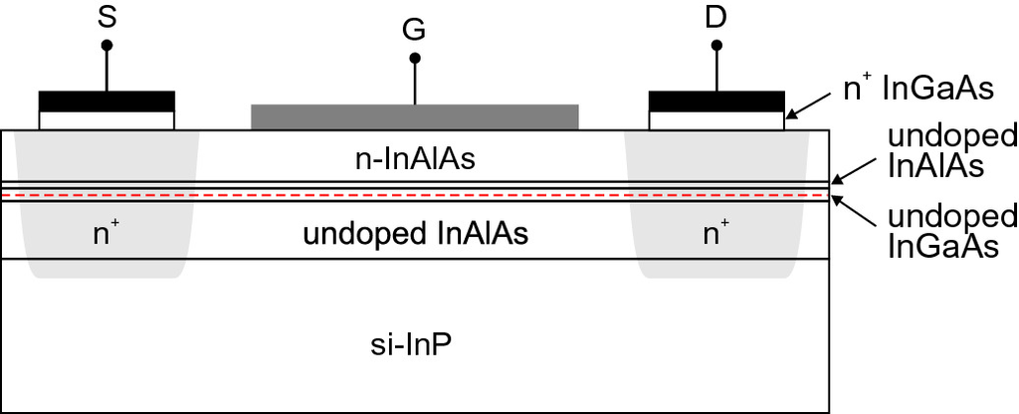

Fig. 24.47

Scheme of a PHEMT structure with n-AlInAs/InGaAs/InAlAs structure on semi-insulating InP. The source and drain contacts (with a highly doped InGaAs contact layer) are an n-doped such that this structure can be used as an n-channel HEMT. The *horizontal dashed line* represents schematically the position of the 2DEG in the InGaAs layer

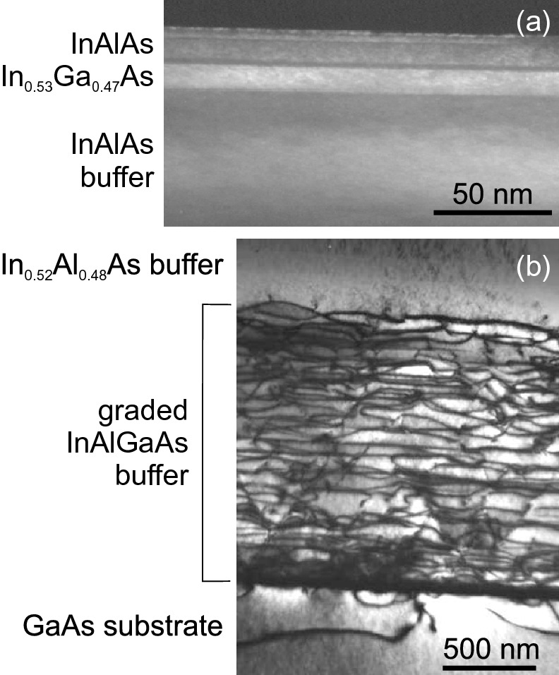

Fig. 24.48

Cross-sectional TEM image of an InAlAs/InGaAs MHEMT: **a** Active layer with rms surface roughness of 2.0 nm (from AFM), **b** graded InGaAlAs buffer layer (1.5

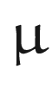

m) on GaAs substrate.

Adapted from [2111]

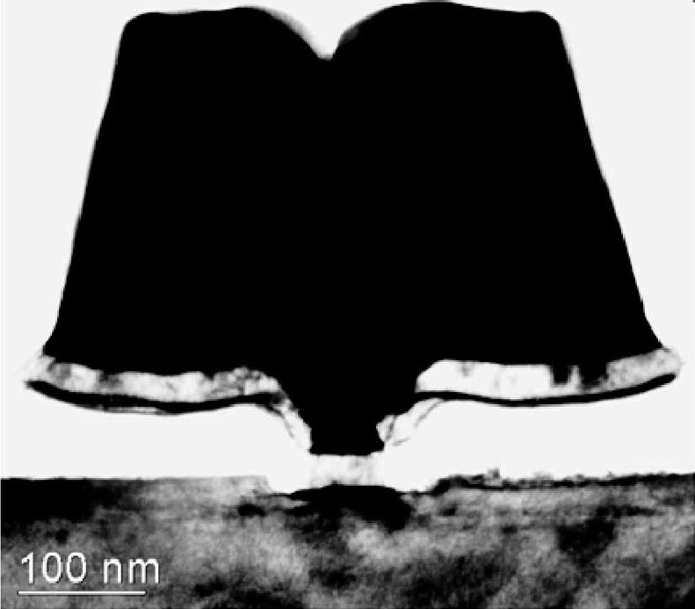

Fig. 24.49

Cross-sectional TEM image of the 70-nm gate of an InAlAs MHEMT on GaAs substrate.

From [2110]

### 24.6 Thin-Film Transistors

Thin-film transistors (TFTs) are field-effect transistors with a channel formed as thin film on insulating substrate. A detailed treatment is available in [2112]. TFTs are typically fabricated as large-area arrays from thin layers of polycrystalline or amorphous silicon [2113] or organic semiconductors [2114–2117] on cheap substrates such as glass. Their most prominent use is driving pixels in active-matrix displays such as electroluminescence (EL) displays or twisted nematic liquid crystal displays (LCD) [2118]. Various gates and gate geometries have been reported as depicted in Fig. [24.50](#u116076_4_En_24_Chapter-Fig50).

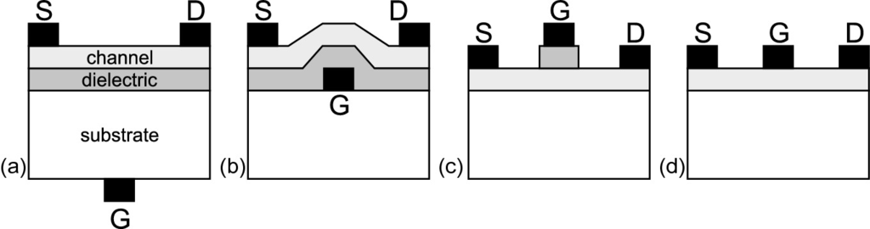

Fig. 24.50

Schematic geometries of TFTs: **a**–**c** MISFETs, **d** MESFET with **a**, **b** bottom gate and **c**, **d** top gate. Semiconductor channel layer (*light grey*), insulating dielectric (*dark grey*) and metals (*black*)

#### 24.6.1 Annealing of Amorphous Silicon

Since the mobility in polycrystalline silicon is much higher (up to several hundred cm



/Vs depending on grain size, see Sect. [8.​3.​8](The_Physics_of_Semiconductors00004.docx#u116076_4_En_8_Chapter)) than in amorphous silicon (

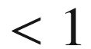

 cm



/Vs), such material is much more desirable as channel in TFTs. However, it requires high deposition temperatures. In order to achieve polycrystalline silicon with large grain size from amorphous silicon films that can be deposited at low temperature (down to room temperature) several schemes have been developed, the most important being thermal annealing and (excimer) laser annealing (ELA). Crystallization occurs by thermally activated nucleation and growth processes [2119]. Polycrystalline layers with small grain size can be made amorphous with implantation of Si (self-implantation) and a subsequent optimized (re-)crystallization processes.

In laser annealing energy is locally introduced during short pulses (several 10 ns or even fs); subsequent material change occurs on a sub-



s time scale [2120]. Laser induced crystallization enables the use of inexpensive low-temperature substrates, such as plastic or glass, since it involves the ultrafast melting and resolidification of the near-surface region of the sample, and minimal heating of the substrate. Local processing is also possible using laser crystallization.

In Fig. [24.51](#u116076_4_En_24_Chapter-Fig51) the effect of thermal annealing of amorphous silicon is shown. The annealing time necessary to convert the amorphous phase completely to polycrystalline, e.g. 10 h at 640

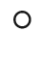

C, depends largely on temperature as detailed in [2121, 2122] (Fig. [24.51](#u116076_4_En_24_Chapter-Fig51)a) with a large activation energy of 3.9 eV. Also the final grain size is temperature dependent (Fig. [24.51](#u116076_4_En_24_Chapter-Fig51)b).

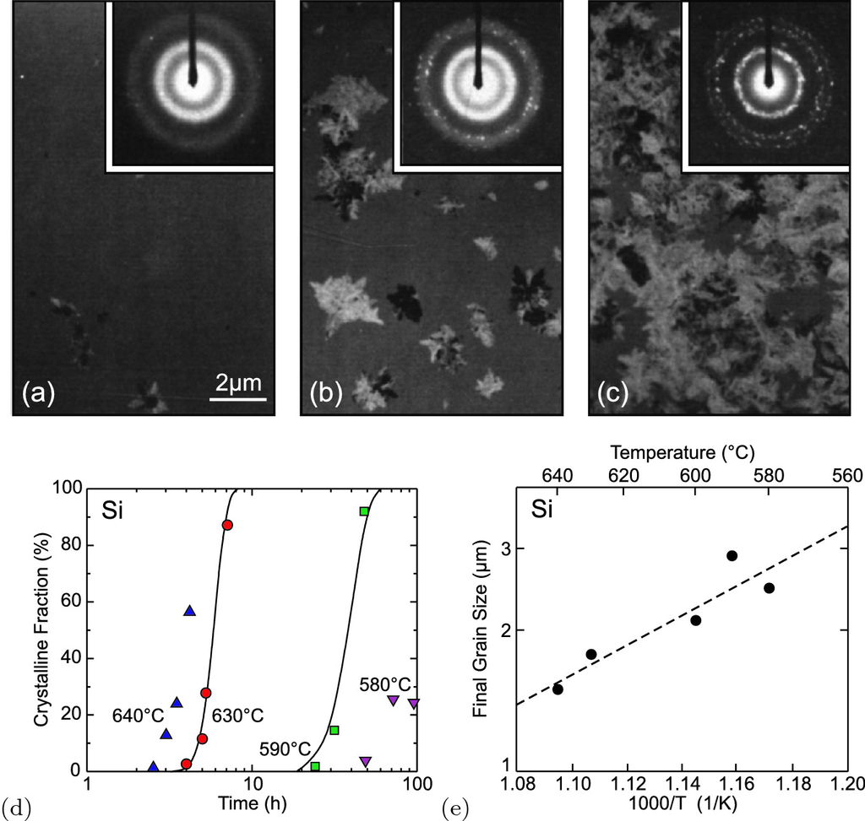

Fig. 24.51

Thermal annealing of 100 nm thick film of amorphous silicon (fabricated from LPCVD and amorphized by 100 keV Si

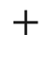

implantation with a dose of

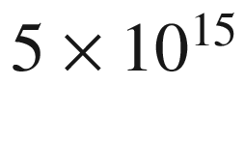

 cm

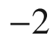

). TEM images and diffraction patterns (*insets*) for amorphized Si after **a** 4 h, **b** 5.25 h and **c** 7.1 h annealing at

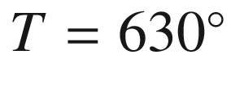

C. The crystalline fractions are 2%, 28% and 87%, respectively. **d** Crystalline fraction as a function of annealing time for various annealing temperatures as labeled. *Symbols* are experimental data, *solid lines* depict theory considering grain nucleation and growth. **e** Final grain size for various annealing temperature. *Dashed line* is exponential with a slope of 0.6 eV.

Adapted from [2121]

The introduction of certain metals like Pd [2123], Al [2124], Au [2125] or Ni [2126] induces crystallization and allows for much lower annealing temperatures. Pd and Ni create silicides that play an important role for the grain nucleation or growth front. Au and Al are solved in the bulk but have a similar effect. For example, using Pd complete crystallization of a 150 nm thick a-Si film deposited at 480



C can be achieved by thermal annealing after 10 h at only 500

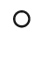

C [2127] (using metal-induced lateral crystallization, MILC).

#### 24.6.2 TFT Devices

A schematic cross section of an amorphous silicon-based TFT is shown in Fig. [24.52](#u116076_4_En_24_Chapter-Fig52)a. Carriers in amorphous silicon have a low mobility typically less than 1 cm



/Vs [2128, 2129]. As-grown polycrystalline silicon has a mobility of typically less than 10 cm



/Vs. With the use of laser irradiation or thermal annealing, amorphous or small-grain polycrystalline silicon layers can be recrystallized, increasing the mobility up to several 100 cm



/Vs, improving transistor performance [2128, 2130, 2131]. However, for display applications a mobility of 10 cm

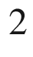

/Vs is large enough.

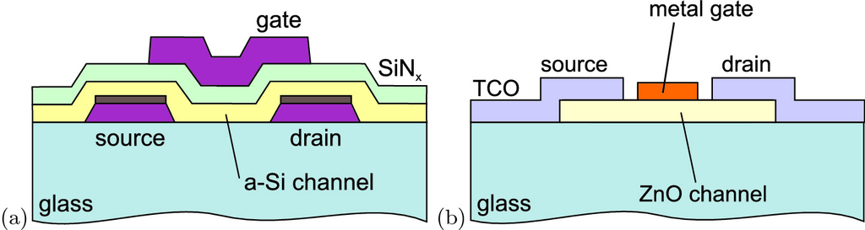

Fig. 24.52

**a** Schematic cross section of a top-gate amorphous silicon (a-Si) thin-film transistor (MISFET) on glass substrate. **b** Schematic cross section of a transparent ZnO thin-film transistor (MESFET)

The main optimization criteria for thin-film transistors are high on-off ratio, long-term stability, good uniformity and reproducibility, and low cost. Recently, flexible (on polymer substrate) and transparent TFTs (TFET, transparent FET), e.g. with polycrystalline ZnO or GaInZnO (GIZO) channel (Fig. [24.52](#u116076_4_En_24_Chapter-Fig52)b), are being investigated for advanced applications such as all-transparent electronics and displays [151, 2132–2135]. A compilation of recent results on transparent semiconducting oxide (TSO) channel FETs can be found in [2136]. In Fig. [24.53](#u116076_4_En_24_Chapter-Fig53) performance data for various TSO channel FETs are visualized. In Fig. [24.54](#u116076_4_En_24_Chapter-Fig54) a transparent inverter based on ZnO-MESFETs is depicted [2137].

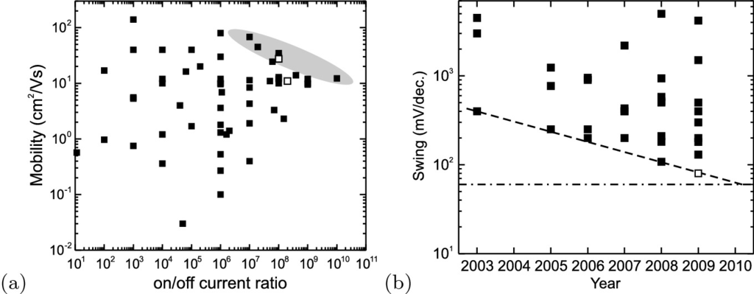

Fig. 24.53

**a** Field effect mobility and on/off current ratio for oxide channel transistors. *Filled squares* represent MISFET transistors; *open squares* are for MESFETs from [2135]. The *shaded area* indicates best performance. **b** Voltage swing for MISFETs (*filled squares*, subthreshold voltage swing) and MESFET (*empty square*, above turn-on voltage from [2135]) with TSO channels. The *dashed line* is guide to the eye for the trend of best performance. The *dash-dotted line* indicates the thermodynamic limit of about 60 meV/decade for the swing [2138].

Adapted from [2136]

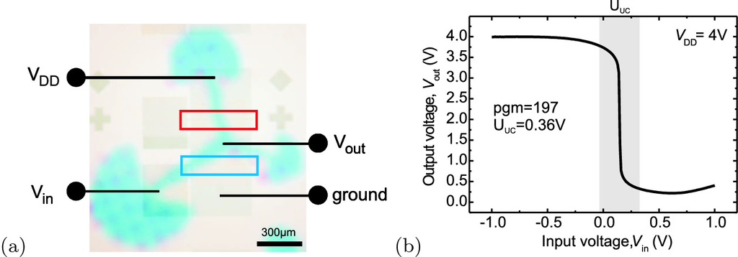

Fig. 24.54

**a** Optical image of transparent MESFET inverter based on ZnO. The *two rectangles* indicate the two gates. **b** Transfer characteristic for supply voltage

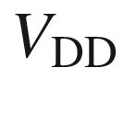

=4 V

#### 24.6.3 Transistors with 2D Materials

The ultimate thin film transistor is one with a single monolayer as channel. Various 2D materials (cf. Sect. [13](The_Physics_of_Semiconductors00006.docx#u116076_4_En_13_Chapter)) as mono- or multi-layers have been investigated in transistors [2140, 2141]. The channel mobility for conventional layers decreases typically for thickness *d* below 10 nm and strongly below 5 nm. The idea to use 2D materials is to avoid a rough surface and interface defects towards the gate. A single layer MoS



transistor with HfO



gate and Au ohmic contacts has been reported in [2142] with a (field effect) mobility above 200 cm



/Vs, low sub-threshold voltage swing and high on/off ratios above

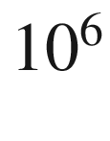

. Also, a thinner channel allows further gate size scaling. However, the realities are complicated [2143, 2144] and clear performance gains have not been achieved yet. Also, the upscaling to wafer size is an unresolved issue.

#### 24.6.4 OFETs

Organic field effect transistors (OFETs) [2139, 2145–2147] are transistors for which at least the channel consists of an organic material. Most work is done on thin film transistors, although some work on OFETs using bulk organic semiconductors has been reported [2148, 2149]. Organic materials are also used for the insulator and the contact materials. Often organic and flexible substrates are used. Applications are in low cost electronics, e.g. for driving display pixels or RFID tags (typically operating at 13.56 MHz or 900 MHz). Processes like spin-on and printing can be used. Due to their larger chemical stability against oxidation, mostly p-type channel materials are used. The highest mobilities are reached for pentacene (6 cm



/Vs) and sexithiophene (1 cm



/Vs); n-type organic semiconductors exhibit field mobility below 0.1 cm



/Vs [2145].

Footnotes

[1](#u116076_4_En_24_Chapter-Fn1_source)

The term ‘transistor’ was coined from the combination of ‘transconductance’ or ‘transfer’ and ‘varistor’ after initially such devices were termed ‘semiconductor triodes’. The major breakthrough was achieved in 1947 when the first transistor was realized that showed gain (Figs. [1.​9](The_Physics_of_Semiconductors00001.docx#u116076_4_En_1_Chapter-Fig9) and [24.1](#u116076_4_En_24_Chapter-Fig1)b).

[2](#u116076_4_En_24_Chapter-Fn2_source)

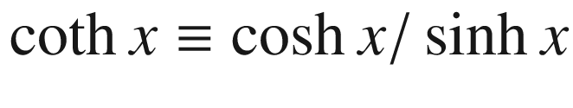

,

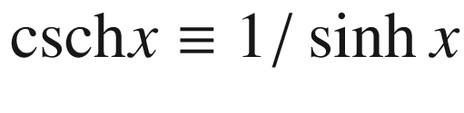

.

[3](#u116076_4_En_24_Chapter-Fn3_source)

Also, a recombination current in the emitter–base depletion region is possible. However, since in normal operating conditions this diode is forward biased, the depletion layer is short and the associated recombination current is small, cf. p. xx.

[4](#u116076_4_En_24_Chapter-Fn4_source)

We neglect recombination, in particular since the current is a majority-carrier current.

[5](#u116076_4_En_24_Chapter-Fn5_source)

The threshold voltage can also be obtained from the condition

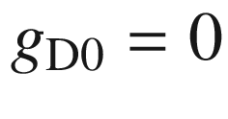

(cf. ([24.49](#u116076_4_En_24_Chapter-Equ69))).

[6](#u116076_4_En_24_Chapter-Fn6_source)

Technically, here

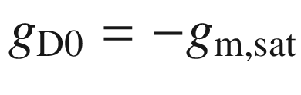

, however, we had counted

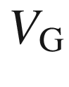

positive for the reverse direction.

[7](#u116076_4_En_24_Chapter-Fn7_source)

except for the subthreshold current and other leakage currents. These need to be reduced further since the dissipated power limits chip performance (speed and device density) and battery lifetime in handheld applications.

[8](#u116076_4_En_24_Chapter-Fn8_source)

The term ‘high-*k* dielectric’ means a dielectric material with large dielectric constant

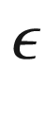

.

[9](#u116076_4_En_24_Chapter-Fn9_source)

After year 2003 data for maximum clock rate are not for highest integration density processors.

[10](#u116076_4_En_24_Chapter-Fn10_source)

Only commercial profit, rather than testing physical limits, drives the miniaturization. Insufficient economic advantages or low yield of further chip generations possibly can limit or slow down large-scale integration.

[11](#u116076_4_En_24_Chapter-Fn11_source)

www.semichips.org.

Appendix A

## Tensors

### A.1 Introduction

A physical quantity

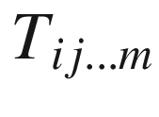

with a total of *k* indices that is independent of translations of the coordinate system and transforms with respect to all indices like a vector is called a tensor  of rank *k*.

Often, Einstein’s sum convention is used; a sum is built over indices with the same symbol. For example,

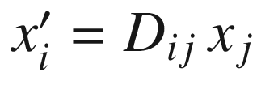

shall be read as

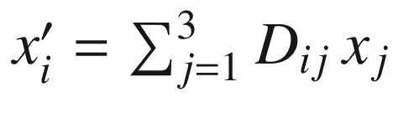

.

### A.2 Rotation of Coordinate System

A rotation  of the coordinate system is a transformation

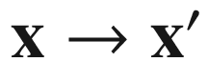

that is written in components as

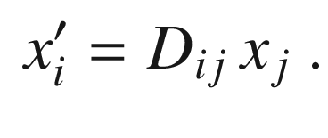

(A.1)



is called the rotation matrix. The inverse of the rotation matrix is

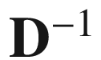

with

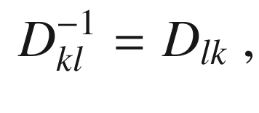

(A.2)

i.e. it is the transpose of matrix



. The inverse transformation is

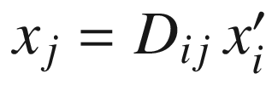

. Thus,

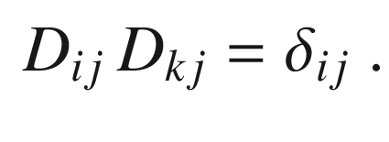

(A.3)

A simple example is the azimuthal rotation around the *z*-axis by an angle

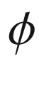

(in the mathematically positive direction)

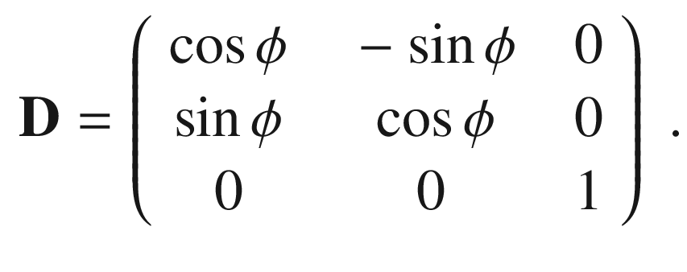

(A.4)

For the description of an arbitrary rotation

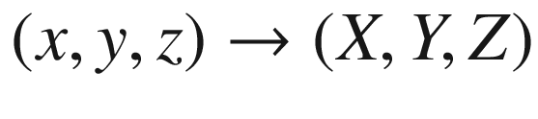

, generally three angles are necessary. Typically, the Euler angles

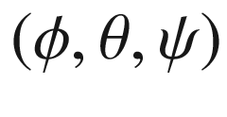

are used (Fig. [A.1](#u116076_4_En_BookBackmatter_OnlinePDF-Fig1)). First, the system is rotated by

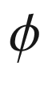

around the *z*-axis. The *y*-axis becomes the *u*-axis. Then, the system is tilted by

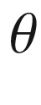

around the *u*-axis and the *z*-axis becomes the *Z*-axis. Finally, the system is rotated by

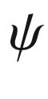

around the *Z*-axis.

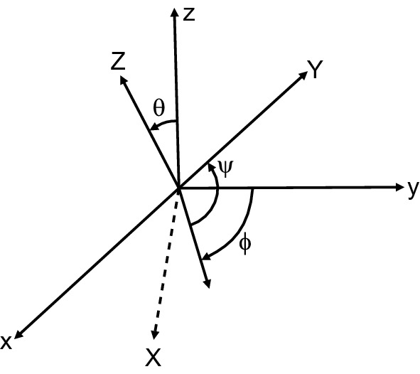

Fig. A.1

Rotation of a coordinate system (*x*, *y*, *z*) by the Euler angles

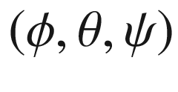

into the system (*X*, *Y*, *Z*)

The matrix for the general rotation by the Euler angles is

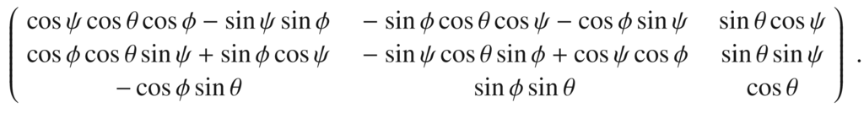

(A.5)

### A.3 Rank-n Tensors

***Rank-0 Tensors***

A tensor of rank 0 is also called a scalar. For example, the length

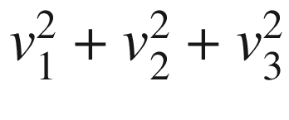

of the vector

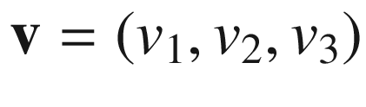

is a scalar  since it is invariant under rotation of the coordinate system. However, ‘scalar’ is not equivalent to ‘number’ since, e.g. the number

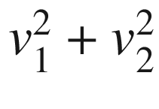

is not rotationally invariant.

***Rank-1 Tensors***

A tensor of rank 1 is a vector. It transforms under coordinate rotation



 as

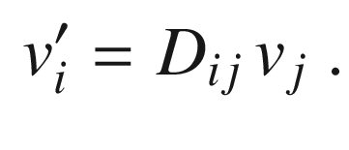

(A.6)

***Rank-2 Tensors***

A tensor of rank 2 is also called a dyade and is a

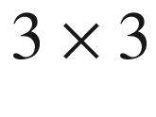

matrix



that transforms under coordinate rotation as

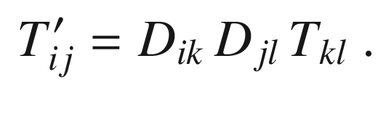

(A.7)

The physical meaning is the following: Two vectors



and

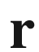

shall be related to each other via

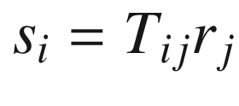

. This could be, e.g., the current



and the electric field



that are connected via the tensor of conductivity

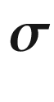

, i.e.

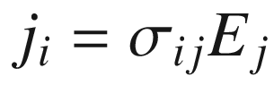

.

Such an equation only makes physical sense if it is also valid in a (any) rotated coordination system. The tensor

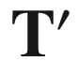

in the rotated coordinate system must fulfill

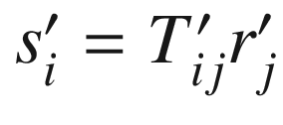

. This implies the transformation law ([A.7](#u116076_4_En_BookBackmatter_OnlinePDF-Equ7)).

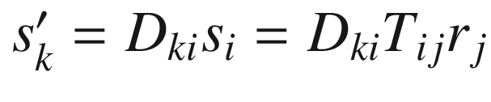

and also

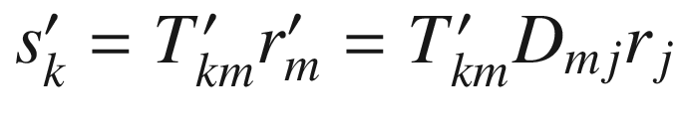

. Thus,

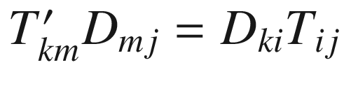

since the previous relations are valid for arbitrary

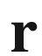

. Multiplication by

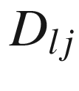

yields

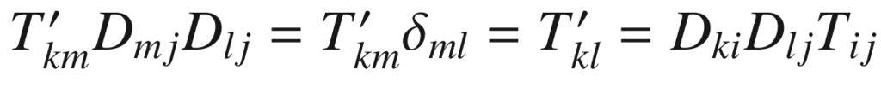

.

The trace of a rank-2 tensor is defined as

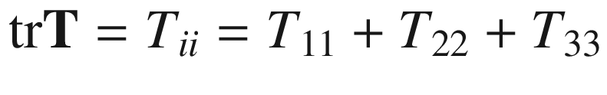

. It is a scalar, i.e. invariant under coordinate rotation, since

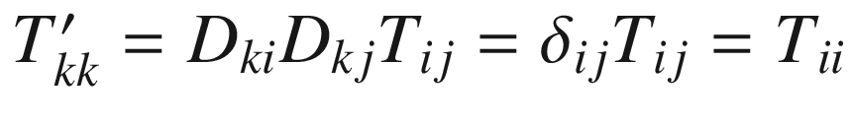

. Next to the trace invariant, rank-2 tensors have two more invariants, i.e. scalars that are independent of rotation:

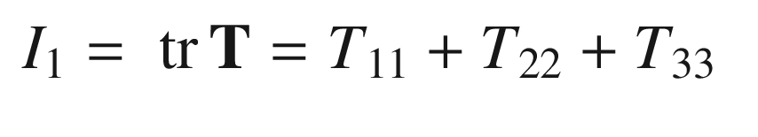

(A.8a)

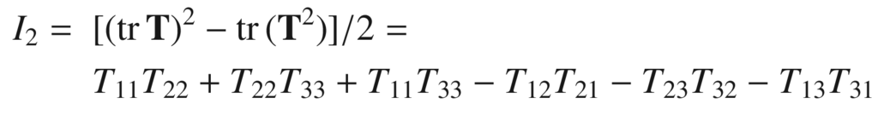

(A.8b)

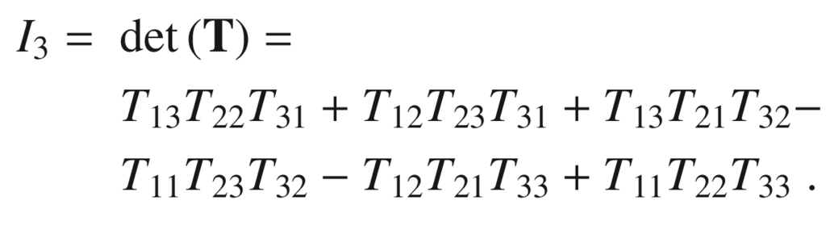

(A.8c)

Of course any function of the invariants is also invariant. In terms of the eigenvalues

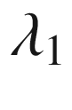

,

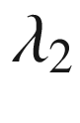

, and

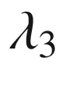

of



, the invariants are given by

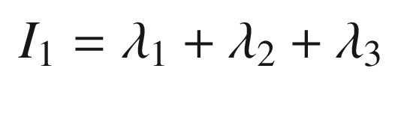

(A.9a)

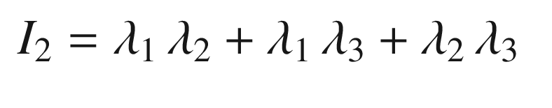

(A.9b)

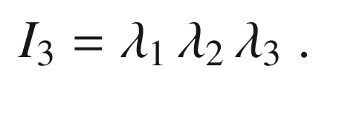

(A.9c)

It shall be noted that the relation

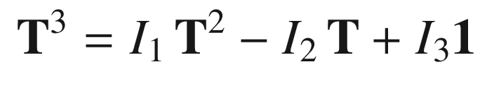

(A.10)

holds,

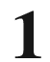

being the unity matrix. Further information on tensor invariants can be found in [[2150](The_Physics_of_Semiconductors00010.docx#u116076_4_En_BookBackmatter_OnlinePDF-CR2150)].

A rank-2 tensor can be separated into a symmetric part

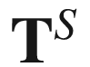

and an antisymmetric part

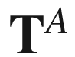

, i.e.

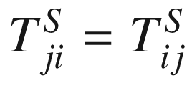

and

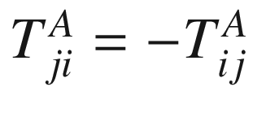

with

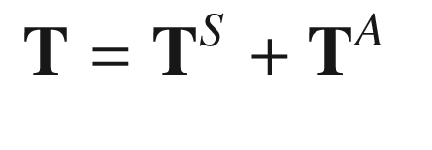

(A.11a)

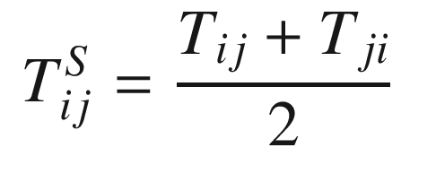

(A.11b)

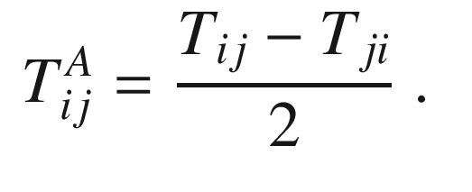

(A.11c)

A rank-2 tensor can be separated into an isotropic (spherical) part

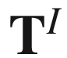

and a deviatoric part

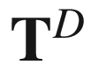

. The isotropic part is invariant under coordinate rotation.

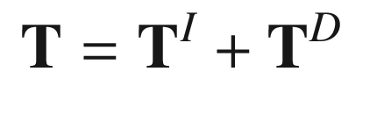

(A.12a)

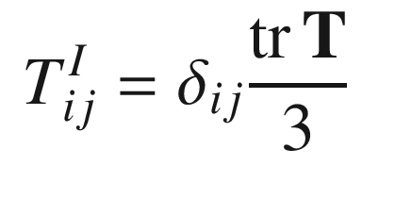

(A.12b)

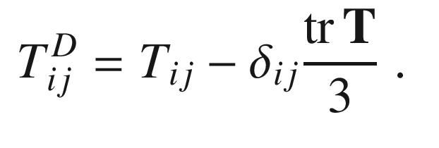

(A.12c)

The trace of



is the same as that of

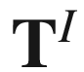

. The trace of

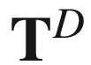

is zero.

***Rank-3 Tensors***

A tensor of rank 3 transforms according to

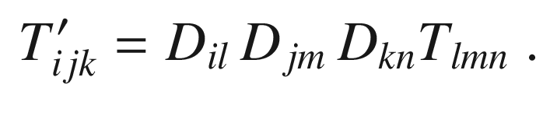

(A.13)

An example is the tensor

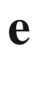

of piezoelectric constants that relates the rank-2 tensor of the strains

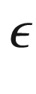

with the polarization vector



, i.e.

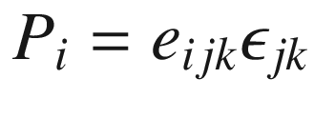

.

***Rank-4 Tensors***

A tensor of rank 4 transforms according to

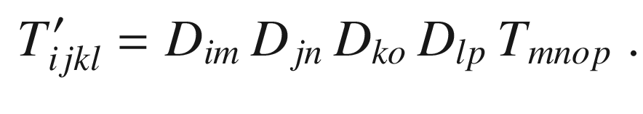

(A.14)

An example is the tensor

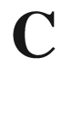

of elastic constants that relates the rank 2 tensors

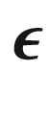

and

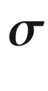

of the elastic strains and stresses, i.e.

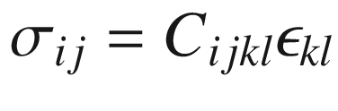

. The reduction of the rotation of a rank-4 tensor to a

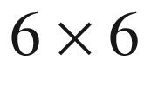

matrix problem is discussed in [[2151](The_Physics_of_Semiconductors00010.docx#u116076_4_En_BookBackmatter_OnlinePDF-CR2151)].

Appendix B

## Point and Space Groups

Table B.1

The 10 two-dimensional point groups in group and full and abbreviated international notation.

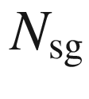

denotes the number of space groups

| Group | Notation | | $$N_{\mathrm {sg}}$$ | Symmetry elements |
| --- | --- | --- | --- | --- |
| Full | Abbreviated |
| International | |  |
| $$C_1$$ | 1 | 1 | 1 | $$C_1$$ |
| $$D_1$$ | 1 m | m | 3 | $$C_1$$  , m |
| $$C_2$$ | 2 | 2 | 1 | $$C_2$$ |
| $$D_2$$ | 2 mm | mm | 4 | $$C_2$$  , 2 m |
| $$C_3$$ | 3 | 3 | 1 | $$C_3$$ |
| $$D_3$$ | 3 m | 3 m | 2 | $$C_3$$  , 3 m |
| $$C_4$$ | 4 | 4 | 1 | $$C_4$$ |
| $$D_4$$ | 4 mm | 4 m | 2 | $$C_4$$  , 2 m |
| $$C_6$$ | 6 | 6 | 1 | $$C_6$$ |
| $$D_6$$ | 6 mm | 6 m | 1 | $$C_6$$  , 6 m |

Table B.2

The 32 point groups in Schönfließ and international notation.

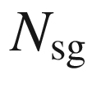

denotes the number of space groups

| System | Class | | $$N_{\mathrm {sg}}$$ | Symmetry elements |
| --- | --- | --- | --- | --- |
| International | Schönfließ |
| Triclinic | $$\begin{array}{l} 1 \\ \bar{1} \end{array} $$ | $$\begin{array}{l} C_1 \\ C_i \end{array}$$ | $$\begin{array}{l} 1 \\ 1 \end{array}$$ | $$\begin{array}{l} E \\ E\;i \end{array}$$ |
| Monoclinic | $$ \begin{array}{l} \mathrm{m} \\ 2 \\ 2/\mathrm{m} \end{array} $$ | $$\begin{array}{l} C_s \\ C_2 \\ C_{2h} \end{array}$$ | $$\begin{array}{l} 3 \\ 4 \\ 6 \end{array}$$ | $$\begin{array}{l} E \; \sigma _h \\ E \; C_2 \\ E \; C_2 \; i \; \sigma _h \end{array}$$ |
| Orthorhombic | $$ \begin{array}{l} 2~\mathrm{mm} \\ 222 \\ \mathrm{mmm} \end{array} $$ | $$\begin{array}{l} C_{2v} \\ D_2 \\ D_{2h} \end{array}$$ | $$\begin{array}{l} 9 \\ 22 \\ 28 \end{array}$$ | $$\begin{array}{l} E \; C_2 \; \sigma _v' \; \sigma _v'' \\ E \; C_2 \; C_2' \; C_2'' \\ E \; C_2 \; C_2' \; C_2'' \; i \; \sigma _h \; \sigma _v' \; \sigma _v'' \end{array}$$ |
| Tetragonal | $$ \begin{array}{l} 4 \\ \bar{4} \\ 4/\mathrm{m} \\ 4~\mathrm{mm} \\ \bar{4} 2~\mathrm{m} \\ 422 \\ 4/\mathrm{mmm} \end{array}$$ | $$\begin{array}{l} C_4 \\ S_4 \\ C_{4h} \\ C_{4v} \\ D_{2d} \\ D_4 \\ D_{4h} \end{array}$$ | $$\begin{array}{l} 6 \\ 2 \\ 6 \\ 10\\ 12\\ 12\\ 20 \end{array}$$ | $$\begin{array}{l} E \;2C_4 \;C_2 \\ E \;2S_4 \;C_2 \\ E \;2C_4 \; C_2 \;i \; 2S_4\;\sigma _h \\ E\;2C_4\;C_2\;2 \sigma _v' \;2 \sigma _d\\ E\;C_2\;C_2'\;C_2''\;2 \sigma _d\;2S_4\\ E\;2C_4\;C_2\;2C_2'\;2C_2''\\ E\;2C_4\;C_2\;2C_2'\;2C_2''\;i\;2S_4\;\sigma _h\;2\sigma _v'\;2 \sigma _h\end{array}$$ |
| $$\begin{array}{l} \mathrm {Trigonal} \\ \mathrm {(rhombohedral)} \end{array}$$ | $$\begin{array}{l} 3 \\ \bar{3} \\ 3~\mathrm{m} \\ 32 \\ \bar{3}~ \mathrm{m} \end{array}$$ | $$\begin{array}{l} C_3 \\ S_6 \\ C_{3v} \\ D_3 \\ D_{3d} \end{array}$$ | $$\begin{array}{l} 4\\ 2\\ 7\\ 6\\ 6 \end{array}$$ | $$\begin{array}{l} E\;2C_3 \\ E\;2C_3\;i\;2S_6 \\ E\;2C_3\;3\sigma _v \\ E\;2C_3\;3C_2 \\ E\;2C_3\;3C_2\;i\;2S_6\;3 \sigma _d \end{array}$$ |
| Hexagonal | $$\begin{array}{l} \bar{6} \\ 6 \\ 6/\mathrm{m} \\ \bar{6}~\mathrm{m} 2 \\ 6~\mathrm{mm} \\ 622 \\ 6/\mathrm{mmm} \\ \end{array}$$ | $$\begin{array}{l} C_{3h} \\ C_6 \\ C_{6h} \\ D_{3h} \\ C_{6v} \\ D_6 \\ D_{6h} \\ \end{array}$$ | $$\begin{array}{l} 6\\ 1\\ 2\\ 6\\ 4\\ 4\\ 4 \end{array}$$ | $$\begin{array}{l} E\;2C_3\;\sigma _h\;2S_3 \\ E\;2C_6\;2C_3\;C_2 \\ E\;2C_6\;2C_3\;C_2\;i\;2S_3\;2S_6\;\sigma _h \\ E\;2C_3\;3C_2\;\sigma _h\;2S_3\;3\sigma _v \\ E\;2C_6\;2C_3\;C_2\;3\sigma _v\,3\sigma _d \\ E\;2C_6\;2C_3\;C_2\;3C_2'\;3C_2'' \\ E\;2C_6\;2C_3\;C_2\;3C_2'\;3C_2''\;i\;2S_3\; \\ \;\;2S_6\;\sigma _h\;3\sigma _d\;3\sigma _v\end{array}$$ |
| Cubic | $$ \begin{array}{l} 23 \\ m3 \\ \bar{4} 3~\mathrm{m} \\ 432 \\ m3~\mathrm{m} \end{array} $$ | $$\begin{array}{l} T \\ T_h \\ T_d \\ O \\ O_h \end{array}$$ | $$\begin{array}{l} 5\\ 7\\ 8\\ 6\\ 10 \end{array}$$ | $$\begin{array}{l} E\;4C_3\;4C_3^2\;3C_2 \\ E\;4C_3\;4C_3^2\;3C_2\;i\;8S_6\;3\sigma _h \\ E\;8C_3\;3C_2\;6\sigma _d\;6S_4 \\ E\;8C_3\;3C_2\;6C_2'\;6C_4 \\ E\;8C_3\;3C_2\;6C_2\;6C_4\;i\;8S_6\;3\sigma _h\;6\sigma _d\;6S_4 \end{array}$$ |

Table B.3

Space group numbers and corresponding space group symbols in standard international notation

|  |  |  |  |  |  |  |  |  |  |
| --- | --- | --- | --- | --- | --- | --- | --- | --- | --- |
| 1 | P1 | 2 | P  $$\bar{1}$$ | 3 | P2 | 4 | P2  $$_1$$ | 5 | C2 |
| 6 | Pm | 7 | Pc | 8 | Cm | 9 | Cc | 10 | P2/m |
| 11 | P2  $$_1$$  /m | 12 | C2/m | 13 | P2/c | 14 | P2  $$_1$$  /c | 15 | C2/c |
| 16 | P222 | 17 | P222  $$_1$$ | 18 | P2  $$_1$$  2  $$_1$$  2 | 19 | P2  $$_1$$  2  $$_1$$  2  $$_1$$ | 20 | C222  $$_1$$ |
| 21 | C222 | 22 | F222 | 23 | I222 | 24 | I2  $$_1$$  2  $$_1$$  2  $$_1$$ | 25 | Pmm2 |
| 26 | Pmc2  $$_1$$ | 27 | Pcc2 | 28 | Pma2 | 29 | Pca2  $$_1$$ | 30 | Pnc2 |
| 31 | Pmn2  $$_1$$ | 32 | Pba2 | 33 | Pna2  $$_1$$ | 34 | Pnn2 | 35 | Cmm2 |
| 36 | Cmc2  $$_1$$ | 37 | Ccc2 | 38 | Amm2 | 39 | Abm2 | 40 | Ama2 |
| 41 | Aba2 | 4  $$_2$$ | Fmm2 | 43 | Fdd2 | 44 | Imm2 | 45 | Iba2 |
| 46 | Ima2 | 47 | Pmmm | 48 | Pnnn | 49 | Pccm | 50 | Pban |
| 51 | Pmma | 52 | Pnna | 53 | Pmna | 54 | Pcca | 55 | Pbam |
| 56 | Pccn | 57 | Pbcm | 58 | Pnnm | 59 | Pmmn | 60 | Pbcn |
| 61 | Pbca | 62 | Pnma | 63 | Cmcm | 64 | Cmca | 65 | Cmmm |
| 66 | Cccm | 67 | Cmma | 68 | Ccca | 69 | Fmmm | 70 | Fddd |
| 71 | Immm | 72 | Ibam | 73 | Ibca | 74 | Imma | 75 | P4 |
| 76 | P4  $$_1$$ | 77 | P4  $$_2$$ | 78 | P4  $$_3$$ | 79 | I4 | 80 | I4  $$_1$$ |
| 81 | P  $$\bar{4}$$ | 82 | I  $$\bar{4}$$ | 83 | P4/m | 84 | P4  $$_2$$  /m | 85 | P4/n |
| 86 | P4  $$_2$$  /n | 87 | I4/m | 88 | I4  $$_1$$  /a | 89 | P422 | 90 | P42  $$_1$$  2 |
| 91 | P4122 | 92 | P412  $$_1$$  2 | 93 | P4  $$_2$$  22 | 94 | P4  $$_2$$  2  $$_1$$  2 | 95 | P4  $$_3$$  22 |
| 96 | P4  $$_3$$  2  $$_1$$  2 | 97 | I422 | 98 | I4  $$_1$$  22 | 99 | P4mm | 100 | P4bm |
| 101 | P4  $$_2$$  cm | 102 | P4  $$_2$$  nm | 103 | P4cc | 104 | P4nc | 105 | P4  $$_2$$  mc |
| 106 | P4  $$_2$$  bc | 107 | I4mm | 108 | I4cm | 109 | I4  $$_1$$  md | 110 | I4  $$_1$$  cd |
| 111 | P  $$\bar{4}$$  2m | 112 | P  $$\bar{4}$$  2c | 113 | P  $$\bar{4}$$  2  $$_1$$  m | 114 | P  $$\bar{4}$$  2  $$_1$$  c | 115 | P  $$\bar{4}$$  m2 |
| 116 | P  $$\bar{4}$$  c2 | 117 | P  $$\bar{4}$$  b2 | 118 | P  $$\bar{4}$$  n2 | 119 | I  $$\bar{4}$$  m2 | 120 | I  $$\bar{4}$$  c2 |
| 121 | I  $$\bar{4}$$  2m | 122 | I  $$\bar{4}$$  2d | 123 | P4/mmm | 124 | P4/mcc | 125 | P4/nbm |
| 126 | P4/nnc | 127 | P4/mbm | 128 | P4/mnc | 129 | P4/nmm | 130 | P4/ncc |
| 131 | P4  $$_2$$  /mmc | 132 | P4  $$_2$$  /mcm | 133 | P4  $$_2$$  /nbc | 134 | P4  $$_2$$  /nnm | 135 | P4  $$_2$$  /mbc |
| 136 | P4  $$_2$$  /mnm | 137 | P4  $$_2$$  /nmc | 138 | P4  $$_2$$  /ncm | 139 | I4/mmm | 140 | I4/mcm |
| 141 | I4  $$_1$$  /amd | 142 | I4  $$_1$$  /acd | 143 | P3 | 144 | P3  $$_1$$ | 145 | P3  $$_2$$ |
| 146 | R3 | 147 | P  $$\bar{3}$$ | 148 | R  $$\bar{3}$$ | 149 | P312 | 150 | P321 |
| 151 | P3  $$_1$$  12 | 152 | P3  $$_1$$  21 | 153 | P3  $$_2$$  12 | 154 | P3  $$_2$$  21 | 155 | R32 |
| 156 | P3m1 | 157 | P31m | 158 | P3c1 | 159 | P31c | 160 | R3m |
| 161 | R3c | 162 | P  $$\bar{3}$$  1m | 163 | P  $$\bar{3}$$  1c | 164 | P  $$\bar{3}$$  m1 | 165 | P  $$\bar{3}$$  c1 |
| 166 | R  $$\bar{3}$$  m | 167 | R  $$\bar{3}$$  c | 168 | P6 | 169 | P6  $$_1$$ | 170 | P6  $$_5$$ |
| 171 | P6  $$_2$$ | 172 | P6  $$_4$$ | 173 | P6  $$_3$$ | 174 | P  $$\bar{6}$$ | 175 | P6/m |
| 176 | P6  $$_3$$  /m | 177 | P622 | 178 | P6  $$_1$$  22 | 179 | P6  $$_5$$  22 | 180 | P6  $$_2$$  22 |
| 181 | P6  $$_4$$  22 | 182 | P6  $$_3$$  22 | 183 | P6mm | 184 | P6cc | 185 | P6  $$_3$$  cm |
| 186 | P6  $$_3$$  mc | 187 | P  $$\bar{6}$$  m2 | 188 | P  $$\bar{6}$$  c2 | 189 | P  $$\bar{6}$$  2m | 190 | P  $$\bar{6}$$  2c |
| 191 | P6/mmm | 192 | P6/mcc | 193 | P6  $$_3$$  /mcm | 194 | P6  $$_3$$  /mmc | 195 | P23 |
| 196 | F23 | 197 | I23 | 198 | P2  $$_1$$  3 | 199 | I2  $$_1$$  3 | 200 | Pm  $$\bar{3}$$ |
| 201 | Pn  $$\bar{3}$$ | 202 | Fm  $$\bar{3}$$ | 203 | Fd  $$\bar{3}$$ | 204 | Im  $$\bar{3}$$ | 205 | Pa  $$\bar{3}$$ |
| 206 | Ia  $$\bar{3}$$ | 207 | P432 | 208 | P4  $$_2$$  32 | 209 | F432 | 210 | F4  $$_1$$  32 |
| 211 | I432 | 212 | P4  $$_3$$  32 | 213 | P4  $$_1$$  32 | 214 | I4  $$_1$$  32 | 215 | P  $$\bar{4}$$  3m |
| 216 | F  $$\bar{4}$$  3m | 217 | I  $$\bar{4}$$  3m | 218 | P  $$\bar{4}$$  3n | 219 | F  $$\bar{4}$$  3c | 220 | I  $$\bar{4}$$  3d |
| 221 | Pm  $$\bar{3}$$  m | 222 | Pn  $$\bar{3}$$  n | 223 | Pm  $$\bar{3}$$  n | 224 | Pn  $$\bar{3}$$  m | 225 | Fm  $$\bar{3}$$  m |
| 226 | Fm  $$\bar{3}$$  c | 227 | Fd  $$\bar{3}$$  m | 228 | Fd  $$\bar{3}$$  c | 229 | Im  $$\bar{3}$$  m | 230 | Ia  $$\bar{3}$$  d |

Appendix C